A Project Report on

# Resume Match: Job Role Matching and Skill

**Assessment System**

Submitted in partial fulfillment of the requirements for the award of the degree of

#### BACHELOR OF TECHNOLOGY

In

**COMPUTER SCIENCE AND ENGINEERING**

**Submitted by**

|  |  |
| --- | --- |
| **Vangapandu Chandrika** | **(20MH1A05C0)** |
| **Mallipudi Bhaskar Satya Pavan Kumar** | **(20MH1A0594)** |
| **Vundavalli Bhargavi Devi** | **(20MH1A05C8)** |
| **Kadavala Nikhil Kumar** | **(20MH1A0585)** |

### Under the esteemed supervision of Mrs. P.N.S. LAKSHMI, M.Tech

**Assistant Professor**



**Department of Computer Science & Engineering**

# ADITYA COLLEGE OF ENGINEERING (A)

**Approved by AICTE, Permanently Affiliated to JNTUK, Accredited by NBA & NAAC Recognized by UGC under Section 2(f) and 12(B) of UGC Act, 1956**

**Aditya Nagar, ADB Road, Surampalem – 5334367, E.G.Dist., Ph: 99631 76662**

**(2020-2024)**

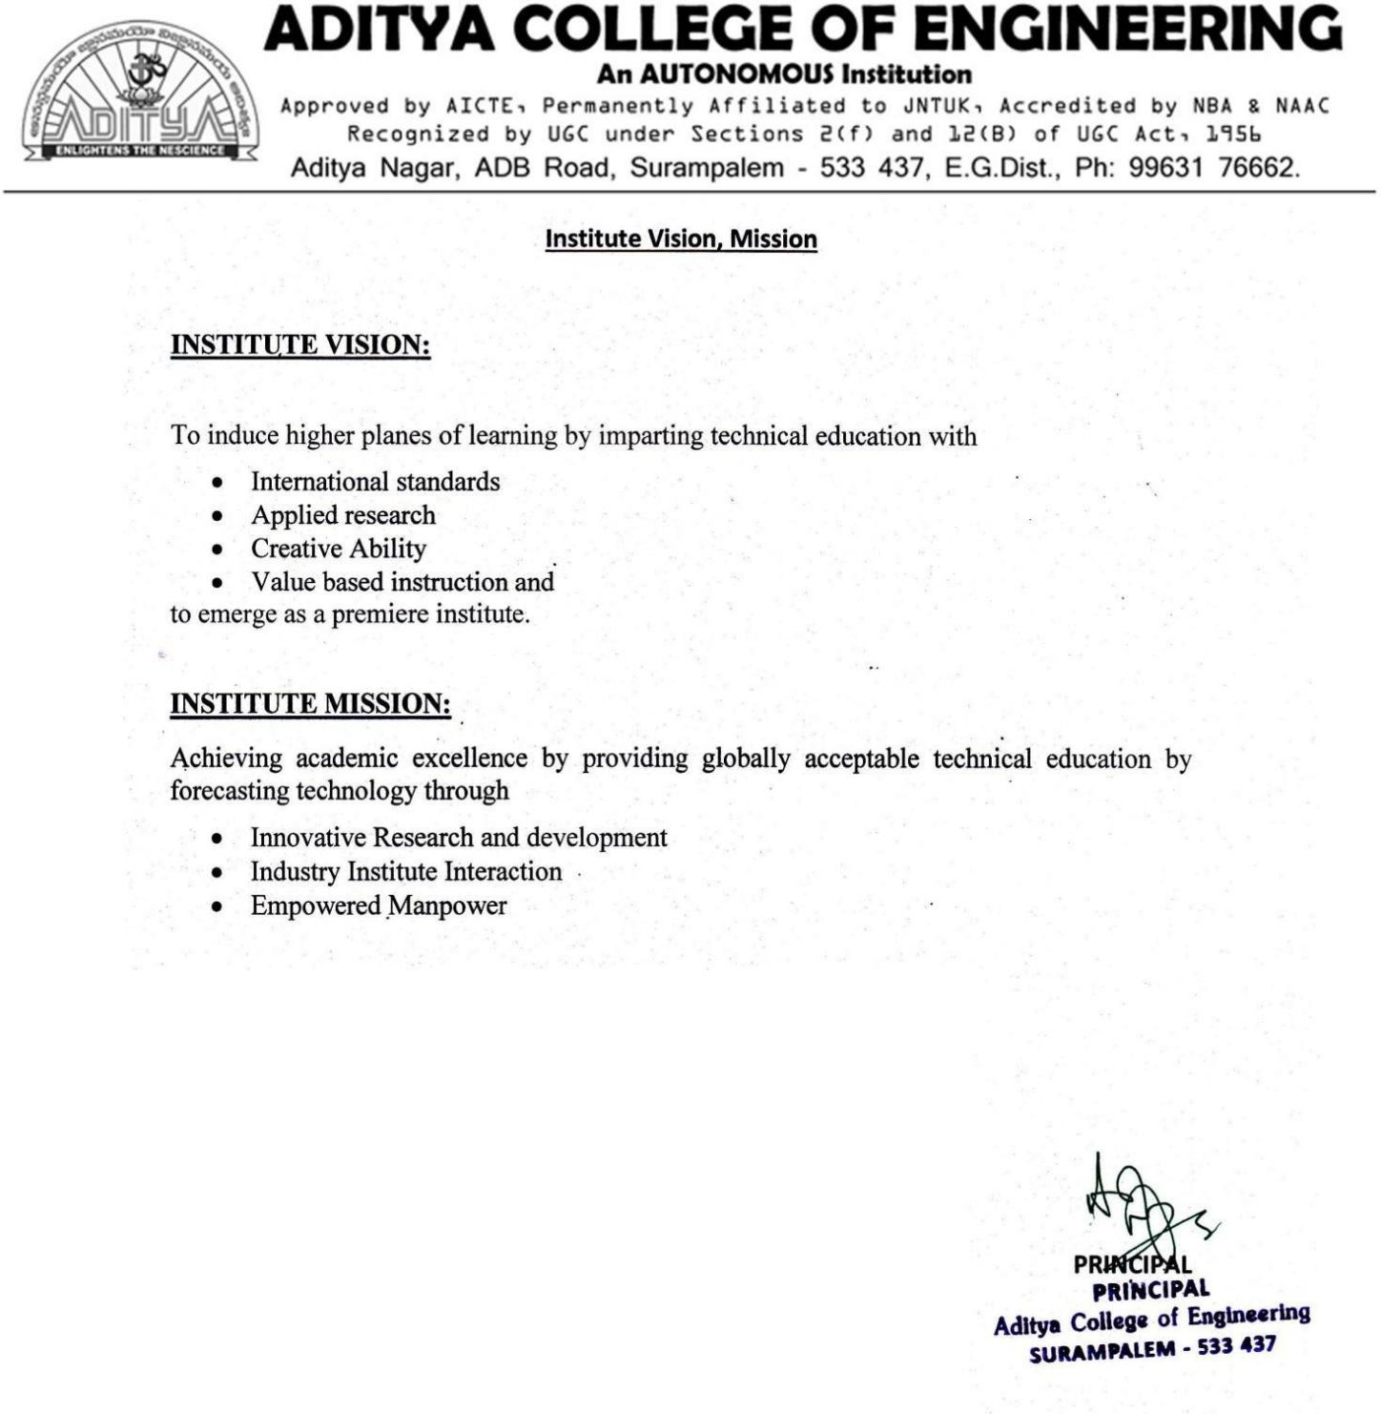

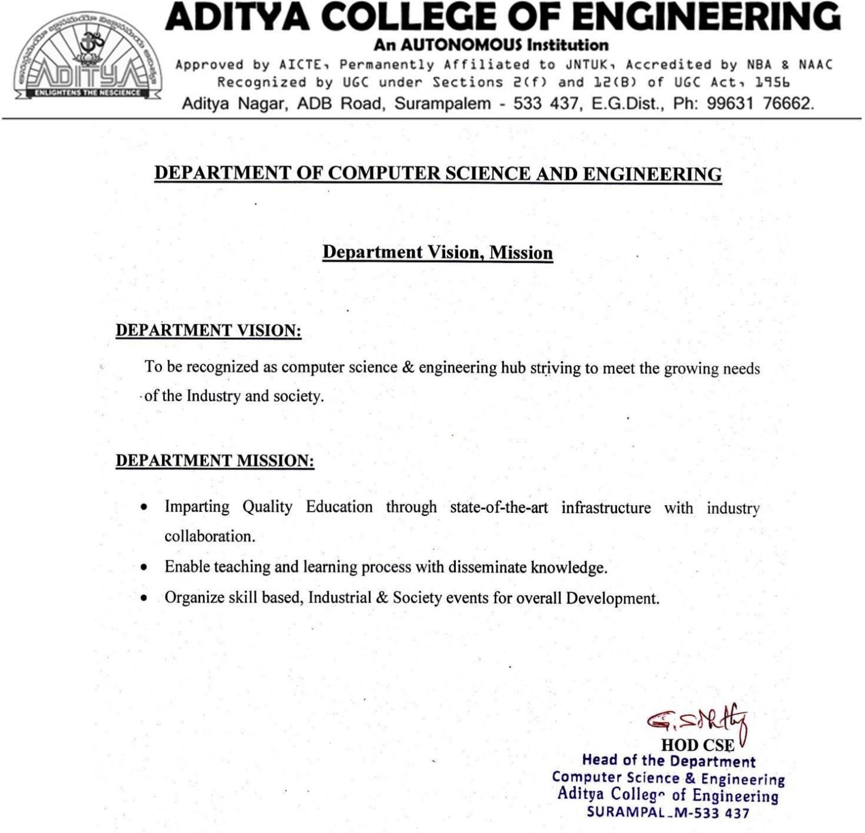

**ADITYA COLLEGE OF ENGINEERING (A)**

#### Approved by AICTE, Permanently Affiliated to JNTUK, Accredited by NBA & NAAC Recognized by UGC under Section 2(f) and 12(B) of UGC act, 1956

**Aditya Nagar, ADB Road, Surampalem – 5334367, E.G.Dist., Ph: 99631 76662 (2020 - 2024)**

**Department of Computer Science and Engineering**



#### CERTIFICATE

This is to certify the project report entitled **Resume Match: Job Role Matching and Skill Assessment System** is a bonafied work carried out by **Vangapandu Chandrika** bearing with Reg No: 20MH1A05C0, **Mallipudi Bhaskar Satya Pavan Kumar** bearing with Reg No: 20MH1A0594, **Vundavalli Bhargavi Devi** bearing with Reg No: 20MH1A05C8, **Kadavala Nikhil Kumar** bearing with Reg No: 20MH1A0585, at the college for the award of Bachelor of Technology in COMPUTER SCIENCE AND ENGINEERING from ADITYA COLLEGE OF

ENGINEERING(A) during the academic year of 2020-2024.

#### Project Guide Head of the Department

**Mrs. P.N.S. LAKSHMI, M.Tech. Dr.G.S.N. Murthy, M.Tech, Ph.D.**

Dept. Of CSE Dept. Of CSE

**Assistant Professor Professor & HOD**

**EXTERNAL EXAMINER**

# DECLARATION

We hereby declare that this project entitled **"Resume Match: Job Role Matching and Skill Assessment System"** has been undertaken by us and this work has been submitted to **ADITYA COLLEGE OF ENGINEERING (A),** Surampalem affiliated to JNTUK, Kakinada, in partial fulfillment of the requirements for the award of the degree of **BACHELOR OF TECHNOLOGY** in **COMPUTER SCIENCE AND ENGINEERING.**

We further declare that this project work has not been submitted in full or part to any other University or educational institute for the award of any degree or diploma.

**PROJECT ASSOCIATES**

**V.Chandrika (20MH1A05C0)**

**M.Pavan Kumar (20MH1A0594)**

**V.Bhargavi Devi (20MH1A05C8)**

**K.Nikhil Kumar (20MH1A0585)**

# ACKNOWLEDGEMENT

It is with immense pleasure that we would like to express our indebted gratitude to my **Project Supervisor**, **Mrs.P.N.S.Lakshmi, M.Tech** who has guided us a lot and encouraged us in every step of the project work, her valuable moral support and guidance has been helpful in the successful completion of this Project. We wish to express our sincere thanks to **Dr. G.S.N Murthy, Head of the Department of CSE**, for his valuable guidance given to us throughout the period

of the project work.

We feel elated to thank **Dr A. Ramesh, Principal** of Aditya College of Engineering (A) for his cooperation in completion of our project and throughout our course.

We feel elated to thank **Dr. P. S. V. V. S. Ravi Kumar**, **Dean (Academics)** of Aditya College of Engineering(A) for his cooperation in completion of our project work.

We wish to express our sincere thanks to all faculty members, and lab programmers for their valuable guidance given to us throughout the period of the project.

We avail this opportunity to express our deep sense and heart full thanks to the **Management** of **Aditya College of Engineering (A)** for providing a great support for us by arranging the trainees, and facilities needed to complete our project and for giving us the opportunity for doing this work.

**PROJECT ASSOCIATES**

|  |  |
| --- | --- |
| **V.Chandrika** | **(20MH1A05C0)** |
| **M.Pavan Kumar** | **(20MH1A0594)** |
| **V.Bhargavi Devi** | **(20MH1A05C8)** |
| **K.Nikhil Kumar** | **(20MH1A0585)** |

# ABSTRACT

"Resume Match: Job Role Matching and Skill Assessment System" is a critical concept in today's rapidly evolving job market. Identifying the intersection between individuals' current skill sets and the skills that will be in demand in the future is crucial for long-term career success. This strategic approach not only enhances employability but also ensures resilience in the face of technological advancements and economic changes. As technological advancements continue to shape industries, the need for individuals to possess relevant and adaptable skills becomes increasingly important. This paper explores the concept of correlating existing skill sets with the evolving demands of future careers, emphasizing the significance of aligning one's competencies with emerging trends and job requirements. Resume screening is the process of analyzing the resumes where the candidates apply for the different types of jobs where the company feel the tedious job to find the appropriate candidate due to the complexity in resumes formats since it has different styles.

By understanding the correlation between current skills and future job prospects, individuals can proactively enhance their skill sets and remain competitive in the ever-changing workplace landscape. Through the utilization of tools such as skills assessments, training programs, and career development resources, individuals can identify areas for improvement and acquire new skills that are in demand by employers. Resume screening is the process of evaluating a candidate's suitability for a position based on factors such as credentials, education, work history, and other data from their CV. Ultimately, the goal is to equip individuals with the necessary skills and knowledge to thrive in future-proofed careers, ensuring their long-term employability and success in an increasingly dynamic job market.

**LIST OF FIGURES**

|  |  |  |
| --- | --- | --- |
| **S.No.** | **NAME OF FIGURE** | **PAGE No.** |
| 1 | System Architecture | 13 |
| 2 | Use Case Diagram | 25 |
| 3 | Activity diagram | 26 |
| 4 | Sequence diagram | 28 |
| 5 | State Chart Diagram | 30 |
| 6 | Class Diagram | 31 |
| 7 | Component Diagram | 33 |
| 8 | ER Diagram | 34 |
| 9 | Data Flow Diagram Level1 | 35 |
| 10 | Data Flow Diagram Level2 | 36 |
| 11 | Logo | 41 |

**LIST OF TABLES**

|  |  |  |
| --- | --- | --- |
| **S No.** | **NAME OF TABLE** | **PAGE No.** |
| 1 | List of use cases and actors associated | 24 |
| 2 | Use cases and descriptions | 24 |

|  |  |
| --- | --- |
| **INDEX** |  |
| **CHAPTER** | **PAGE NO** |
| **ABSTRACT** | **VI** |
| **Chapter 1: INTRODUCTION** |  |
| 1.1 Introduction | 1 |
| 1.2 Introduction to Machine Learning | 2 |
| 1.2.1 Supervised Learning | 2 |
| 1.2.2 Unsupervised Learning | 3 |
| 1.2.3 Reinforcement Learning | 4 |
| 1.2.4 Applications of Machine Learning | 4 |
| 1.2.5 Advantages of Machine Learning | 5 |
| 1.2.6 Disadvantages of Machine Learning | 6 |
| 1.3 Introduction to Data mining | 6 |
| 1.3.1 What is Correlation? | 7 |
| 1.4 Motivation of the Work | 8 |
| **Chapter 2: LITERATURE SURVEY** | **9** |
| **Chapter 3: PROBLEM STATEMENT AND METHODOLOGY** |  |
| 3.1 Problem Definition | 10 |
| 3.2 Existing System | 11 |
| 3.2.1 Disadvantage | 11 |
| 3.3 Proposed System | 12 |
| 3.3.1 Advantage | 12 |
| 3.3.2 System Architecture | 12 |
| 3.4 Modules Division | 13 |
| 3.4.1 Data Cleaning and Standardization | 13 |
| 3.4.1.1 Data Cleaning and Standardization | 13 |
| 3.4.1.2 Identifying Key Skills and Competencies | 13 |
| 3.4.1.3 Establishing Correlation between Current and Future Skills | 14 |
| 3.4.1.4 Matching Skills with Emerging Career Trends | 14 |
| 3.4.1.5 Creating a Personalized Skills Development Plan | 14 |
| 3.4.2 Model Improvisation | 15 |
| 3.4.2.1 Importance of Model Improvisation in Career Development | 15 |

|  |  |
| --- | --- |
| 3.4.2.2 Training Techniques for Enhancing  Correlation of Skills | 15 |
| 3.4.2.3 Future-Proofing Careers Through Skill Matching | 15 |
| 3.4.2.4 Implementing a Model Improvisation Strategy for Career Success | 16 |
| 3.5 Creating User Interface | 16 |
| 3.5.1 Web User Interface | 16 |
| 3.5.2 Database | 16 |
| 3.5.3 Security | 17 |
| **Chapter 4: SYSTEM STUDY** |  |
| 4.1 Feasibility Study | 18 |
| 4.1.1 Economic feasibility | 18 |
| 4.1.2 Technical feasibility | 19 |
| 4.1.3 Operational feasibility | 20 |
| 4.1.4 Social feasibility | 21 |
| **Chapter 5: SYSTEM DESIGN** |  |
| 5.1 System Architecture | 22 |
| 5.2 UML Diagrams | 23 |
| 5.2.1 Behavior Diagram | 23 |
| 5.2.1.1 Use Case Diagram | 23 |
| 5.2.1.2 Activity Diagram | 26 |
| 5.2.1.3 Sequence Diagram | 28 |
| 5.2.1.4 State Chart Diagram | 30 |
| 5.2.2 Structure Diagram | 31 |
| 5.2.2.1 Class Diagram | 31 |
| 5.2.2.2 Component Diagram | 33 |
| 5.3 ER Diagram | 34 |
| 5.4 Data Flow Diagram | 35 |
| **Chapter 6**: **REQUIREMENT ANALYSIS** |  |
| 6.1 Introduction to Requirement Analysis | 37 |
| 6.2 System Requirements | 37 |
| 6.3 Functional Requirements | 37 |
| 6.4 Non-Functional Requirements | 37 |
| 6.4.1 User Interface and Human Factors | 38 |
| 6.4.2 Software Requirements | 38 |
| 6.4.3 Hardware Requirements | 38 |
| 6.4.4 Usability | 38 |
| 6.4.5 Reliability | 39 |
| 6.4.6 Performance | 39 |

|  |  |
| --- | --- |
| 6.4.7 Supportability | 39 |
| 6.4.8 Physical Environment | 39 |
| 6.4.9 Security Requirements | 39 |
| 6.4.9.1 Access requirement | 39 |
| 6.4.9.2 Integrity requirements | 40 |
| 6.4.9.3 Private requirements | 40 |
| 6.4.10 Resource Requirements | 40 |
| **Chapter 7: IMPLEMENTATION** |  |
| 7.1 Software Used | 41 |
| 7.1.1Python | 41 |
| 7.1.2Introduction to Streamlit frame work | 52 |
| 7.1.3 Python Libraries | 52 |
| 7.1.4Technology/Algorithm Used | 55 |
| 7.1.5Visual Studio | 55 |
| 7.2 Source Code | 56 |
| 7.2.1 Python code | 56 |
| 7.2.2 Data.json | 71 |
| **Chapter 8: Testing** |  |
| 8.1 Testing Levels | 74 |
| 8.1.1Unit Testing | 74 |
| 8.1.2 integration Testing | 75 |
| 8.1.3 Functional Testing | 75 |
| 8.1.4 Py Test | 76 |
| 8.2 Testing Methods | 77 |
| 8.2.1 Black Box Testing | 77 |
| 8.2.2White Box Testing | 77 |
| **Chapter 9: OUTPUT SCREENS** |  |
| 9.1 Sign Up | 79 |
| 9.2 Login Page | 80 |
| 9.3 Dashboard | 81 |
| 9.4 Resume Analysis | 82 |
| 9.5 Apply for a job | 85 |
| 9.6 Generated Questions | 86 |
| 9.7 Candidate Evolution | 86 |
| 9.8 Log Out | 87 |
| 9.9 Test Cases & Result | 88 |
| **CONCLUSION** | 90 |
| **FUTURE SCOPE** | 91 |
| **PUBLICATION WORK** | 92 |
| **BIBLIOGRAPHY** | 103 |

**CHAPTER 1 INTRODUCTION**

### Introduction to Resume Match

* In today's rapidly changing job market, the quest for sustainable career success demands more than just securing a job—it requires a strategic alignment of skills with future-proofed career paths. As industries evolve and technologies advance, individuals must navigate this dynamic landscape with foresight and adaptability.
* Understanding one's own strengths and interests serves as the compass in this journey. By introspectively assessing their skill sets, individuals can identify areas of expertise that resonate with the evolving demands of the workforce. This self-awareness forms the bedrock upon which strategic career planning is built, mitigating the risk of skill obsolescence and ensuring long-term relevance.
* Strategic planning isn't merely a theoretical exercise—it's a proactive endeavor rooted in continuous education and development. By embracing lifelong learning, individuals can stay ahead of the curve, acquiring new skills and knowledge to remain competitive in an ever-changing job market. This commitment to growth not only enhances employability but also opens doors to new career opportunities aligned with personal aspirations.
* Enterprises in today's landscape require efficient tools to sift through the vast pool of talent and identify the best fit for their organizational needs. Herein lies the significance of a robust Job Role Matching and Skill Assessment System. By leveraging technology, such systems streamline the hiring process, matching resumes with job roles and assessing skills with precision. This not only saves time and resources but also ensures that candidates are evaluated objectively, fostering fairness and transparency in recruitment practices.
* By focusing on the correlation and matching of skills for future-proofed careers, individuals not only enhance their employability but also position themselves as valuable assets in an ever-evolving job landscape. In the pages that follow, we'll delve deeper into the mechanisms and benefits of such systems, exploring how they facilitate the seamless alignment of talent with opportunity, driving mutual success for both individuals and organizations alike.

### Introduction to Machine Learning:

Machine Learning may be a sub-area of AI, whereby the term refers to the power of IT systems to independently find solutions to problems by recognizing patterns in databases. In other words: Machine Learning enables IT systems to acknowledge patterns in the idea of existing algorithms and data sets and to develop adequate solution concepts. Therefore, in Machine Learning, artificial knowledge is generated on the idea of experience. In order to enable the software to independently generate solutions, the prior action of people is important. For example, the required algorithms and data must be fed into the systems in advance and the respective analysis rules for the recognition of patterns in the data stock must be defined. Once these two steps have been completed, the system can perform the following tasks by Machine Learning:

* Finding, extracting and summarizing relevant data
* Making predictions based on the analysis data
* Calculating probabilities for specific results

### Supervised learning:

Basically, algorithms play a crucial role in Machine Learning: On the one hand, they're liable for recognizing patterns and on the opposite hand, they will generate solutions.

Algorithms can be divided into different categories:

In the course of monitored learning, example models are defined beforehand. So as to make sure an adequate allocation of the knowledge to the respective model groups of the algorithms, these then need to be specified. In other words, the system learns on the idea of given input and output pairs. within the course of monitored learning, a programmer, who acts as a sort of teacher, provides the acceptable values for specific input. The aim is to coach the system within the context of successive calculations with different inputs and outputs to determine connections. Supervised learning is where you've got input variables (X) and an output variable (Y) and you employ an algorithm to find out the mapping function from the input to the output. Y = f(X) The goal is to approximate the mapping function so well that once you have a new input file (X) that you simply can predict the output variables (Y) for that data. It's called supervised learning because the method of an algorithm learning from the training dataset is often thought of as an educator supervising the training process. We all know the correct answers, the algorithm iteratively makes predictions on the training data and is corrected. Learning stops when the algorithm achieves a suitable level of performance. Techniques of Supervised Machine Learning algorithms include linear and logistic regression, multi-class classification, Decision Tree, and

Support Vector Machine.

Supervised Learning problems are a kind of machine learning technique often further grouped into Regression and Classification problems. The difference between these two is that the dependent attribute is numerical for regression and categorical for classification: **Regression:**

Linear regression could also be a linear model, e.g. a model that assumes a linear relationship between the input variables (x) and thus the only output variable (y). More specifically, that y is usually calculated from a linear combination of the input variables (x).

When there's one input variable (x), the tactic is mentioned as simple linear regression. When there are multiple input variables, literature from statistics often refers to the tactic as multiple linear regression.

### Classification:

Classification could also be a process of categorizing a given set of data into classes, It is often performed on both structured or unstructured data. the tactic starts with predicting the category of given data points. The classes are often mentioned as target, label, or categories.

In short, classification either predicts categorical class labels or classification data supported the training set and thus the values (class labels) in classifying attributes and uses it in classifying new data.

There is a variety of classification models. Classification models include Logistic Regression, Decision Tree, Random Forest, Gradient Boosted Tree, One-vs.-One, and Naïve Bayes.

### Unsupervised learning:

In unsupervised learning, AI learns without predefined target values and without rewards. It's mainly used for learning segmentation (clustering). The machine tries to structure and type the info entered consistent with certain characteristics. For instance, a machine could (very simply) learn that coins of various colors are often sorted consistent with the characteristic "color" so as to structure them. Unsupervised Machine Learning algorithms are used when the knowledge used to train is neither classified nor labeled. The system doesn't determine the right output but it explores the data and should draw inferences from datasets to elucidate hidden structures from unlabeled data. Unsupervised Learning is that the training of Machines using information that's neither classified nor labeled and allowing the algorithm to act thereon information without guidance.

Unsupervised Learning is accessed into two categories of algorithms:

* + - * **Clustering**: A clustering problem is where you would like to get the inherent grouping in the data such as grouping customers by purchasing behavior. Association: An

Association rule learning problem is where you would wish to get rules that describe large portions of your data such as folks that buy X also tend to shop for Y.

### Reinforcement learning:

Reinforcement machine learning trains machines through trial and error to take the best action by establishing a reward system. Reinforcement learning can train models to play games or train autonomous vehicles to drive by telling the machine when it made the right decisions, which helps it learn over time what actions it should take. Reinforcement learning is an area of machine learning concerned with how software agents ought to take actions in an environment so as to maximize some notion of cumulative reward. Due to its generality, the field is studied in many other disciplines, such as game theory, control theory, operations research, information theory, simulation-based optimization, multi-agent systems, swarm intelligence, statistics and genetic algorithms. In machine learning, the environment is typically represented as a Markov decision process (MDP). Many reinforcements learning algorithms use dynamic programming techniques. Reinforcement learning algorithms do not assume knowledge of an exact mathematical model of the MDP and are used when exact models are infeasible. Reinforcement learning algorithms are used in autonomous vehicles or in learning to play a game against a human opponent.

### Applications of Machines Learning:

Machine Learning is the most rapidly growing technology and according to researchers we are in the golden year of AI and ML. It is used to solve many real- world complex problems which cannot be solved with traditional approach. Following are some real-world applications of ML-

* Emotion analysis
* Sentiment analysis
* Error detection and prevention
* Weather forecasting and prediction
* Stock market analysis and forecasting
* Speech synthesis
* Speech recognition
* Customer segmentation
* Object recognition
* Fraud detection
* Fraud prevention
* Recommendation of products to customer in online shopping

### Advantages of Machine Learning:

1. **Easily identifies trends and patterns**

Machine Learning can review large volumes of data and discover specific trends and patterns that would not be apparent to humans. For instance, for an e-commerce website like Amazon, it serves to understand the browsing behaviors and purchase histories of its users to help cater to the right products, deals, and reminders relevant to them. It uses the results to reveal relevant advertisements to them

### No human intervention needed (automation)

With ML, you don’t need to babysit your project every step of the way. Since it means giving machines the ability to learn, it lets them make predictions and also improve the algorithms on their own. A common example of this is anti-virus software’s they learn to filter new threats as they are recognized. ML is also good at recognizing spam.

### Continuous Improvement

As ML algorithms gain experience, they keep improving in accuracy and efficiency. This lets them make better decisions. Say you need to make a weather forecast model. As the amount of data you have keeps growing, your algorithms learn to make more accurate predictions faster.

### Handling multi-dimensional and multi-variety data

Machine Learning algorithms are good at handling data that are multi-dimensional and multi-variety, and they can do this in dynamic or uncertain environments.

### Wide Applications

You could be an e-tailor or a healthcare provider and make ML work for you. Where it does apply, it holds the capability to help deliver a much more personal experience to customers while also targeting the right customers.

### Disadvantages of Machine Learning:

1. **Data Acquisition**

Machine Learning requires massive data sets to train on, and these should be inclusive/unbiased, and of good quality. There can also be times where they must wait for new data to be generated.

### Time and Resources

ML needs enough time to let the algorithms learn and develop enough to fulfill their purpose with a considerable amount of accuracy and relevancy. It also needs massive resources to

function. This can mean additional requirements of computer power for you.

### Interpretation of Results

Another major challenge is the ability to accurately interpret results generated by the algorithms. You must also carefully choose the algorithms for your purpose.

### High error-susceptibility

[Machine Learning](https://en.wikipedia.org/wiki/Machine_learning) is autonomous but highly susceptible to errors. Suppose you train an algorithm with data sets small enough to not be inclusive. You end up with biased predictions coming from a biased training set. This leads to irrelevant advertisementsbeing displayed to customers. In the case of ML, such blunders can set off a chain of errors that can go undetected for long periods of time. And when they do get noticed,it takes quite some time to recognize the source of the issue, and even longer to correct it.

### Introduction to Data Mining:

Data mining is the process of discovering patterns, trends, correlations, or relationships within large datasets to extract useful information or insights. It involves analyzing vast amounts of data from various sources, such as databases, data warehouses, and the internet, to uncover previously unknown patterns or relationships.

The process typically involves several steps:

1. **Data Collection**: Gathering data from multiple sources, which can include databases, text files, spreadsheets, and other structured or unstructured sources.
2. **Data Preprocessing**: Cleaning and transforming the data to ensure its quality and compatibility with the analysis process. This may involve handling missing values, removing duplicates, and normalizing data.
3. **Exploratory Data Analysis**: Exploring the data to understand its characteristics and identify initial patterns or trends. This step often involves visualizing the data using charts, graphs, or statistical summaries.
4. **Model Building**: Applying various data mining techniques, such as classification, clustering, regression, or association rule mining, to extract patterns or relationships from the data.
5. **Evaluation**: Assessing the quality and effectiveness of the data mining models or patterns generated. This step helps ensure that the insights obtained are meaningful and reliable.
6. **Deployment**: Integrating the insights obtained from data mining into decision-making processes or operational systems to derive value from the discovered knowledge.

Data mining is widely used across various industries and applications, including marketing, finance, healthcare, retail, and telecommunications, to uncover valuable insights, make

predictions, and drive informed decision-making.

### What is correlation?

In data mining, correlation refers to the statistical measure that quantifies the strength and direction of the relationship between two variables. It indicates how much one variable change when another variable changes.

There are different types of correlation measures, but the most common one is Pearson correlation coefficient (r). It ranges from -1 to +1.

* A correlation of +1 indicates a perfect positive linear relationship, meaning that as one variable increases, the other variable also increases proportionally.
* A correlation of -1 indicates a perfect negative linear relationship, meaning that as one variable increases, the other variable decreases proportionally.
* A correlation close to 0 indicates no linear relationship between the variables. Correlation analysis is crucial in data mining for various reasons:

1. **Identifying Relationships**: It helps identify potential relationships between variables, which can provide insights into how they interact with each other.
2. **Feature Selection**: Correlation analysis can assist in selecting the most relevant features (variables) for building predictive models. Highly correlated features might not provide additional information and could be redundant.
3. **Predictive Modeling**: Understanding the correlation between input variables and the target variable is essential for building accurate predictive models. It helps in selecting the most predictive variables and understanding their impact on the target variable.
4. **Data Exploration**: Correlation analysis aids in exploring relationships between different variables in the dataset, uncovering patterns, and gaining a deeper understanding of the data.

### Motivation of the Work

For a resume match job role matching and skill assessment system, the motivation lies in bridging the gap between job seekers and employers by efficiently matching their respective needs and capabilities. Here are some key motivations that you can highlight:

* **Efficiency:** Streamlining the hiring process saves time and resources for both job seekers and employers. By leveraging technology to match resumes with job roles and assess skills accurately, the system facilitates faster and more precise hiring decisions.
* **Accuracy**: Traditional hiring processes often rely on manual screening, which can be prone to biases and errors. A robust matching and assessment system ensures that candidates are evaluated based on objective criteria, enhancing the fairness and accuracy of the hiring process.
* **Cost-Effectiveness**: Hiring the wrong candidate can be costly for organizations in terms of training expenses, decreased productivity, and potential turnover. By identifying the most suitable candidates upfront, the system helps reduce turnover rates and associated costs.
* **Enhanced Candidate Experience**: Job seekers appreciate a seamless and transparent hiring process. By providing personalized job recommendations and constructive feedback on skills assessment, the system enhances the overall candidate experience, fostering positive employer branding.
* **Data-Driven Insights**: Collecting and analyzing data on job roles, candidate profiles, and hiring outcomes can yield valuable insights for employers. By tracking key metrics such as time-to-hire, candidate quality, and diversity metrics, the system enables continuous improvement in recruitment strategies.
* **Scalability**: As businesses grow and evolve, their hiring needs also change. A scalable matching and assessment system can adapt to varying demands, whether it's scaling up recruitment efforts during periods of expansion or optimizing processes during leaner times. Highlighting these motivations in your resume demonstrates your understanding of the challenges in traditional hiring processes and your commitment to leveraging technology to address them effectively. It also showcases your ability to develop solutions that meet both

employer and candidate need.

# CHAPTER 2

## LITEARTURE SURVEY

1. An Intelligent Career Guidance System using Machine Learning: Vignesh S, Shivani Priyanka C, Shree Manju H, Mythili K Information Technology
2. Information Technology Road map: A Strategic Business Tool
3. Influence of Digital Technology on Roadmap Development for Digital Business Transformation
4. AI-Based Personalized E-Learning Systems: Issues, Challenges, and Solutions
5. RESUME SCREENING USING MACHINE LEARNING - MUNGI NAGA VENKATA SAI RAGHAVENDRA
6. REAL TIME RESUME SCREENING USING NLP AND TOKEN BASED INDEXING -

1Bussa Sai Swe Shika, 2Golla DivyaSri, 3Madapati Aishwarya, 4K. Pharisee

1. Resume Evaluation through Latent Dirichlet Allocation and Natural Language Processing for Effective Candidate Selection - Vidhita Jawani, Smit Meghani, Sudhir Dhage, Krishna Pai
2. Smart Resume Analyzer - Ms. Y. Sowjanya |Mar eddy Keerthana |Pulluri Suneeksha | Dorgipati Sai Sri Harsha
3. Automated Resume Screening Using Natural Language Processing - Dr. D. Lakshmi Padmaja1 , Ch. Vishnuvardhan2 , G. Rajeev3 , K. Nitish Sanjeev Kumar
4. Information Extraction From Free-Form CV Documents in Multiple Languages -DAVOR VUKADIN, ADRIAN SATJA KURDIJA , GORAN DELAČ AND MARIN ŠILIĆ .
5. Recommendation for Jobs and Resume Analyzer Using NLP - *Jasmit Gharat*
6. AI Resume Analyzer - Ashvini Chavan, Nikita Tatewar, Pavina Naicker
7. RESUME MATCHING FRAMEWORK VIA RANKING AND SORTING USING NLP

AND DEEP LEARNING - Lav Kumar, Karthik Penikalapati, Sudheer Kumar Reddy Gowrigari

1. AN AUTOMATED RESUME SCREENING SYSTEM USING NATURAL LANGUAGE

PROCESSING AND SIMILARITY Chirag Daryania, Gurneet Singh Chhabrab, Harsh Patelc ,

Indrajeet Kaur Chhabrad, Ruchi Patele

1. JOB RECOMMENDATION SYSTEM BASED ON SKILL SETS - G.Mahalakshmi ,

A.Arun Kumar, B.Senthilnayaki, J.Duraimurugan

1. Method and System for Matching a Candidate Profile for Job Openings based on Qualitative Parameters By Anurag Kumar & Ashish Mukherjee

# CHAPTER 3

**PROBLEM STATEMENT AND METHODOLOGY**

### Problem Definition:

In today's dynamic job market, both job seekers and employers face challenges in effectively matching candidates to suitable job roles. Traditional recruitment processes often rely on keyword matching, which can overlook candidates with valuable skills or experiences not explicitly mentioned in their resumes. Furthermore, assessing a candidate's skills accurately can be time-consuming and subjective.

Challenges:

* **Keyword-Based Matching Limitations**: Existing systems primarily rely on keyword matching algorithms, which may fail to capture the nuances of a candidate's skills and experiences.
* **Subjectivity in Skill Assessment**: Assessing candidates' skills often relies on subjective evaluation methods, leading to inconsistencies and biases in the recruitment process.
* Mismatch Between Job Requirements and Candidate Skills: Candidates may possess relevant skills and experiences that are not adequately highlighted in their resumes, leading to mismatches between their capabilities and the job requirements.
* **Time-Intensive Recruitment Process**: Manual screening of resumes and skill assessments can be time-consuming for recruiters, delaying the hiring process and potentially resulting in missed opportunities.
* **Ineffective Utilization of Talent Pool**: Employers may overlook qualified candidates due to limitations in the recruitment system's ability to accurately assess their skills and suitability for a particular role.

The proposed system is to address the aforementioned challenges by developing an advanced job role matching and skill assessment system. This system aims to improve the efficiency and effectiveness of the recruitment process by leveraging machine learning algorithms, natural language processing techniques, and data analytics to accurately match candidates to job roles based on their skills, experiences, and preferences.

Solution Approach:

* **Advanced Matching Algorithms:** Develop advanced algorithms that go beyond keyword matching to analyze the semantic meaning of resumes and job descriptions, enabling more accurate and comprehensive candidate-job role matching.
* **Objective Skill Assessment:** Implement objective skill assessment methodologies, such as automated coding assessments, simulations, and competency-based evaluations, to ensure

fair and consistent evaluation of candidates' capabilities.

* **Skills Gap Analysis**: Provide insights to candidates and employers regarding skills gaps and development opportunities, facilitating proactive skill enhancement and talent management.
* **Personalized Recommendations:** Utilize machine learning models to personalize job recommendations for candidates based on their skills, preferences, and career aspirations, enhancing the overall candidate experience.
* **Efficient Talent Acquisition:** Streamline the recruitment process by automating repetitive tasks, such as resume screening and initial candidate assessments, to accelerate time-to-hire while maintaining the quality of candidate selection.

By addressing these challenges and implementing the proposed solution approach, the Resume Match system aims to revolutionize the recruitment process, making it more efficient, objective, and tailored to the needs of both candidates and employers.

### Existing System

* The existing system for correlation and matching of skills for careers utilizes various tools and platforms to analyze job requirements and individual skill sets. These tools often encompass algorithms and AI technology to identify correlations between specific skills and career paths.
* Additionally, career advisors and counselors play a crucial role in helping individuals understand the necessary skills and training needed for future job opportunities. The system also relies on continuous data collection and analysis to stay updated with evolving job trends and skill demands in the market.

### Disadvantages

* + - * The existing system for correlating and matching skills for careers is often criticized for being rigid and outdated, relying too heavily on traditional academic qualifications and standardized tests.
      * This approach fails to adequately capture and assess the full range of skills and competencies that are valuable in today's rapidly changing job market.
      * Additionally, the emphasis on formal credentials can disadvantage individuals who have gained valuable experience and skills through non-traditional pathways.
      * Moreover, the lack of emphasis on soft skills and emotional intelligence in the existing system can lead to gaps in preparing individuals for the dynamic and collaborative nature of modern work environments.

### Proposed System

* The proposed system aims to match individuals with careers by correlating their skills

and attributes.

* Through the use of advanced algorithms and machine learning technologies, the system will analyze a person's skill set and qualities to identify suitable career paths that align with their strengths and interests.
* By considering factors such as industry trends, job market demands, and individual aspirations, the system will offer personalized recommendations to help individuals navigate their career development.
* Ultimately, the goal is to empower users to make informed decisions and pursue rewarding and sustainable career opportunities in the ever-evolving job market.

### Advantages

* + - * The proposed system for correlation and matching of skills for careers offers several advantages.
      * It enhances the alignment between an individual's skill set and the requirements of future job roles, increasing the likelihood of successful career transitions.
      * By providing personalized recommendations based on skills analysis, it enables individuals to discover new opportunities and pathways for growth.
      * Additionally, the system facilitates better workforce planning and talent development strategies for organizations by identifying skill gaps and strengths within their workforce.
      * Overall, the system contributes to a more agile and resilient workforce equipped to thrive in dynamic career landscapes.

### System Architecture

Machine learning has given computer systems the ability to automatically learn without being explicitly programmed. It represents the flow of execution and it involves the following five major steps:

* The architecture diagram is defined with the flow of the process which is used to refine the raw data and used for predicting the resumes data.
* The next step is preprocessing the collected raw data into an understandable format.
* Then we have to train the data by splitting the dataset into train data and test data.
* The resumes data is evaluated with the application of a machine learning
* algorithm that is NLP algorithm, and the classification accuracy of this model is found

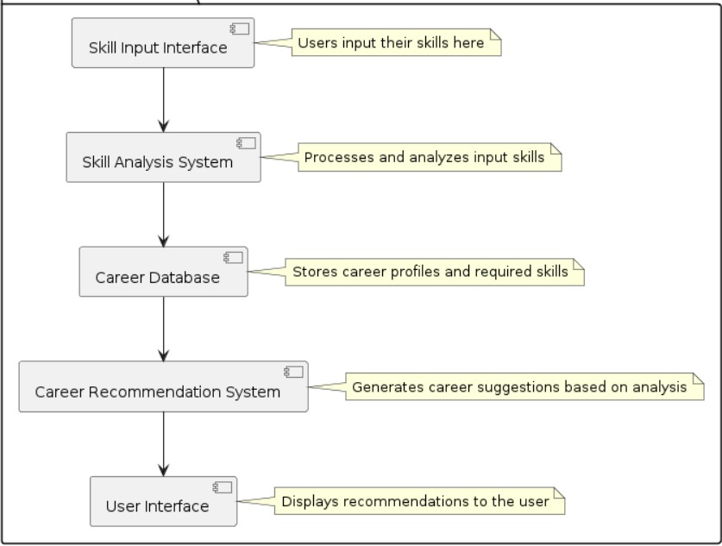

### Modules Division

**Fig3.1: System architecture**

Let us discuss about the various modules in our proposed system and what each module contributes in achieving our goal.

#### Data Cleaning and Standardization

Data cleaning and standardization are crucial processes for ensuring accurate correlation and matching of skills in the context of future-proofed careers. By effectively cleaning and standardizing data, inconsistencies, errors, and duplication can be reduced, allowing for more reliable analysis and identification of relevant skill sets. This streamlined approach not only enhances the accuracy of correlations between different data points but also facilitates the matching of skills with emerging career trends, ultimately empowering individuals to stay relevant in a rapidly evolving job market.

#### Identifying Key Skills and Competencies

Identifying key skills and competencies for future-proofed careers involves a thorough assessment of current market trends and technological advancements. Critical thinking, problem-solving, adaptability, and technological proficiency are essential skills that professionals need to develop to stay relevant in a rapidly evolving job landscape. Additionally, communication, collaboration, and leadership abilities are crucial for effective teamwork and

innovation in a dynamic work environment. By correlating these key skills with emerging industry demands and job opportunities, individuals can better match their skill sets to potential career paths that are likely to withstand future disruptions and changes in the market. Continuous learning, flexibility, and a growth mindset are also vital for professionals seeking to future-proof their careers and remain competitive in the ever-evolving job market.

#### Establishing Correlations between Current and Future Skills

Establishing correlations between current skills and future skills is essential for individuals aiming to future-proof their careers. By identifying the overlap and gaps between the skills they possess now and those that will be in demand in the future, individuals can make informed decisions about acquiring new competencies. This correlation and matching process involves assessing the market trends, technological advancements, and industry demands to forecast the skills that will be most valuable. It also requires individuals to self-assess their current skill set and determine areas for improvement or development. By aligning current skills with future needs, individuals can strategically position themselves for career success and adaptability in a rapidly changing job market. This proactive approach to skill development can enhance job security, employability, and overall career satisfaction in the long term.

#### Matching Skills with Emerging Career Trends

Developing critical thinking, problem-solving, and adaptability skills are crucial for matching emerging career trends that require innovative solutions and flexibility in the face of constant change. As industries evolve towards digitization and automation, honing skills in data analytics, artificial intelligence, and machine learning can significantly enhance one's career prospects in fields such as data science and cybersecurity. Additionally, effective communication and collaboration skills are essential for thriving in a remote and globally connected work environment, aligning with the rising trend of remote work and virtual teams. Lastly, embracing continuous learning and upskilling ensures individuals can stay competitive in dynamic job markets and pivot to new opportunities, well-suited for evolving careers in areas like renewable energy, sustainable development, and digital marketing. By closely correlating these skills with emerging career trends, individuals can future-proof their careers and remain agile in an ever-changing professional landscape.

#### 3.1.4.5 Creating a Personalized Skills Development Plan

To create a Personalized Skills Development Plan for correlation and matching of skills for future-proofed careers, start by assessing current skills and identifying strengths and areas for improvement. Utilize tools such as career aptitude tests and self-assessment exercises to gain insights into interests and abilities. Research future job trends and identify in-demand skills by industry. Develop a tailored learning path that includes acquiring new skills through online

courses, workshops, or certifications. Networking with professionals in desired fields can provide mentorship opportunities and valuable insights. Regularly review and update the skills development plan to stay relevant in a rapidly evolving job market. Continuously seeking feedback and adapting to changes in the industry will position you for success in future-proofed careers.

## MODEL IMPROVISATION

#### Importance of Model Improvisation in Career Development

Model improvisation plays a crucial role in career development by enabling individuals to adapt and enhance their skills to align with the demands of future-proofed careers. As the job market continuously evolves, the ability to correlate and match one's skills with the changing needs of industries becomes essential for sustainable career growth. By embracing model improvisation, individuals not only stay relevant but also demonstrate agility and versatility in navigating dynamic professional landscapes. This proactive approach allows them to bridge skill gaps, explore new opportunities, and position themselves as valuable assets in competitive job markets. Therefore, incorporating model improvisation into career development strategies ensures that individuals can continuously refine and align their skill sets to meet the evolving requirements of future-proofed careers, ultimately enhancing their employability and long-term success.

#### Training Techniques for Enhancing Correlation of Skills

Two training techniques for enhancing correlation and matching of skills for future- proofed careers include skills mapping and personalized development plans. Skills mapping involves identifying existing skills, competencies, and strengths to understand how they align with the requirements of future job roles. This helps individuals prioritize skill development areas and make informed decisions about career paths. Personalized development plans involve creating individualized learning pathways tailored to enhance specific skills or competencies needed for future career success. By setting specific goals, creating actionable steps, and incorporating feedback mechanisms, individuals can systematically improve their skill set and increase their marketability in a rapidly changing job market. Both techniques aim to bridge the gap between current skills and future job requirements, leading to a more strategic and effective approach to career development.

#### Future-Proofing Careers Through Skill Matching

Future-proofing careers through skill matching is essential for ensuring individuals are equipped to thrive in the rapidly evolving job market. By establishing correlations and effectively matching skills required for future-proofed careers, individuals can enhance their employability and adaptability to changing industry demands. This process involves identifying

key skills that are in high demand across various sectors and aligning them with an individual's skillset through targeted training and development. By staying proactive in identifying emerging trends and acquiring relevant skills, individuals can position themselves for long-term success in their chosen career paths. Embracing a continuous learning mindset and actively seeking opportunities to upskill and reskill can further solidify one's competitive edge in the job market, ultimately fostering career sustainability and growth.

#### Implementing a Model Improvisation Strategy for Career Success

Implementing a model improvisation strategy involves continuously assessing and enhancing skills to adapt to the evolving job market for future-proofed careers. Begin by identifying current strengths and weaknesses, then correlate them with emerging industry trends to match and prioritize skill development. Engage in ongoing learning and training to stay ahead of technological advancements and market demands, while also seeking opportunities for practical application of new skills. Embrace flexibility and a growth mindset to navigate uncertainties and seize opportunities for career advancement. By consistently refining and adapting skill sets based on correlation and matching with market needs, individuals can position themselves for sustained success in their careers.

## CREATING USER INTERFACE

#### Web User Interface

Model improvisation plays a crucial role in career development by enabling individuals to adapt and enhance their skills to align with the demands of future-proofed careers. As the job market continuously evolves, the ability to correlate and match one's skills with the changing needs of industries becomes essential for sustainable career growth. By embracing model improvisation, individuals not only stay relevant but also demonstrate agility and versatility in navigating dynamic professional landscapes. This proactive approach allows them to bridge skill gaps, explore new opportunities, and position themselves as valuable assets in competitive job markets. Therefore, incorporating model improvisation into career development strategies ensures that individuals can continuously refine and align their skill sets to meet the evolving requirements of future-proofed careers, ultimately enhancing their employability and long-term success.

#### Database

Two training techniques for enhancing correlation and matching of skills for future- proofed careers include skills mapping and personalized development plans. Skills mapping involves identifying existing skills, competencies, and strengths to understand how they align with the requirements of future job roles. This helps individuals prioritize skill development areas and make informed decisions about career paths. Personalized development plans involve

creating individualized learning pathways tailored to enhance specific skills or competencies needed for future career success. By setting specific goals, creating actionable steps, and incorporating feedback mechanisms, individuals can systematically improve their skill set and increase their marketability in a rapidly changing job market. Both techniques aim to bridge the gap between current skills and future job requirements, leading to a more strategic and effective approach to career development.

#### Security

Future-proofing careers through skill matching is essential for ensuring individuals are equipped to thrive in the rapidly evolving job market. By establishing correlations and effectively matching skills required for future-proofed careers, individuals can enhance their employability and adaptability to changing industry demands. This process involves identifying key skills that are in high demand across various sectors and aligning them with an individual's skillset through targeted training and development. By staying proactive in identifying emerging trends and acquiring relevant skills, individuals can position themselves for long-term success in their chosen career paths. Embracing a continuous learning mindset and actively seeking opportunities to upskill and reskill can further solidify one's competitive edge in the job market, ultimately fostering career sustainability and growth.

* 1. **Feasibility Study:**

# CHAPTER 4 SYSTEM STUDY

Job role matching and skill assessment system of Skills for Future-Proofed Careers is crucial for individuals navigating the rapidly evolving job market. Understanding the relationship between current skill sets and the demands of future job roles is essential for career sustainability. This entails identifying transferable skills that can be applied across different roles and industries, as well as upskilling or reskilling to meet the evolving demands of the labor market. Building a strong correlation between individual skills and the requirements of future- proofed careers involves continuous learning, adaptability, and a proactive approach to career development. Emphasizing soft skills such as critical thinking, problem-solving, and communication, alongside technical competencies, can enhance employability and resilience in the face of technological disruptions.

Additionally, leveraging resources such as career development programs, online learning platforms, and networking opportunities can aid in aligning skills with future job prospects. By staying attuned to industry trends, honing relevant skills, and embracing a growth mindset, individuals can position themselves for success in the ever-changing landscape of work.

## ECONOMICAL FEASIBILITY

* + - * Job role matching and skill assessment system for future-proofed careers is a critical aspect in today's rapidly evolving job market. As technology advances and industries transform, it is essential for individuals to develop skills that align with the changing demands of the workforce to ensure long-term career success and sustainability.
      * One key consideration in correlating and matching skills for future-proofed careers is the identification of emerging trends and technologies in specific industries. By understanding the skills that will be in demand in the future, individuals can proactively develop and acquire the necessary capabilities to stay relevant and competitive in their field.
      * Furthermore, it is crucial to assess one's existing skill set and identify areas for improvement or upskilling to meet the evolving requirements of the job market. Continuous learning and development of new skills, such as digital literacy, data analysis, and adaptability, are essential for staying ahead in a rapidly changing work environment.
      * Collaborating with industry professionals, mentors, and career counselors can also help individuals gain insights into the skills and competencies that are highly valued in their desired career paths. Networking and seeking guidance from experienced professionals can provide valuable opportunities for skill development and career advancement.
      * Moreover, embracing a growth mindset and being open to learning new skills and technologies is key to future-proofing one's career. Adapting to change, being flexible, and continuously seeking opportunities for professional growth can enhance one's employability and resilience in the face of industry disruptions. In conclusion, the correlation and matching of skills for future-proofed careers involve proactive skill development, continuous learning, networking, and adaptability. By staying informed about emerging trends, assessing and improving existing skills, and fostering a growth mindset, individuals can position themselves for success in a rapidly changing job market.

## TECHNICAL FEASIBILITY

Ensuring a correlation and matching of skills for future-proofed careers is vital in today's rapidly evolving job market. The alignment between skill sets and the demands of the future job landscape can significantly impact an individual's career success and employability. Here are some key points to consider in this regard:

1. **Continuous Learning and Adaptability**: Future-proofed careers require individuals to have a growth mindset and a commitment to continuous learning. It is crucial to stay updated on emerging technologies, industry trends, and skill requirements to remain competitive in the job market. Adaptability to changing environments and skill demands is essential for long-term career sustainability.
2. **Interdisciplinary Skills:** As industries become more interconnected, professionals with a diverse set of skills and knowledge from multiple disciplines are highly sought after. The ability to work across different fields and apply a range of skills to solve complex problems is becoming increasingly valuable. Developing a mix of technical, analytical, creative, and communication skills can help individuals navigate diverse career paths.
3. **Digital Literacy and Technology Skills:** With the rise of automation, artificial intelligence, and digital transformation, proficiency in technology-related skills

is becoming non-negotiable. Individuals should focus on improving their digital literacy, mastering data analysis, programming languages, and understanding emerging technologies like blockchain and machine learning to stay relevant in future job roles.

1. **Soft Skills and Emotional Intelligence:** While technical skills are essential, soft skills such as communication, collaboration, leadership, and emotional intelligence are equally crucial for career advancement. The ability to work well in teams, adapt to different work cultures, and communicate effectively can set individuals apart in a competitive job market.
2. **Career Guidance and Mentorship:** Seeking guidance from industry experts, mentors, and career advisors can provide valuable insights into the skills and competencies needed for future-

proofed careers. Mentorship can help individuals set career goals, navigate career transitions, and acquire the necessary skills to thrive in a rapidly changing workplace. By aligning skill development initiatives with the demands of future job markets, individuals can enhance their career prospects, adapt to evolving industry needs, and build a resilient career path that is well- equipped to withstand technological disruptions and market changes.

## OPERATIONAL FEASIBILITY

* + - * Correlation and Matching of Skills for Future-Proofed Careers is a critical consideration for individuals looking to thrive in a rapidly evolving job market. This concept underscores the importance of aligning one's skillset with the demands of future job roles and industries to ensure long-term career success and adaptability. In the context of preparing for future- proofed careers, individuals need to focus on developing a versatile set of skills that are in high demand and have staying power in the face of technological advancements and market changes.
      * One key aspect of this correlation and matching of skills is understanding current and emerging trends in various industries. By staying informed about advancements in technology, market demands, and job projections, individuals can identify areas where their skills align or where they need to upskill to remain competitive. Continuous learning and upskilling are essential components of future-proofing one's career, as they allow individuals to adapt to changing job requirements and industry dynamics.
      * Another critical element is the ability to identify transferable skills that can be applied across different roles and industries. Soft skills such as communication, critical thinking, problem-solving, and adaptability are highly valued in today's job market and are likely to remain relevant in the future. By honing these transferable skills, individuals can position themselves for success in a wide range of career paths and navigate transitions between different roles more seamlessly.
      * Furthermore, building a strong professional network and seeking mentorship can also enhance the correlation and matching of skills for future-proofed careers. Networking with industry professionals, participating in skill-sharing platforms, and connecting with mentors who have experience in the desired field can provide valuable insights, guidance, and opportunities for skill development and career advancement.
      * Overall, by proactively correlating their skills with future job market trends, focusing on continuous learning and upskilling, identifying transferable skills, and leveraging professional networks, individuals can better position themselves for success in future- proofed careers. Embracing a growth mindset, being adaptable, and staying abreast of industry developments are key strategies for thriving in a rapidly changing work

environment and ensuring long-term career resilience.

## SOCIAL FEASIBILITY

* + - * Correlation and Matching of Skills for Future-Proofed Careers is a crucial concept in today's rapidly evolving job market. As technology advances and industries undergo transformations, ensuring that individuals possess the necessary skills to thrive in future- proofed careers becomes essential. This involves aligning skill sets with the demands of emerging job roles to facilitate long-term professional success and adaptability.
      * One key aspect of correlation and matching of skills is identifying the core competencies that will be in high demand across various industries in the future. Skills such as critical thinking, problem-solving, adaptability, and digital literacy are increasingly becoming essential for individuals to navigate the ever-changing job landscape. By acquiring and honing these skills, individuals can position themselves for success in future-proofed careers that require flexibility and continuous learning.
      * Another consideration in correlation and matching of skills is the importance of upskilling and reskilling to remain competitive in the job market. As industries evolve and new technologies emerge, individuals need to invest in lifelong learning to acquire new skills and update existing ones. This continuous development of skills ensures that individuals stay relevant and marketable, enabling them to pursue opportunities in growth sectors and future-proofed professions.
      * Additionally, fostering a growth mindset and a willingness to embrace change is crucial for effectively correlating skills to future-proofed careers. By being open to acquiring new knowledge, adapting to new technologies, and exploring different career paths, individuals can position themselves as valuable assets in a dynamic and unpredictable job market.
      * In conclusion, correlation and matching of skills for future-proofed careers require individuals to proactively identify and cultivate the skills that will be in demand in the future, engage in ongoing learning and development, and maintain a flexible mindset to adapt to evolving industry trends. By aligning skill sets with emerging job roles and staying abreast of industry changes, individuals can increase their employability and thrive in careers that are resilient to technological disruptions and market shifts.

# CHAPTER 5

**SYSTEM DESIGN**

### Introduction

Systems analysis is "the process of studying a procedure or [business](https://en.wikipedia.org/wiki/Business) to identify its goal and purposes and create [systems](https://en.wikipedia.org/wiki/System) and procedures that will efficiently achieve them". Another view sees system analysis as a [problem-solving](https://en.wikipedia.org/wiki/Problem-solving) technique that breaks down a system into its component pieces, and how well those parts work and interact to accomplish their purpose. Performing an effective systems analysis often requires experts to have knowledge of a software product's or package's requirements so that they can approach their analysis effectively. There are several ways to analyze a system like constructing system usage patterns, performing feasibility analysis, etc. It is required as it-

* + - * + Improves the user experience
        + Reduces errors or inefficiencies
        + Identifies potential issues in code
        + Helps businesses improve their systems time to time

# System Architecture:



### Fig1.1 System Architecture

* 1. **UML Diagrams:**

UML (Unified Modelling Language) is a standard language for specifying, visualizing, constructing, and documenting the artifacts of software systems.

Two types of UML diagrams:

1. Behavior Diagrams
2. Structure Diagrams
   * 1. **Behavior Diagrams**

### Use Case Diagram:

Use case diagrams are usually referred to as behavior diagrams used to describe a set of actions (use cases) that some system or systems (subject) should or can perform in collaboration with one or more external users of the system (actors). A use case is a methodology used in system analysis to identify, clarify, and organize system requirements.

The use case is made up of a set of possible sequences of interactions between systems and users in a particular environment and related to a particular goal. It consists of a group of elements (for example, classes and interfaces) that can be used together in a way that will have an effect larger than the sum of the separate elements combined.

The use case should contain all system activities that have significance to the users. A use case can be thought of as a collection of possible scenarios related to a particular goal, indeed, the use case and goal are sometimes considered to be synonymous. The main purpose of a use case diagram is to show what system functions are performed for which actor.

### Actors

Actors represent roles which may include human users, external hardware, or other systems. Our proposed system is quite simple in terms of user interface. It is only two

actor’s user and the system.

Following are the actors in our project-

#### User:

User is the actor who can enter into the system by entering login details for testing the diseases of fruit using images.

#### System:

System is an actor that interacts with the user. The system will perform several actions

#### Admin:

Admin can do training, run machine learning algorithms and testing on the dataset.

### List of use cases

|  |  |
| --- | --- |
| **Use case name** | Actors |
| Login | User and Admin |
| Upload Dataset | Admin |
| Process Dataset Features | Admin |
| Run all Machine Learning Algorithms | Admin |
| Average ranking graph | Admin |
| Upload image and test | User |
| Display output | System |

|  |  |
| --- | --- |
| **Use case name** | **Description** |
| Login | The user can login into the system |
| Upload Dataset | The dataset is uploaded by the Admin |
| Process dataset features | Different features are extracted |
| Run all ML algorithms | After features extraction, the system should run the algorithms |
| Average ranking graph | A graph is produced based on classification |
| All train graph | The user can select the parking slot if it is available |
| Upload image and test | User is tests the r e s u m e s c o r e by uploading the image |
| Display output | The system displays the output |

**Use Case and Description**

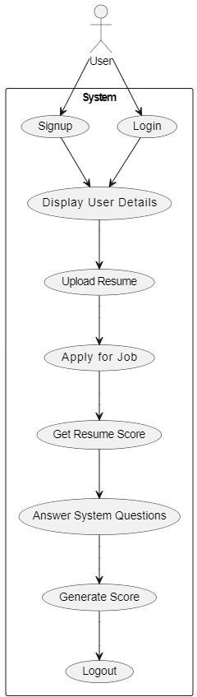

**Fig 1.2:(a) Use Case Diagram**

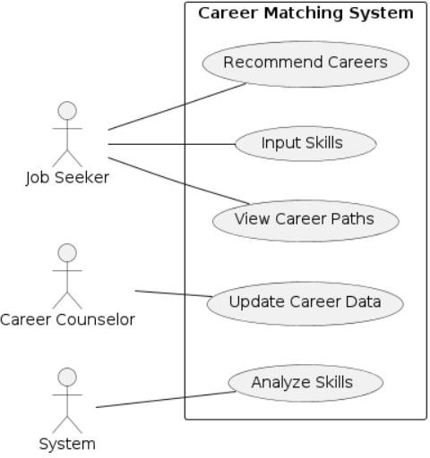

### Activity diagram

An activity diagram is basically a flowchart to represent the flow from one activity to another activity. The activity can be described as an operation of the system. The control flow is drawn from one operation to another. This flow can be sequential, branched, or concurrent. The flow carries from the starting of an activity to end of an activity, it performs different types of operations through the flow that are shown.

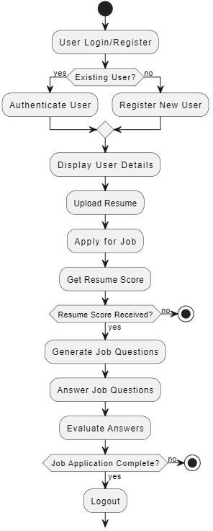

Fig1.3 (a)Activity Diagram

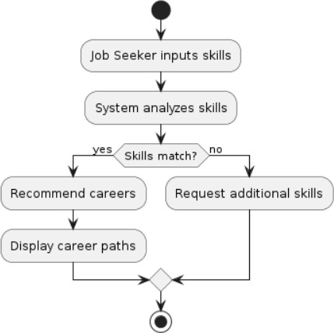

Fig1.3 (b)Activity Diagram

### Sequence Diagram

Sequence diagrams are used to display the interaction between users, screens, objects, and entities within the system. It provides a sequential map of message passing between objects over time.

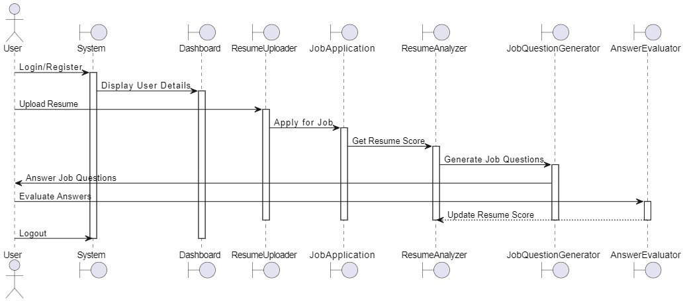

Fig1.4 (a) Sequence Diagram

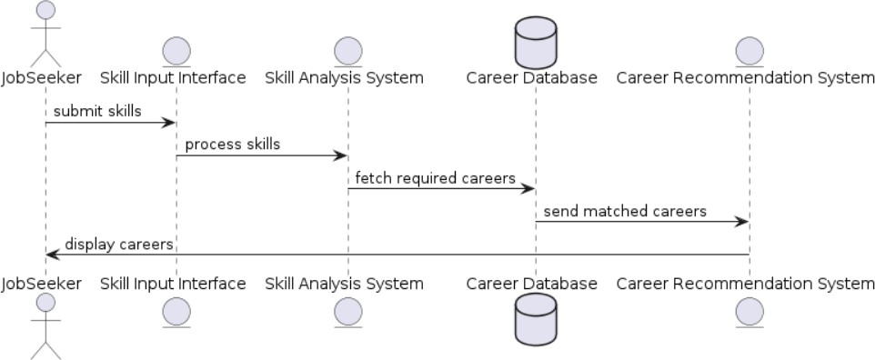

Fig1.4 (b) Sequence Diagram

### State Chart Diagram:

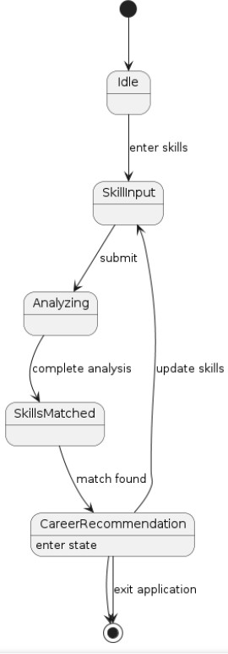

#### Fig5.8: State Chart Diagram

* + 1. **Structure Diagram**

### Class Diagram

Class diagram is a static diagram. It represents the static view of an application. Class diagram is not only used for visualizing, describing, and documenting different aspects of a system but also for constructing executable code of the software application Class diagram describes the attributes and operations of a class and also the constraints imposed on the system. The class diagrams are widely used in the modelling of object-oriented systems because they are the only UML diagrams, which can be mapped directly with object-oriented languages.

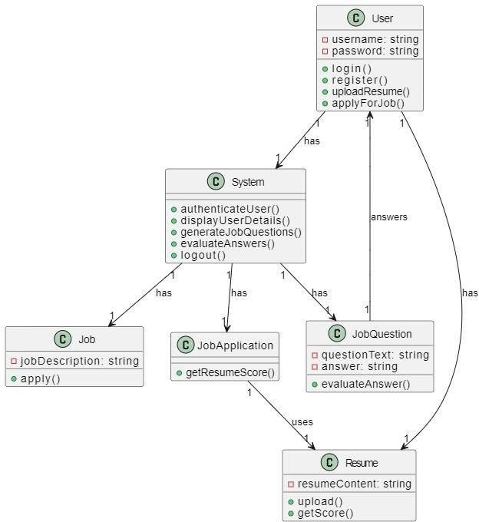

Fig5.9 (a) Class Diagram

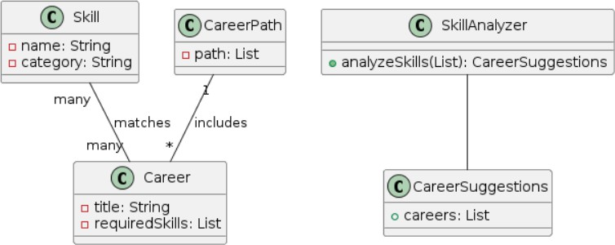

Fig5.10 (b) Class Diagram

#### Component Diagram

The component diagram for active liveness detection system is an illustration of how the system components work together to make the system operate correctly. It shows how the software’s parts are organized and how they depend on each other. This diagram also gives a high level look at the parts of a system

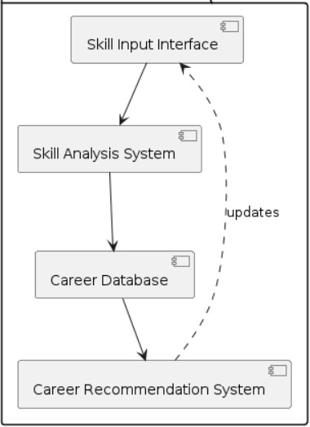

.

Fig5.11:Component Diagram

## ER DIAGRAM

The Job Role Matching and Skill Assessment System for Future-Proofed Careers focuses on the alignment of individual skills with evolving job requirements in order to adapt to changing industry landscapes. The project aims to create a platform that analyzes the skills possessed by professionals and matches them with the in-demand skills needed for future-proofed careers. The ER diagram for this project would showcase entities like skills, job roles, industry trends, individual profiles, and skill assessments. Through cardinality indicators, the relationships between these entities would be illustrated to facilitate effective skill matching and career planning. This ER diagram serves as a road map for enhancing workforce readiness and ensuring relevance in the ever-changing job market.

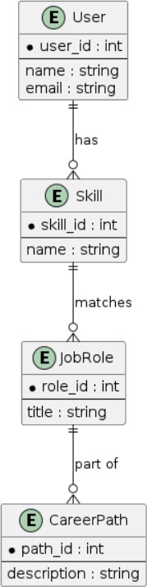

Fig5.12:ER Diagram

## DATA FLOW DIAGRAM

A Data Flow Diagram (DFD) visually depicts how data moves through a system, detailing input, processing, and output stages in a structured manner. Utilizing symbols like circles, rectangles, arrows, and lines, DFDs represent data sources, processes, storage, and destinations. Vital in system analysis and design, DFDs enhance understanding of information flow, pinpoint inefficiencies, and facilitate effective system design. By providing clarity on data movement, identifying bottlenecks, and optimizing processing systems, DFDs play a crucial role in modeling and streamlining data flow within a system, making them a powerful tool for stakeholders in system development.



Fig 5.13 DATA FLOW DIAGRAM Level 1

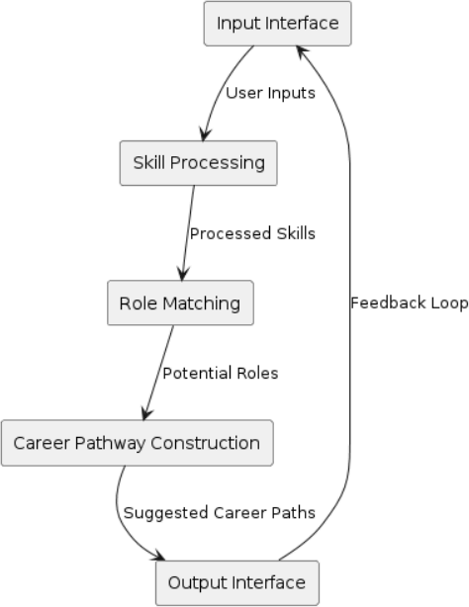

Fig5.14 DATA FLOW DIAGRAM Level 2

# CHAPTER 6 REQUIREMENT ANALYSIS

### Introduction to Requirement Analysis:

In the realm of career planning and skill development, understanding the correlation between skills and future job demands is paramount. Requirement analysis involves identifying the needs and objectives of individuals seeking to future-proof their careers. This entails assessing existing skill sets, career aspirations, and market trends to determine the most relevant skills for long-term success.

### System Requirements

A requirement is a feature that the system must have or a constraint that it must to be accepted by the client. Requirement Engineering aims at defining the wants of the system under construction. Requirement Engineering include two main activities requirement elicitation which results in the specification of the system that the client understands and analysis which in analysis model that the developer can unambiguously interpret. A requirement may be a statement about what the proposed system will do. Requirements can be divide into two major categories:

Functional Requirements

Non-Functional Requirements

### Functional Requirements

* **Skill Data Acquisition:** Retrieve skill-related data from various sources, including job descriptions, resumes, and educational qualifications.
* **Skill Correlation and Analysis:** Apply algorithms to analyze correlations between skills, occupations, and market trends.
* **Career Recommendation:** Develop recommendation systems to match individuals with suitable career paths based on their skill profiles and aspirations.
* **User Interface:** Design intuitive user interfaces for interacting with the system, including skill assessment tools and career planning dashboards

### Non-Functional Requirements

Non-Functional Requirements specifies the standard attribute of a software. They judge the software supported Responsiveness, Usability, Security, Portability, and other non-functional standards that are critical to the success of the software. An example of a nonfunctional

requirement, “how fast does the website load?” Failing to satisfy non-functional requirements may result in systems that fail to satisfy user needs. Non-functional Requirements allow you to impose constraints or restrictions on the planning of the system across the varied agile backlogs.

### User Interface and Human Factors

To insert the data set and to test and train the data we require human factor. Humans are required to give the reviews of our products. This is achieved through a user interface to interact with human factor for taking reviews for training and testing on the data.

### software requirements

**Operating Systems:** Compatible with Windows, macOS, and Linux distributions. **Development Environments:** Integrated Development Environments (IDEs) such as Jupyter Notebooks, or Visual Studio Code.

**Programming Language:** Python for implementing algorithms and building software components.

**Libraries and Frameworks:** Utilization of machine learning libraries (e.g., TensorFlow, PyTorch), data processing frameworks (e.g., Pandas, NumPy), and natural language processing tools (e.g., NLTK, spaCy).

**Collaboration Tools:** Platforms for team collaboration and version control (e.g., GitHub, GitLab).

### Hardware Requirements

* Standard computing hardware (laptops, desktops, servers) with adequate processing power and memory.
* Storage devices for managing large datasets and model parameters.
* Networking infrastructure to facilitate data exchange and communication between system components.

### Usability

The system must be simple to use in terms of user interface and must avoid any complexity. It should be capable of having minimum interaction with the user to avoid much manual work, but at the same time should provide the best results possible. It should not take much time on

processing or should stuck at many moments. In simple terms it should satisfy user needs with simplicity in terms of usability.

### Reliability

The system must be reliable, it should not lead to unnecessary crashes and shouldn’t stuck at most cases of errors when occur, it should have good exception handling mechanisms. The system should perform well in critical situations to provide user most friendly experience in terms of handling the system with little or less failures.

### Performance

The system or software designed should not slow down while performing. The system should be fast enough to produce results. Additionally, it should be able to perform well in case of more workloads. This attribute determines the overall functionality of the system in terms of resource consumption, response time and efficiency.

### Supportability

This type of non-functional is concerned with characteristics such as maintainability, scalability of the solution. This includes considerations for the ability of the solution to be easily modified to accommodate enhancements and repairs.

### Physical Environment

The environment includes external factors that impact how your system performs. For example, light condition, background, etc., may affect the speed or reliability of an application.

### Security Requirements

* + - 1. **Access Requirement**

The system provides token base authentication system with proper user authorization. In this authorization system user must need to provide legal credential. Then our system provides an access token for the user. Without use the token no one can access the selected path. The token provides user details with user privilege logs.

### Integrity Requirements

Our system provides token on demand data delivery process. Every post request must have provided a token for ensuring that each request to a server is accompanied by a signed token. As comfortably as the get, put and delete request carry an authorize token every time. By using this our system easily understand authenticated user are permitted for this data or not.

### Privacy Requirements

Data integrity is the most significant part in the system. Along with that the access token is almost as significant. So, we store token on the data infrastructure. After verifying the request, it removes from the database. A fixed timer also set to validate the token. A refresh token must generate with every authentication. Each token has a limited life line. After breathing out the time the session of authenticated user must be nigh.

### Resource Requirements

Resource Requirements should be defined by the Project manager to establish the resources needed to execute work on the project.

* 1. **Software Used**
     1. **Python**

# CHAPTER 7 IMPLEMENTATION

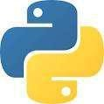

**Fig7.1:Logo**

Python is a high-level, interpreted, interactive and object-oriented scripting language Python is designed to be highly readable. It uses English words frequently whereas other languages use punctuation, and it has fewer syntactic constructions than other languages.

* + - * Python is Interpreted-Python is processed at runtime by the interpreter. You need to compile your program before executing it. This is similar to PERL and PHP.
      * Python is Interactive - You can actually sit at a Python prompt and interact with the interpreter directly to write your programs.
      * Python is Object-Oriented - Python supports Object-Oriented style or technique of programming that encapsulates code within objects.
      * Python is a Beginner's Language - Python is a great language for the beginner level programmers and supports the development of a wide range of applications from simple text processing to WWW browsers to games.

Python language is being used by almost all tech-giant companies like – Google, Amazon, Facebook, Instagram, Dropbox, Uber… etc.

The biggest strength of Python is huge collection of standard libraries which can be used for the following –

* + - * + [Machine Learning](https://www.geeksforgeeks.org/machine-learning/)
        + GUI Applications (like [Kivy](https://www.geeksforgeeks.org/kivy-tutorial/), Tkinter, PyQt etc. )
        + Web frameworks like [Django](https://www.geeksforgeeks.org/django-tutorial/) (used by YouTube, Instagram,Dropbox)
        + Image processing (like [OpenCV](https://www.geeksforgeeks.org/opencv-python-tutorial/), Pillow)
        + Web scraping (like Scrapy, BeautifulSoup, Selenium)
        + Test frameworks
        + Multimedia

### History of Python

Python was developed by Guido van Rossum in the late eighties and early nineties at the National Research Institute for Mathematics and Computer Science in the Netherlands. Python is derived from many other languages, including ABC, Modula-3, C, C++, Algol-68,Small Talk, and Unix shell and other scripting languages. Python is copyrighted. Like Perl, Python source code is now available under the GNU General Public License (GPL) Python is now maintained by a core development team at the institute, although Guido van Rossum still holds a vital role in directing its progress. Python was conceived in the late 1980s by Guido van Rossum at Centrum Wiskunde & Informatica (CWI) in the Netherlands as a successor to ABC programming language, which was inspired by SETL, capable of exception handling and interfacing with the Amoeba operating. system. Its implementation began in December 1989.

### Python Features

#### Python's features include-

* + - * **Easy-to-learn-** Python has few keywords, simple structure, and a clearly defined syntax. This allows the student to pick up the language quickly.
      * **Easy-to-read-** Python code is more clearly defined and visible to the eyes.
      * **Easy-to-maintain-** Python's source code is fairly easy-to-maintain
      * **A broad standard library-** Python's bulk of the library is very portable and cross platform compatible on UNIX, Windows, and Macintosh.
      * **Interactive Mode-** Python has support for an interactive mode which allows interactive testing and debugging of snippets of code.
      * **Portable-** Python can run on a wide variety of hardware platforms and has the same interface on all platforms.
      * **Extendable-** You can add low-level modules to the Python interpreter. These modules enable programmers to add to or customize their tools to be more efficient.
      * **Databases-** Python provides interfaces to all major commercial databases.
      * **GUI Programming-** Python supports GUI applications that can be created and ported to

many system calls, libraries and windows systems, such as Windows MFC, Macintosh, and the X Window system of Unix.

* + - * **Scalable-** Python provides a better structure and support for large programs than shell scripting.
      * Apart from the above-mentioned features, Python has a big list of good features, few are listed below-
      * It supports functional and structured programming methods as well as OOP.
      * It can be used as a scripting language or can be compiled to byte-code for building large applications
      * Python supports Object-Oriented style or technique of programming that encapsulates code within objects.
      * It provides very high-level dynamic data types and supports dynamic type checking. It supports automatic garbage collection.
      * It can be easily integrated with C, C++, COM, ActiveX, CORBA, and Java.

### Advantages of Python:

#### Extensive Libraries

Python downloads with an extensive library and it contain code for various purposes like regular expressions, documentation-generation, unit-testing, web browsers, threading, databases, CGI, email, image manipulation, and more*.* So, we don’t have to write the complete code for that manually.

#### Extensible

As we have seen earlier, Python can be extended to other languages. You can write some of your code in languages like C++ or C. This comes in handy, especially in projects.

#### Embeddable

Complimentary to extensibility, Python is embeddable as well. You can put your Python code in your source code of a different language, like C++. This lets usadd scripting capabilities to our code in the other language.

#### Improved Productivity

The language’s simplicity and extensive libraries render programmers more productive than languages like Java and C++ do. Also, the fact that you need to write less and get more things

done.

#### IOT Opportunities

Since Python forms the basis of new platforms like Raspberry Pi, it finds the futurebright for the Internet of Things. This is a way to connect the language with thereal world.

#### Simple and Easy

When working with Java, you may have to create a class to print **‘**Hello World**’**. But in Python, just a print statement will do. It is also quite easy to learn, understand, and code. This is why when people pick up Python, they have a hard time adjusting to other more verbose languages like Java.

#### Readable

Because it is not such a verbose language, reading Python is much like reading English. This is the reason why it is so easy to learn, understand, and code. It also does not need curly braces to define blocks, and indentation is mandatory. These further aids the readability of the code.

#### Object-Oriented

This language supports both the procedural and object-oriented programming paradigms. While functions help us with code reusability, classes and objects let us model the real world. A class allows the encapsulation of data and functions into one.

#### Free and Open-Source

Like we said earlier, Python is freely available. But not only can you [download](https://data-flair.training/blogs/install-python-windows/) Python for free, but you can also download its source code, make changes to it, andeven distribute it. It downloads with an extensive collection of libraries to help you with your tasks.

#### Portable

When you code your project in a language like C++, you may need to make some changes to it if you want to run it on another platform. But it isn’t the same with Python. Here, you need to code only once, and you can run it anywhere. This is called Write Once Run Anywhere (WORA). However, you need to be careful enough not to include any system-dependent features.

### Advantages of Python over Other Languages

#### Less Coding

Almost all of the tasks done in Python requires less coding when the same task is done in

other languages. Python also has an awesome standard library support, so you don’t have to search for any third-party libraries to get your job done. This is the reason that many people suggest learning Python to beginners.

#### Affordable

Python is free therefore individuals, small companies or big organizations can leverage the free available resources to build applications. Python is popular and widely used so it gives you better community support.

The 2019 GitHub annual survey showed us that Python has overtaken Java in the most popular programming language category.

#### Python is for Everyone

Python code can run on any machine whether it is Linux, Mac or Windows.Programmers need to learn different languages for different jobs but with Python, you can professionally build web apps, perform data analysis and [machine learning](https://data-flair.training/blogs/machine-learning-tutorials-home/),automate things, do web scraping and also build games and powerful visualizations.It is an all-rounder programming language.

#### Disadvantages of Python

Let’s now see the downsides of choosing Python over another language.

#### Speed Limitations

We have seen that Python code is executed line by line. But since [Python](https://www.python.org/) is interpreted, it often results in slow execution. This, however, isn’t a problem unlessspeed is a focal point for the project. In other words, unless high speed is a requirement, the benefits offered by Python are enough to distract us from its speedlimitations.

#### Weak in Mobile Computing and Browsers

While it serves as an excellent server-side language, Python is much rarely seen on the client-side. Besides that, it is rarely ever used to implement smartphone-based applications. One such application is called Carbon Nelle.

The reason it is not so famous despite the existence of Brython is that it isn’t that secure.

#### Design Restrictions

As you know, Python is dynamically-typed. This means that you don’t need to declare the type of variable while writing the code. It uses duck-typing. But wait, what’s that? Well, it just means that if it looks like a duck, it must be a duck. Whilethis is easy on the programmers during coding, it can raise run-time errors.

#### Underdeveloped Database Access Layers

Compared to more widely used technologies like JDBC (Java Database Connectivity) and ODBC (Open Database Connectivity), Python’s database accesslayers are a bit underdeveloped. Consequently, it is less often applied in huge enterprises.

#### Simple

No, we’re not kidding. Python’s simplicity can indeed be a problem. Take my example. I don’t do Java, I’m more of a Python person. To me, its syntax is so simple that the verbosity of Java code seems unnecessary.

### How to Install Python on Windows and Mac:

There have been several updates in the Python version over the years. The question ishow to install Python? It might be confusing for the beginner who is willing to startlearning Python but this tutorial will solve your query. The latest or the newest version of Python is version 3.11.8 or in other words, it is Python 3.

**Note:** The python version 3.11.8 cannot be used on Windows XP or earlier devices.

Before you start with the installation process of Python. First, you need to know aboutyour System Requirements. Based on your system type i.e. operating system and based processor, you must download the python version. My system type isa Windows 64-bit operating system. So the steps below are to install python version3.11.8 on Windows 7 device or to install Python 3. [Download the Python Cheat sheet](https://myelearninghub.com/python-cheat-sheet/) here**.** The steps on how to install Python on Windows 11,10 and 8 are divided into 4 parts to help understand better.

#### Download the Correct version into the system

**Step 1:** Go to the official site to download and install python using Google Chrome orany other web browser. OR Click on the following link: **[https://www.python.org.](https://www.python.org/)**

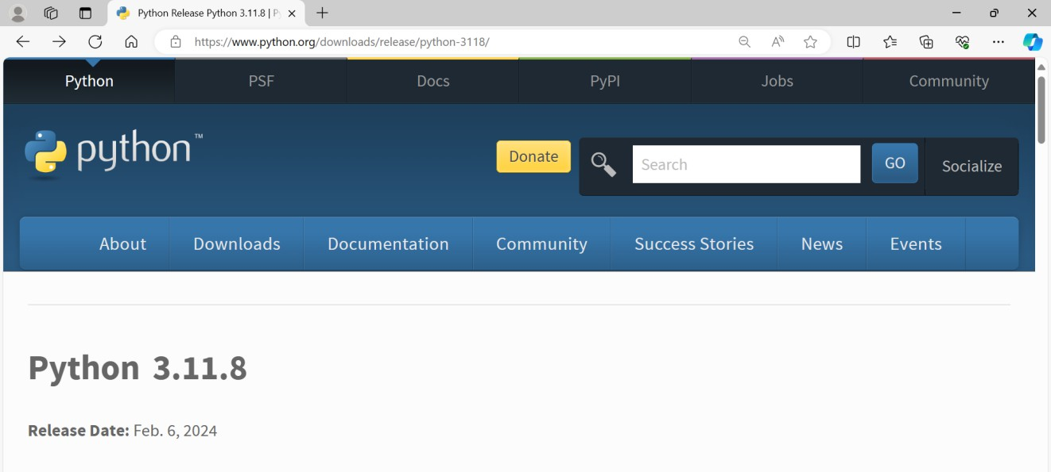

Now, check for the latest and the correct version for your operating system.

**Step 2:** Click on the Download Tab.

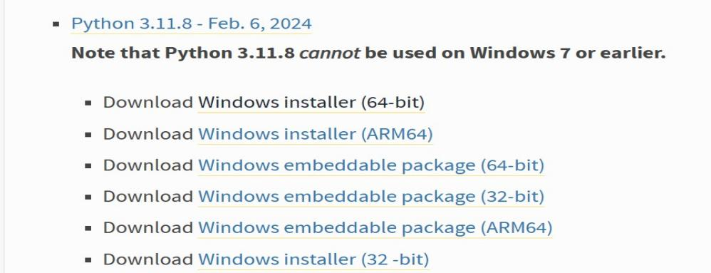

**Step 3:** You can either select the Download Python for windows 3.11.8 link inblue Color or you can scroll further down and click on download with respective to their version. Here, we are downloading the most recent python version for windows 3.11.8.

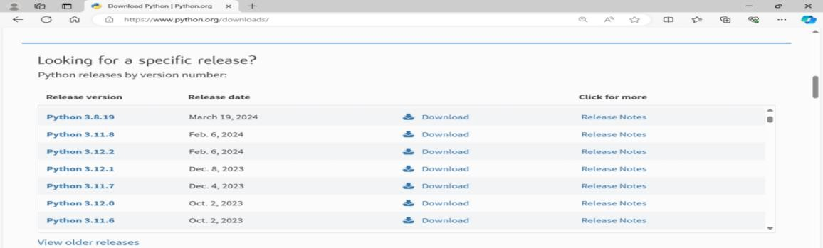

**Step 4:** Scroll down the page until you find the Files option.

**Step 5:** Here you see a different version of python along with the operating system.

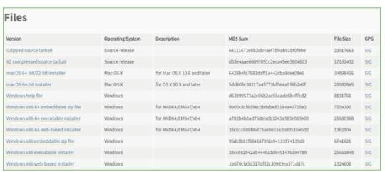

* To download **Windows 64-bit python**, you can select any one from the three options: Windows x86-64 embeddable zip file, Windows x86-64 executable installer or Windows x86-64 web-based installer.

Here we will install Windows x86-64 web-based installer. Here your first part regarding which version of python is to be downloaded is completed. Now we move ahead with the second part in installing python i.e. Installation

**Note:** To know the changes or updates that are made in the version you can click on the Release Note Option.

### Installation of Python

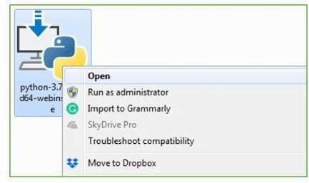**Step 1:** Go to Download and Open the downloaded python version to carry out the installation process.

**Step 2:** Before you click on Install Now, make sure to put a tick on Add Python 3.11.8 to PATH.

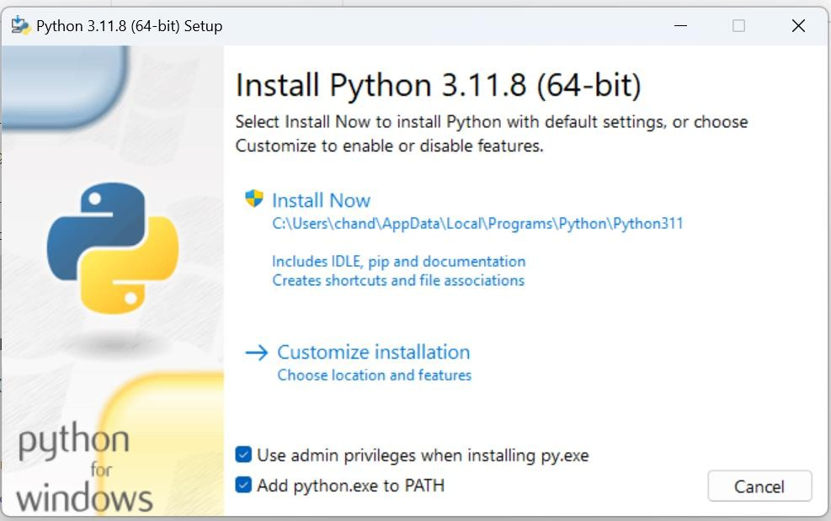

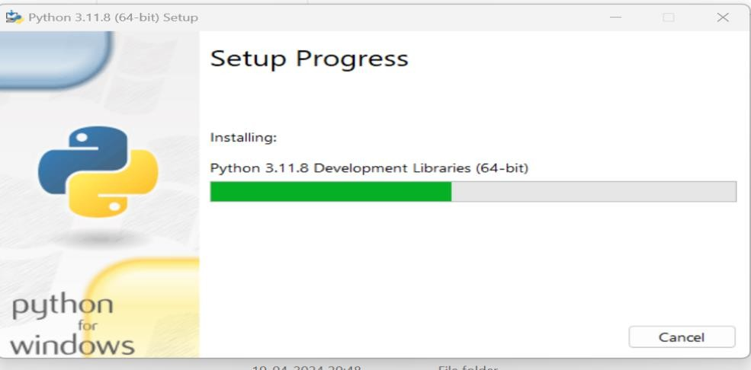

**Step 3:** Click on Install NOW After the installation is successful. Click on Close.

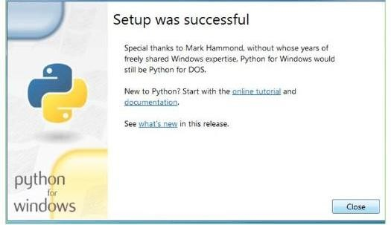

With these above three steps on python installation, you have successfully andcorrectly installed Python. Now is the time to verify the installation.

**Verify the Python Installation Step 1:** Click on Start

**Step 2:** In the Windows Run Command, type “cmd”

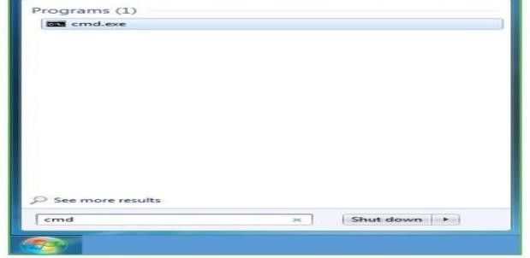

**Step 3:** Open the Command prompt option.

**Step 4:** Let us test whether the python is correctly installed. Type **python –V** andpress Enter.

**Step 5:** You will get the answer as 3.11.8

**Note*:*** If you have any of the earlier versions of Python already installed. You mustfirst uninstall the earlier version and then install the new one

**Check how the Python IDLE works Step 1: Step 1:** Click on Start

**Step 2:** In the Windows Run command, type “python idle”

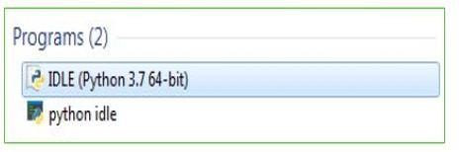

**Step 3:** Click on IDLE (Python 3.7 64-bit) and launch the program

**Step 4:** To go ahead with working in IDLE you must first save the file. **Click onFile**

#### > Click on Save

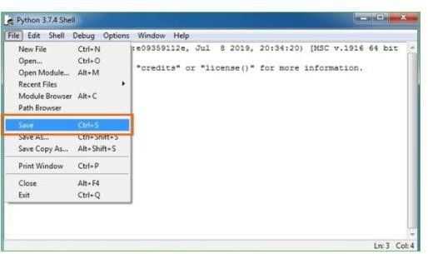

**Step 5:** Name the file and save as type should be Python files. Click on SAVE. Here Ihave named the files as Hey World.

**Step 6:** Now for e.g. **enter print (“Hey World”)** and Press Enter.

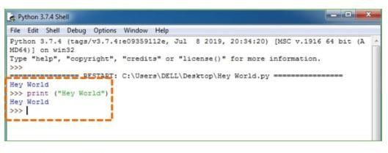

You will see that the command given is launched. With this, we end our tutorial on how to install Python. You have learned how to download python for windows into your respective operating system.

**Note*:*** Unlike Java, Python doesn’t need semicolons at the end of the statements otherwise it won’t work.

### Introduction to Streamlit frame work

Streamlit is a free and open-source framework to rapidly build and share beautiful machine learning and data science web apps. It is a Python-based library specifically designed for machine learning engineers. Data scientists or machine learning engineers are not web developers and they're not interested in spending weeks learning to use these frameworks to build web apps. Instead, they want a tool that is easier to learn and to use, as long as it can display data and collect needed parameters for modeling. Streamlit allows you to create a stunning-looking application with only a few lines of code.

### Python libraries:

#### Numpy

Numpy is a general-purpose array-processing package. It provides a high- performance

* A powerful N-dimensional array object
* Sophisticated (broadcasting) functions
* Tools for integrating C/C++ and Fortran code
* Useful linear algebra, Fourier transform, and random number multidimensional array object, and tools for working with these arrays.

It is the fundamental package for scientific computing with Python. It contains various features including these important ones:

Besides its obvious scientific uses, Numpy can also be used as an efficient multi- dimensional container of generic data. Arbitrary data-types can be defined using Numpy which allows Numpy to seamlessly and speedily integrate with a wide variety of databases.

#### Pandas

Pandas is an open-source Python Library providing high-performance data manipulation and analysis tool using its powerful data structures. Python was majorly used for data mugging and preparation. It had very little contribution Towards data analysis. Pandas solved this problem. Using Pandas, we can accomplish five typical steps in the processing and analysis of data, regardless of the origin of data load, prepare, manipulate, model, and analyze. Python with

Pandas is used in a wide range of fields including academic and commercial domains including fi

#### Matplotlib

Matplotlib is a Python 2D plotting library which produces publication quality figures in a variety of hardcopy formats and interactive environments across platforms. Matplotlib can be used in Python scripts, the Python and [IPython](http://ipython.org/) shells, the [Jupyter](http://jupyter.org/) Notebook, web application servers, and four graphical user interface toolkits. Matplotlib tries to make easy things easy and hard things possible. Youcan generate plots, histograms, power spectra, bar charts, error charts, scatter plots, etc., with just a few lines of code. For examples, see the [sample](https://matplotlib.org/tutorials/introductory/sample_plots.html)plots and [thumbnail gallery.](https://matplotlib.org/gallery/index.html)

For simple plotting the pyplot module provides a MATLAB-like interface, particularly when combined with IPython. For the power user, you have full control of line styles, font properties, axes properties, etc, via an object-oriented interface or via a set of functions familiar to MATLAB users.

#### Streamlit

Streamlit is an open-source Python library used to create web applications for machine learning, data science, and other data-intensive tasks. It simplifies the process of building interactive web apps by allowing developers to create them directly from Python scripts, without needing to write HTML, CSS, or JavaScript code. With Streamlit, you can easily visualize data, build dashboards, and share your projects with others.

#### Json

JSON stands for JavaScript Object Notation. It's a lightweight data interchange format that is easy for humans to read and write and easy for machines to parse and generate. It's commonly used for transmitting data between a server and a web application as an alternative to XML. JSON is built on two structures:

1. A collection of key/value pairs (similar to a dictionary in Python).
2. An ordered list of values (similar to an array in Python).

It's widely used in web development for sending data between a client and a server and is supported by most programming languages.

#### Os

The os module provides a way of using operating system-dependent functionality. It allows you to interact with the operating system in a platform-independent manner, such as accessing the file system, working with environment variables, and executing system commands.

Some common tasks you can accomplish using the os module include:

#### Docx

1. File and directory operations: Creating, deleting, renaming files or directories, checking file existence, etc.
2. Environment variables: Accessing and modifying environment variables.
3. Process management: Interacting with processes, executing system commands, etc.
4. Miscellaneous operating system-related functions.

The "docx" module is a third-party library used for creating, reading, and manipulating

Microsoft Word .docx files. This module allows you to programmatically work with Word documents, including tasks such as extracting text, formatting, adding tables, images, and more. It's a useful tool for automating tasks involving Word documents, such as generating reports, updating templates, or extracting data from documents.

#### Pdfplumber

Pdfplumber is a Python library used for extracting text and metadata from PDF documents. It provides functionality to parse PDF files, extract text, and perform other operations such as extracting tables and images from PDFs.

It's often used in data extraction tasks where the input data is stored in PDF format, such as in document processing, data mining, or data analysis projects. With pdfplumber, you can programmatically access and manipulate the content of PDF files using Python code. **matplotlib.colors**

colors. A module for converting numbers or color arguments to RGB or RGBA. RGB and RGBA are sequences of, respectively, 3 or 4 floats in the range 0-1. This module includes functions and classes for color specification conversions, and for mapping numbers to colors in a 1-D array of colors called a colormap.

#### Operator

The operator module in Python provides functions that correspond to built-in operations, such as arithmetic or comparison. You can use it to write more concise and readable code, especially with functions like item getter and attrgetter for sorting or retrieving specific elements from data structures.

#### Nltk

NLTK stands for Natural Language Toolkit. It's a popular Python library for working with human language data, providing easy-to-use interfaces to over 50 corpora and lexical resources such as WordNet, along with a suite of text processing libraries for classification, tokenization, stemming, tagging, parsing, and more.

#### String

The string module in Python provides a collection of constants representing ASCII

characters and common string operations. It includes constants like ascii_letters, digits, punctuation, and functions like capwords() for capitalizing words in a string, and Template for string templates.

#### Openai

OpenAI doesn't have an official Python module, but it provides APIs for accessing its various models and services. You can interact with OpenAI's APIs using libraries like OpenAI's Python library, which provides a convenient interface for accessing GPT models and other tools. You can install it via pip: pip install openai.

### Technology/Algorithm Used:

#### Machine Learning (ML) and Natural Language Processing (NLP)

Analyze skill-related data

Extract meaningful information from text

**Data Mining and Data Analytics** Discover patterns and correlations Derive actionable insights

#### Graph Theory and Network Analysis

Model relationships between skills, occupations, and industries Identify skill clusters and pathways

#### Recommendation Systems

Match individuals with suitable career paths

Hybrid approaches for personalized recommendations

### Visual Studio

#### Introduction

**Vscode** is short for **Visual Studio Code**. It is a strong **code editor** that is **open- source** developed via **Microsoft. Visual Studio Code** contains **built-in support** for debugging, snippets, code refactoring, integrated terminal, code completion, syntax highlighting, and

embedded Git control. **Vscode** is **cross-platform** and available on **macOS, Linux**, and **Windows**.

We can install **vscode** as the **deb package** using **Microsoft repositories** or **snap package** using the **Snapcraft store**. Also, we can select the method of installation that is most convenient for our environment.

The recommended and easiest way for installing vscode On Ubuntu systems is to set up the repository of vscode and install the package of vscode using the command-line or terminal.

Visual Studio Code incorporates the power and simplicity of a classic code editor that supports a debugging experience and integrated navigation lacking the requirements of a fully featured Integrated Development Environment (or IDE) like the famous Visual Studio IDE. Vscode is established on the architecture that offers excellent code analysis support of our C# code.

The vision of Microsoft with vscode is to give a cross-platform, fast, and simple code editor for creating cloud and web applications. Vscode has every standard feature we would want a contemporary code editor (refactoring, code navigation, code assistance, etc.) to have with the best support for TypeScript, Node.js, and ASP.Net.

### Source code:

* + 1. **Python Code:**

import streamlit as st import json

import os

import numpy as np

from docx import Document import pdfplumber

import matplotlib.colors as mcolors from operator import index

import pandas as pd import plotly.express as px

import plotly.graph_objects as go import nltk

from nltk.tokenize import word_tokenize from nltk.corpus import stopwords

from nltk.probability import FreqDist import string

from dotenv import load_dotenv import docx

from PIL import Image from openai import OpenAI import os

import nltk load_dotenv()

@st.cache_resource

def download_resource(): nltk.download("punkt") nltk.download("stopwords")

session_state = st.session_state

if "user_index" not in st.session_state: st.session_state["user_index"] = 0

download_resource()

def signup(json_file_path="data.json"): st.title("Signup Page")

with st.form("signup_form"):

st.write("Fill in the details below to create an account:") name = st.text_input("Name:")

username = st.text_input("username:")

age = st.number_input("Age:", min_value=0, max_value=120) sex = st.radio("Sex:", ("Male", "Female", "Other"))

password = st.text_input("Password:", type="password") confirm_password = st.text_input("Confirm Password:", type="password")

if st.form_submit_button("Signup"): if password == confirm_password:

user = create_account(

name, username, age, sex, password, json_file_path

)

session_state["logged_in"] = True session_state["user_info"] = user

else:

st.error("Passwords do not match. Please try again.")

def check_login(username, password, json_file_path="data.json"): try:

with open(json_file_path, "r") as json_file: data = json.load(json_file)

for user in data["users"]:

if user["username"] == username and user["password"] == password: session_state["logged_in"] = True

session_state["user_info"] = user st.success("Login successful!") return user

st.error("Invalid credentials. Please try again.") return None

except Exception as e:

st.error(f"Error checking login: {e}") return None

def initialize_database(json_file_path="data.json"): try:

# Check if JSON file exists

if not os.path.exists(json_file_path): # Create an empty JSON structure data = {"users": []}

with open(json_file_path, "w") as json_file: json.dump(data, json_file)

except Exception as e:

print(f"Error initializing database: {e}")

def create_account(name, username, age, sex, password, json_file_path="data.json"): try:

# Check if the JSON file exists or is empty

if not os.path.exists(json_file_path) or os.stat(json_file_path).st_size == 0: data = {"users": []}

else:

with open(json_file_path, "r") as json_file: data = json.load(json_file)

username = username.lower()

# Append new user data to the JSON structure user_info = {

"name": name, "username": username, "age": age,

"sex": sex, "password": password, "resume": None,

"job_description": None, "job_applied": None, "score": "0", "questions": None,

}

data["users"].append(user_info)

# Save the updated data to JSON

with open(json_file_path, "w") as json_file: json.dump(data, json_file, indent=4)

st.success("Account created successfully! You can now login.")

return user_info

except json.JSONDecodeError as e: st.error(f"Error decoding JSON: {e}") return None

except Exception as e:

st.error(f"Error creating account: {e}") return None

def login(json_file_path="data.json"): st.title("Login Page")

username = st.text_input("Username:")

password = st.text_input("Password:", type="password") login_button = st.button("Login")

if login_button:

username = username.lower()

user = check_login(username, password, json_file_path) if user is not None:

session_state["logged_in"] = True session_state["user_info"] = user

else:

st.error("Invalid credentials. Please try again.")

def get_user_info(username, json_file_path="data.json"): try:

with open(json_file_path, "r") as json_file: data = json.load(json_file)

for user in data["users"]:

if user["username"] == username: return user

return None

except Exception as e:

st.error(f"Error getting user information: {e}") return None

def render_dashboard(user_info, json_file_path="data.json"): try:

st.title(f"Welcome to the Dashboard, {user_info['name']}!") st.subheader("User Information:")

st.write(f"Name: {user_info['name']}")

st.write(f"Sex: {user_info['sex']}")

st.write(f"Age: {user_info['age']}")

if user_info["resume"] is not None: st.subheader("Resume:") st.write(user_info["resume"])

if user_info["job_description"] is not None: st.subheader("Job Applied:") st.write(user_info["job_description"])

except Exception as e:

st.error(f"Error rendering dashboard: {e}")

def extract_text(file) -> str: if isinstance(file, str):

file_extension = os.path.splitext(file)[1].lower() else:

file_extension = os.path.splitext(file.name)[1].lower()

if file_extension == ".pdf": if isinstance(file, str):

with pdfplumber.open(file) as pdf: text = "\n".join(

page.extract_text() for page in pdf.pages if page.extract_text()

)

else:

with pdfplumber.open(file) as pdf: text = "\n".join(

page.extract_text() for page in pdf.pages if page.extract_text()

)

elif file_extension == ".docx": if isinstance(file, str):

doc = docx.Document(file) else:

doc = docx.Document(file)

text = "\n".join([para.text for para in doc.paragraphs]) else:

if isinstance(file, str):

with open(file, "r", encoding="utf-8", errors="ignore") as f: text = f.read()

else:

with file as f: text = f.read()

return text

def process_text(text):

tokens = word_tokenize(text)

tokens = [word.lower() for word in tokens if word.isalpha()] stop_words = set(stopwords.words("english"))

tokens = [word for word in tokens if word not in stop_words] return tokens

def calculate_score(job_description_tokens, resume_tokens): job_description_freq = FreqDist(job_description_tokens) total_tokens_in_job_description = len(job_description_tokens) resume_tokens = list(set(resume_tokens))

score = sum(job_description_freq[token] for token in resume_tokens) score_percentage = (score / total_tokens_in_job_description) * 100 return score_percentage

def extract_keywords_from_resume(resume_text): resume_text = resume_text.lower() resume_tokens = word_tokenize(resume_text) resume_tokens = [

token for token in resume_tokens if token not in string.punctuation

]

stop_words = set(stopwords.words("english"))

resume_tokens = [token for token in resume_tokens if token not in stop_words] processed_resume_text = " ".join(resume_tokens)

client = OpenAI( api_key=os.environ.get("OPENAI_API_KEY"),

)

prompt = f"Extract top most important skill keywords from the given resume text. Separate the skills with comma.\n{processed_resume_text}\nKeywords:"

messages = [{"role": "system", "content": prompt}] response = client.chat.completions.create(

messages=messages, model="gpt-3.5-turbo",

)

return response.choices[0].message.content.split(",")

def suggested_skills(resume_text): client = OpenAI(

api_key=os.environ.get("OPENAI_API_KEY"),

)

prompt = f"""Extract top skills that are not mentioned in the resume but are relevant to tech jobs.

\n{resume_text}\nMissing Keywords:"""

messages = [{"role": "system", "content": prompt}] response = client.chat.completions.create(

messages=messages, model="gpt-3.5-turbo",

)

return response.choices[0].message.content.split(",")

def resume_score(resume_text):

client = OpenAI(api_key=os.environ.get("OPENAI_API_KEY"))

prompt = f"""Analyze the provided resume text to generate a score reflecting the candidate's skills and experience, rated out of 100. Only return the score as an integer. Do not include any other information in the response. Only return the score as an integer.

Resume Text:

\n{resume_text}"""

messages = [{"role": "system", "content": prompt}] response = client.chat.completions.create(

messages=messages, model="gpt-3.5-turbo",

)

return int(response.choices[0].message.content)

def suggestions(resume_text):

client = OpenAI(api_key=os.environ.get("OPENAI_API_KEY"))

prompt = f"""Analyze the provided resume text. Highlight the candidate's skills and experience, and suggest improvements to make the resume more appealing to potential employers.

Task:

1. Analyze the resume text to identify the candidate's skills and experience and provide a brief summary.
2. Suggest improvements to make the resume more appealing to potential employers.

For each skill or experience mentioned in the resume, provide a brief explanation or example to demonstrate the candidate's proficiency or relevance to the job.

Resume Text:

\n{resume_text}"""

messages = [{"role": "system", "content": prompt}] response = client.chat.completions.create(

messages=messages, model="gpt-3.5-turbo",

)

return response.choices[0].message.content

def evaluate_interview(resume_text, job_description_text, candidate_name, questions, responses):

client = OpenAI(api_key=os.environ.get("OPENAI_API_KEY")) question_responses = "\n".join(

f"Q: {question}\nA: {response}\n" for question, response in zip(questions, responses)

)

prompt = f"""Evaluate the candidate's responses to the interview questions based on the provided resume and job description. Rate the candidate's performance on a scale of 0 to 100, with 0 being the lowest and 100 being the highest. Provide feedback on the candidate's strengths and areas for improvement.

Format: Score: Score \n Feedback: Feedback (Detailed feedback on the candidate's performance and areas for improvement)

Resume: {resume_text}

Job Description: {job_description_text} Candidate Name: {candidate_name} Interview Questions:

{question_responses}

"""

messages = [{"role": "system", "content": prompt}] response = client.chat.completions.create(

messages=messages, model="gpt-3.5-turbo",

)

result = response.choices[0].message.content

score = result.split("Score: ")[1].split("Feedback:")[0].strip() feedback = result.split("Feedback: ")[1].strip()

return int(score), feedback

def generate_question( resume_text, job_description_text, candidate_name, previous_response=None, previous_question=None,

):

prompt = f"Resume Text: {resume_text}\nJob Description: {job_description_text}\nCandidate

Name: {candidate_name}\n"

if previous_response and previous_question:

prompt += f"Previous Response: {previous_response}\nPrevious Question:

{previous_question}\n" client = OpenAI(

api_key=os.environ.get("OPENAI_API_KEY"),

)

messages = [

{"role": "system", "content": "You are the interviewer."},

{

"role": "system",

"content": "You are interviewing a candidate. Ask a question based on the resume and job description. If the candidate has already answered a question, you can ask a follow-up question based on their response.",

},

{"role": "user", "content": prompt},

]

response = client.chat.completions.create( messages=messages,

model="gpt-3.5-turbo",

)

return response.choices[0].message.content

def main(json_file_path="data.json"): st.sidebar.title("Resume Screening system") page = st.sidebar.selectbox(

"Go to", (

"Signup/Login", "Dashboard", "Resume Analysis", "Apply for a job", "Generate Questions",

"Candidate Evaluation", "Logout",

),

key="GET YOUR RESUME ANALYZED AND COMPARED",

)

if page == "Signup/Login": st.title("Signup/Login Page") login_or_signup = st.radio(

"Select an option", ("Login", "Signup"), key="login_signup"

)

if login_or_signup == "Login": login(json_file_path)

else:

signup(json_file_path)

elif page == "Dashboard":

if session_state.get("logged_in"): user_info = session_state["user_info"]

render_dashboard(user_info, json_file_path) else:

st.warning("Please login/signup to view the dashboard.")

elif page == "Resume Analysis":

if session_state.get("logged_in"): st.title("Upload resume for analysis")

uploaded_file = st.file_uploader("Choose a file", type=None) if uploaded_file is not None:

resume_text = extract_text(uploaded_file) st.write("File name: ", uploaded_file.name) st.success("File uploaded successfully!")

# st.image(Image.open("Images/logo.png"), use_column_width=True) with open(json_file_path, "r+") as json_file:

data = json.load(json_file) user_index = next(

(

i

for i, user in enumerate(data["users"]) if user["username"]

== session_state["user_info"]["username"]

),

None,

)

if user_index is not None:

user_info = data["users"][user_index] user_info["resume"] = resume_text session_state["user_info"] = user_info json_file.seek(0)

json.dump(data, json_file, indent=4) json_file.truncate()

else:

st.error("User not found.")

resume_keywords = extract_keywords_from_resume(resume_text) st.subheader("Skills of the candidate:")

# use st.multiselect to display the keywords

skills = st.multiselect("Candidate Skills", resume_keywords, resume_keywords) score = resume_score(resume_text)

suggestions_improvements = suggestions(resume_text) st.subheader("Resume Score")

if score >= 60: st.success(

f"Congratulations! Your resume score is {score}. Your resume is well-matched for technical roles"

)

elif score >= 20: st.warning(

f"Your resume score is {score}. Your resume is not well-matched for technical roles. Consider improvements."

)

else:

st.error(

f"Your resume score is {score}. Your resume is not well-matched for technical roles. Consider significant improvements."

)

percentage_score = score / 100 percentage_remainder = 1 - percentage_score

# Create a Plotly figure for the pie chart fig = go.Figure(

data=[

go.Pie(

labels=["Matched", "Unmatched"], values=[percentage_score, percentage_remainder], hole=0.3,

marker_colors=["rgba(0, 128, 0, 0.7)", "rgba(255, 0, 0, 0.7)"],

)

]

)

fig.update_layout(title_text="Resume Score")

# Display the chart st.plotly_chart(fig)

st.subheader("Skills and Experience:") st.write(suggestions_improvements) skills_not_mentioned = suggested_skills(resume_text) st.subheader("Top recommended skills:")

skills = st.multiselect("Recommended Skills", skills_not_mentioned, skills_not_mentioned)

st.subheader("How does your resume compare with other candidates?") scores = [

int(user["score"])

for user in data["users"]

]

# Plot an interactive graph fig = go.Figure() fig.add_trace(

go.Histogram( x=scores, histnorm="percent",

marker_color="rgba(0, 0, 255, 0.7)", opacity=0.75,

)

)

fig.update_layout( title_text=f"Distribution of Scores", xaxis_title="Resume Score", yaxis_title="Percentage of Candidates", bargap=0.05,

)

st.plotly_chart(fig)

else:

st.warning("Please login/signup to view the dashboard.")

elif page == "Apply for a job":

if session_state.get("logged_in"): st.title("Apply for a job")

st.subheader("Select a role to you want to apply for:")

BASE_DIR = "Data\\JobDesc\\" job_description = st.selectbox(

"Select a role", [

"-Select-",

"Backend Developer",

"Billing cum Logistics Manager", "Data Scientist",

"Director of Engineering",

"Global Industry Content Manager", "HTML Developer",

"IT Project Manager",

"Lead Technical Program Manager", "Primary English Teacher", "Revenue Reporting Data Analyst", "Senior Product Manager",

"Senior Software Developer", "Web Developer", "Web_dev_job",

],

key="job_description",

)

if job_description and job_description != "-Select-":

file_path = os.path.join(BASE_DIR, f"{job_description}.docx") job_description_text = extract_text(file_path)

st.subheader("Job Description:") st.write(job_description_text)

if st.button("Apply"):

with open(json_file_path, "r+") as json_file: data = json.load(json_file)

user_index = next((i for i, user in enumerate(data["users"]) if user["username"]

== session_state["user_info"]["username"]), None) if user_index is not None:

user_info = data["users"][user_index] user_info["job_description"] = job_description_text user_info["job_applied"] = job_description session_state["user_info"] = user_info json_file.seek(0)

json.dump(data, json_file, indent=4) json_file.truncate()

else:

st.error("User not found.")

st.success("Job application submitted successfully!")

else:

st.warning("Please login/signup to view the dashboard.") elif page == "Generate Questions":

if session_state.get("logged_in"): user_info = session_state["user_info"] st.title("Give your interview")

st.write("Answer the questions below to complete the interview.") with open(json_file_path, "r") as json_file:

data = json.load(json_file) user_index = next(

(

i

for i, user in enumerate(data["users"])

if user["username"] == session_state["user_info"]["username"]

),

None,

)

if (

session_state["user_info"]["resume"] is None

or session_state["user_info"]["job_description"] is None

):

st.warning(

"Please upload your resume and apply for a job to generate interview questions."

)

return

st.markdown("### Interview Questions")

if "messages" not in st.session_state: st.session_state.messages = []

if user_info["questions"] is None: previous_response = None previous_question = None

else:

previous_response = user_info["questions"][-1]["response"] previous_question = user_info["questions"][-1]["question"]

if user_info["questions"] is not None and len(user_info["questions"]) > 0: for questions in user_info["questions"]:

st.chat_message("Interviewer", avatar="🤖").write(questions["question"]) st.chat_message("Applicant", avatar="👩‍🎨").write(questions["response"])

question = generate_question( session_state["user_info"]["resume"], session_state["user_info"]["job_description"], session_state["user_info"]["name"], previous_response,

previous_question,

)

with st.chat_message("Interviewer", avatar="🤖"): st.markdown(question)

if prompt := st.chat_input("Enter your response here", key="response"): with st.chat_message("Applicant", avatar="👩‍🎨"):

st.markdown(prompt)

with open(json_file_path, "r+") as json_file: data = json.load(json_file)

user_index = next( (

i

for i, user in enumerate(data["users"])

if user["username"] == session_state["user_info"]["username"]

),

None,

)

if user_index is not None:

user_info = data["users"][user_index] if user_info["questions"] is None:

user_info["questions"] = [] user_info["questions"].append(

{"question": question, "response": prompt}

)

session_state["user_info"] = user_info json_file.seek(0)

json.dump(data, json_file, indent=4) json_file.truncate()

else:

st.error("User not found.") st.rerun()

if st.button("Finish Interview"):

with open(json_file_path, "r+") as json_file: data = json.load(json_file)

user_index = next( (

i

for i, user in enumerate(data["users"]) if user["username"]

== session_state["user_info"]["username"]

),

None,

)

if user_index is not None:

user_info = data["users"][user_index] session_state["user_info"] = user_info json_file.seek(0)

json.dump(data, json_file, indent=4) json_file.truncate()

else:

st.error("User not found.")

st.success("Interview questions completed successfully!") return

else:

st.warning("Please login/signup to give your interview.")

elif page == "Candidate Evaluation": if session_state.get("logged_in"):

user_info = session_state["user_info"]

st.title("Candidate Evaluation based on Resume and Interview")

st.write("Evaluate the candidate's responses to the interview questions.") questions = [user_info["questions"][i]["question"] for i in

range(len(user_info["questions"]))]

responses = [user_info["questions"][i]["response"] for i in range(len(user_info["questions"]))]

score, feedback = evaluate_interview( user_info["resume"], user_info["job_description"], user_info["name"],

questions, responses,

)

st.write(f"Score: {score}") percentage_score = score / 100

percentage_remainder = 1 - percentage_score

# Create a Plotly figure for the pie chart fig = go.Figure(

data=[

go.Pie(

labels=["Matched", "Unmatched"], values=[percentage_score, percentage_remainder], hole=0.3,

marker_colors=["rgba(0, 128, 0, 0.7)", "rgba(255, 0, 0, 0.7)"],

)

]

)

fig.update_layout(title_text="Resume Score")

# Display the chart st.plotly_chart(fig)

for (question, response) in zip(questions, responses): st.markdown(f"##### Question:") st.write(question)

st.markdown(f"##### Response:") st.write(response)

st.subheader("Feedback:") st.markdown(f"{feedback}")

elif page == "Logout": st.title("Logout")

if st.button("Logout"): session_state["logged_in"] = False session_state["user_info"] = None

st.success("You have been logged out successfully.") st.image("Images\logo.png", use_column_width=True)

if name == " main ": initialize_database() main()

#### data.json:

{

"users": [

{

"name": "Vangapandu Chandrika", "username": "chandrika",

"age": 12,

"sex": "Female",

"password": "12345",

"resume": "Aditya Singh ThakurFeatured Resume \n \nHR Manager seeking roles in HR Operations,Recruitment ,employee engagement,HR Policies,payroll management,employees attendance ,Relationship Management,Employee Grievances,Service Delivery, HR Coordination,Service Quality\n\n \n \nCurrent Designation: HR Manager\nCurrent Company: Bhavithasri Group Of Companies\nCurrent Location: Warangal\nPref. Location: Hyderabad,Secunderabad,Warangal\nFunctional Area: HR / Administration / IR\nRole: HR Manager\nIndustry: IT-Software/Software Services\nMarital Status: Single/unmarried\nTotal Experience: 6 Year(s) 0 Month(s)\nNotice Period: 1 Month\nHighest Degree: MBA/PGDM [HR/Industrial Relations]\n \nKey Skills: HR Manager, HR Operations,Recruitment ,employee engagement,HR Policies,payroll management,employees attendance ,Relationship Management,Employee Grievances,Service Delivery, HR Coordination,Service Quality\n

\nVerified : Phone Number | Email - id\n \nID: 615e9a9c65bc8d8767Last Active: 17-Sep- 20Last Modified: 17-Sep-20\n \nJump to SectionWork Experience | Education | IT Skills |\n \n

\nSummary\nResult oriented professional with 6 years of experience in Human Resource Management primarily Recruitment including Performance Management administration.\n\nHands on in handling the recruitment process of the candidates in various modes through consultancy, college campuses, and walk-in interviews. Proficiency in planning and implementing abilities with demonstrated success in handling HR issues.\n\nSkilled in handling employees, maintaining peaceful & amicable work environment in the organization and initiating measures for the mutual benefit of the management & staff. Key skills include HR Operations,Recruitment ,employee engagement,HR Policies,payroll management,employees attendance ,Relationship Management,Employee Grievances,Service Delivery, HR Coordination,Service Quality \n\n \nWork Experience\n Bhavithasri Group Of Companies as HR Manager\nJun 2018 to Till Date\nRecruitment & Completion of all formalities such as Obtaining of Indemnity Bonds and\nrelated documents. Maintenance of all Records of the Employees, such as Employment\nApplication Forms, Indemnity Bonds etc.\nBio-Metric Attendance Verification of all Branches, including the Central Office.\nIssuing of ID Cards and Visiting Cards to all eligible Employees.\nVerification / Checking of Monthly Salaries of all Employees of the Organization.\nDealing with the matters relating to Promotions, Demotions, Transfer Orders and Annual\nIncrements of all Employees.\nIssuing and Maintenance of Company SIM Cards, Mobile Phones, & Lap Tops.\nVerification / Checking of all Branches F.Cs Meetings organized and follow up with\nBranch Managers & Zone Incharges to complete F.Cs meeting by 10th of every month.\nChits related stationary maintenance and supply to branches as per their requirements.\nGeneral stationary maintenance and supply to Central office & Warangal Zonal Office as\nper their requirements.\nScheduling Meetings of Board Meetings, Branch Managers, Accounts Officers, Internal\nAuditors, Tele-Callers, C.O.T, E.D.P, Electricians, E.S.I & P.F &

H.R based up on M.D\nand C.E.O availibility and instructions.\n \n Vivo Camera & Music as HR Manager\nAug 2015 to Jun 2018\nRoles and Responsibilities:-\nHandling Recruitment and Selection.\nSourcing desirable profile's from the job portal as per the company requirements.\nCollecting and maintaining new joinees documents for company references.\nEnrolling and creating employee ID's to the new joinees in the company

portal\nDelivering company orientation training to the new joinees.\nExecutive and gather all the employees attendance and leaves by coordinating with all the\ndepartments manager and leaders.\nPreparing & Updating company policies and notice as per the company requirements by\nbalancing benefits to the employer and employees.\nCoordinating with the admin for accomplishing employee motivation & employee\nengagement tasks.\nPreparing statutory payroll sheet for the employee salaries & incentive payouts.\nActively enrollment and completely PF and ESI generating challan payment of all the\nemployees and submitting to finance departments for final payment.\n \n Butler Technical Services as Process Associate\nFeb 2014 to Aug 2015\nRole & Responsibilities:\n\n Collection & updating all the necessary documents information in I-Search ERP (PeopleSoft) of the colleagues & associates.\n(Time cards, benefits, garnishments withholdings, W4 withheld, Social security number ID proof etc.)\n Issuing the W2's tax forms to the employees.\n Audit & validating the time sheets and time cards of the employees with effective observation & calculating the regular, overtime and double overtime work hours with appropriate instructions by the supervisors.\n \n^ Back to Top\n \nEducation\nUG: B.A (Economics) from Kakatiya University in 2010\nPG:

MBA/PGDM (HR/Industrial Relations) from Kakatiya University in 2013\n \n \n^ Back to Top\n

\nIT Skills\nSkill Name\tVersion\tLast Used\tExperience\nM.S OFFICE",

"job_description": "Data Scientist/ ML Engineer\nGame Change Solutions\n-\nGurgaon, Haryana\nTemporarily remote\n\u20b920,00,000 - \u20b925,00,000 a year\nWe are looking for a data scientist that will help us discover the information hidden in vast amounts of data and help us make smarter decisions to deliver even better products. Your primary focus will be in applying data mining techniques, doing statistical analysis, and building high quality prediction systems integrated with our products. Data Scientist at GameChange must be an energetic self- starter who can quickly grasp the company\u2019s vision, develop specific tactical plans, and begin implementation upon appropriate approvals. The candidate must be resourceful and able to deliver on a plan defined.\nResponsibilities \u2013\nData Crunching and data massaging on structured and unstructured data including Numerical, Text,\nAudio and Video data\nImplementation/fine-tuning of machine learning algorithms\nConducting Data science/machine learning experiments and presenting insights\nBuilding innovative data products using cutting edge tools and technologies\nConduct data analysis independently or with limited supervision to generate business insights\nConduct diagnostic on the data to identify the improvement opportunities, design data-backed\nperformance improvement strategy, liaise with internal teams\nRecord keeping and data warehousing to enable Advanced Analytics operations for generating\nmeaningful business insights\nDevelop high quality client deliverables such as R models, Python scripts etc.\nSkills required -\nExcellent understanding of machine learning techniques and algorithms, such as k-NN, Naive Bayes,\nSVM, Decision Forests, CNN, RNN, LSTM etc.\nExperience with common data science toolkits, such as R, Weka, NumPy, OpenCV, MatLab, etc.\nGreat communication skills\nExperience with data visualisation tools, such as D3.js, GGplot, etc.\nProficiency in using query languages such as SQL, Hive, Pig\nExperience with NoSQL databases, such as MongoDB, Cassandra, HBase\nGood applied statistics skills, such as distributions, statistical testing, regression, etc.\nGood scripting and programming skills\nJob Type: Full-time\nSalary: \u20b92,000,000.00 - \u20b92,500,000.00 per year\nExperience:\nData Science: 2 years (Preferred)\nwork: 1 year (Preferred)\nEducation:\nBachelor's (Preferred)\n",

"job_applied": "Data Scientist", "score": "0",

"questions": [

{

"question": "Can you walk me through a specific example of how you handled employee grievances in your role as an HR Manager at Bhavithasri Group Of Companies?",

"response": "Situation: An employee in a large corporation feels they have been passed over for promotion unfairly. They believe the decision was influenced by favoritism rather than merit."

},

{

"question": "Can you provide an example of a time when you successfully handled a challenging recruitment situation at Vivo Camera & Music as an HR Manager?",

"response": "Understand Organizational Goals: Begin by having a clear understanding of the company\u2019s strategic goals and objectives. This involves regular communication with senior management and other department heads.\nEmployee Involvement: Involve employees in the goal-setting process. This can be done through surveys, focus groups, or town hall meetings. When employees contribute to goal setting, they are more likely to be engaged and work towards those goals.\nTailored Initiatives: Design engagement initiatives that are directly linked to organizational goals. For example, if a goal is to improve customer satisfaction, an engagement initiative could be to provide customer service training to employees.\nCommunication: Clearly communicate how each engagement initiative supports the organizational goals. Employees should understand the \u2018why\u2019 behind each program and how their participation contributes to the bigger picture.\nFeedback Mechanisms: Implement feedback mechanisms to gauge the effectiveness of engagement initiatives. Use surveys, suggestion boxes, or regular check-ins to collect employee feedback."

}

]

}

]

}

# CHAPTER 8 TESTING

Discovering and fixing such problems is what testing is all about. The purpose of testing is to find and correct any problems with the final product. It's a method for evaluating the quality of the operation of anything from a whole product to a single component. The goal of stress testing software is to verify that it retains its original functionality under extreme circumstances. There are several different tests from which to pick. Many tests are available since there is such a vast range of assessment options.

Who Performs the Testing: All individuals who play an integral role in the software development process are responsible for performing the testing. Testing the software is the responsibility of a wide variety of specialists, including the End Users, Project Manager, Software Tester, and Software Developer.

When it is recommended that testing begin: Testing the software is the initial step in the process. begins with the phase of requirement collecting, also known as the Planning phase, and ends with the stage known as the Deployment phase. In the waterfall model, the phase of testing is where testing is explicitly arranged and carried out. Testing in the incremental model is carried out at the conclusion of each increment or iteration, and the entire application is examined in the final test. When it is appropriate to halt testing: Testing the program is an ongoing activity that will never end. Without first putting the software through its paces, it is impossible for anyone to guarantee that it is completely devoid of errors. Because the domain to which the input belongs is so expansive, we are unable to check every single input.

## TESTING LEVELS

* + 1. **UNIT TESTING**

The Job Role Matching and Skill Assessment System for Future-Proofed Careers is essential in the rapidly evolving job market. It involves identifying the skills required for sustainable career growth and aligning them with personal strengths and interests. By leveraging unit testing practices, developers can ensure the effectiveness of tools and platforms designed to facilitate this skill correlation process.

**Testcase1**: Input a diverse skill set profile into the skill matching tool and verify that it accurately identifies areas of expertise and suggests relevant career paths.

**Testcase2:** Input a combination of hard and soft skills with varying levels of proficiency and confirm that the tool provides personalized recommendations tailored to individual skill gaps.

**Testcase3:** Introduce a new skill category not originally included in the tool's database and assess how it handles the addition, ensuring that it seamlessly integrates the new skill for accurate matching.

Through meticulous unit testing, developers can enhance the functionality and user experience of skill correlation tools, ultimately empowering individuals to navigate their career paths effectively and stay competitive in a rapidly changing employment landscape.

## INTEGRATION TESTING

To ensure Job Role Matching and Skill Assessment System for future-proofed careers, the integration testing approach focuses on verifying the seamless interaction between different components of the system.

**Testcase1:** Skills Profiling Integration - Verify that the skills profiling process accurately identifies and assesses the skills of individuals based on designated criteria. This test ensures that data collected for skills evaluation is correctly processed and utilized for career matching.

**Testcase2:** Career Path Mapping Integration - Ensure that the career path mapping algorithm effectively matches individuals' skills with future-proofed career options. This test validates the accurate alignment of skills profiles with corresponding career trajectories, considering factors like industry trends and job market demands.

**Testcase3:** Skill Development Integration - Validate the integration of skill development resources and recommendations into the system to assist individuals in bridging any skill gaps identified during the profiling process. This test confirms that the system provides personalized and actionable insights for continuous skill enhancement and career advancement.

## FUNCTIONAL TESTING

The Job Role Matching and Skill Assessment System for Future-Proofed Careers is essential in navigating the constantly evolving job market. This concept highlights the importance of aligning one's skillset with the demands of future careers to maintain relevance and competitiveness. In this context, it is crucial to conduct thorough functional testing to ensure the efficacy of skill matching systems.

**Testcase1:** Input a set of technical skills related to data analysis and ensure that the skill matching system accurately identifies job roles requiring these skills.

**Testcase2:** Input soft skills like communication and teamwork and verify that the system can correlate them with positions emphasizing these qualities.

**Testcase3:** Input a combination of emerging technologies such as AI and blockchain expertise and confirm that the system recommends roles that utilize these innovative skills effectively.

By executing these test cases and similar functional tests, developers can validate the precision and effectiveness of skill correlation systems, thus aiding individuals in pursuing future-proofed careers.

## PYTEST

Pytest is a Python testing framework that originated from the PyPy project. It can be used to write various types of software tests, including unit tests, integration tests, end-to-end tests, and functional tests. Its features include parametrized testing, fixtures, and assert re-writing. Pytest fixtures provide the contexts for tests by passing in parameter names in test cases; its parametrization eliminates duplicate code for testing multiple sets of input and output; and its rewritten assert statements provide detailed output for causes of failures.

Pytest was developed as part of an effort by third-party packages to address Python's built-in module unit test’s shortcomings. It originated as part of PyPy, an alternative implementation of Python to the standard CPython. Since its creation in early 2003, PyPy has had a heavy emphasis on testing. PyPy had unit tests for newly written code, regression tests for bugs, and integration tests using CPython's test suite.In mid-2004, a testing framework called utest emerged and contributors to PyPy began converting existing test cases to utest. Meanwhile, at Euro Python 2004 a complementary standard library for testing, named std, was invented. This package laid out the principles, such as assert rewriting, of what would later become pytest. In late 2004, the std project was renamed to py, std.utest became py.test, and the py library was separated from PyPy. In November 2010, pytest 2.0.0 was released as a package separate from py. It was still called py.test until August 2016, but following pytest 3.0.0 the recommended command line entry point became pytest. Pytest has been classified by developer security platform Snyk as one of the key ecosystem projects in Python due to its popularity. Some well-known projects who switched to pytest from unit test and nose (another testing package) include those of Mozilla and Dropbox.

**Parametrized testing:**

It is a common pattern in software testing to send values through test and check for correct output. In many cases, in order to thoroughly test functionalities, one needs to test multiple sets of input/output, and writing such cases separately would cause duplicate code as most of the actions would remain the same, only differing in input/output values. Pytest's parametrized testing feature eliminates such duplicate code by combining different iterations into one test case, then running these iterations and displaying each test's result separately.

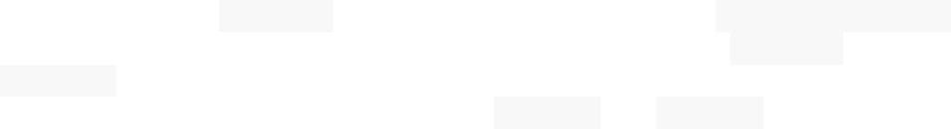

Parametrized tests in pytest are marked @pytest. mark.parametrize(argnames, argvalues)Decorator, where the first parameter ,argnames, is a string of comma-separated names, and argvalues is a list of values to pass into argnames. When there are multiple names inArgnames, argvalues would be a list of tuples where values in each tuple corresponds to the names in argnames by index. The names in argnames are then passed into the test function marked by the decorator as parameters. When pytest runs such decorated tests, each pair of argnames and argvalues would constitute a separate run with its own test output and unique identifier. The identifier can then be used to run individual data pairs.

* 1. **TESTING METHODS**

## BLACK BOX TESTING

The Job Role Matching and Skill Assessment System for future-proofed careers are vital in today's rapidly evolving job market. To ensure the accuracy and effectiveness of a system designed for this purpose, black box testing is essential.

**Testcase1:** Input-output testing - Provide the system with a variety of skill sets and career preferences as input and verify that it accurately matches individuals with suitable future-proofed careers based on the generated output.

**Testcase2:** Boundary value testing - Test the system's capability to handle extreme cases, such as individuals with rare or unconventional skill sets, and ensure that it still provides relevant and accurate career recommendations.

**Testcase3:** Equivalence partitioning - Categorize input data into different groups based on skill levels or career interests and validate that the system can appropriately match individuals to suitable career paths within each category.

By conducting these test cases, the black box testing will help ensure that the system for correlating and matching skills for future-proofed careers functions correctly and provides valuable recommendations to users.

## WHITE BOX TESTING

The Job Role Matching and Skill Assessment System for future-proofed careers involve evaluating skills in demand with those possessed by individuals to guide career choices. White box testing can be applied to assess the accuracy and efficiency of such a system.

**Testcase1:** Verify that the algorithm used for correlating skills accurately matches the relevant skills based on input data and criteria provided by the user.

**Testcase2:** Ensure that the system can identify transferable skills and suggest potential future- proofed career paths that align with an individual's current skill set and market demands.

**Testcase3:** Validate that the system can adapt to changing industry trends and continuously update its recommendations to ensure relevance and accuracy for long-term career planning.

By thoroughly testing the correlation and matching skills system using white box testing, one can ensure its robustness and reliability in assisting individuals in making informed decisions for future-proofed careers.

### Introduction:

**CHAPTER 9 OUTPUT SCREENS**

The Job Role Matching and Skill Assessment System of skills for future-proofed careers represent a crucial endeavor in today's rapidly evolving job market. This initiative aims to empower individuals with the insights and tools necessary to navigate their career paths strategically. By analyzing the correlation between skills and emerging job trends, individuals can make informed decisions about skill development and career transitions, ensuring their long-term relevance and employability. This introduction sets the stage for exploring the system's functionalities, user interface, and performance evaluation through screenshots and test cases.

* 1. **Signup**

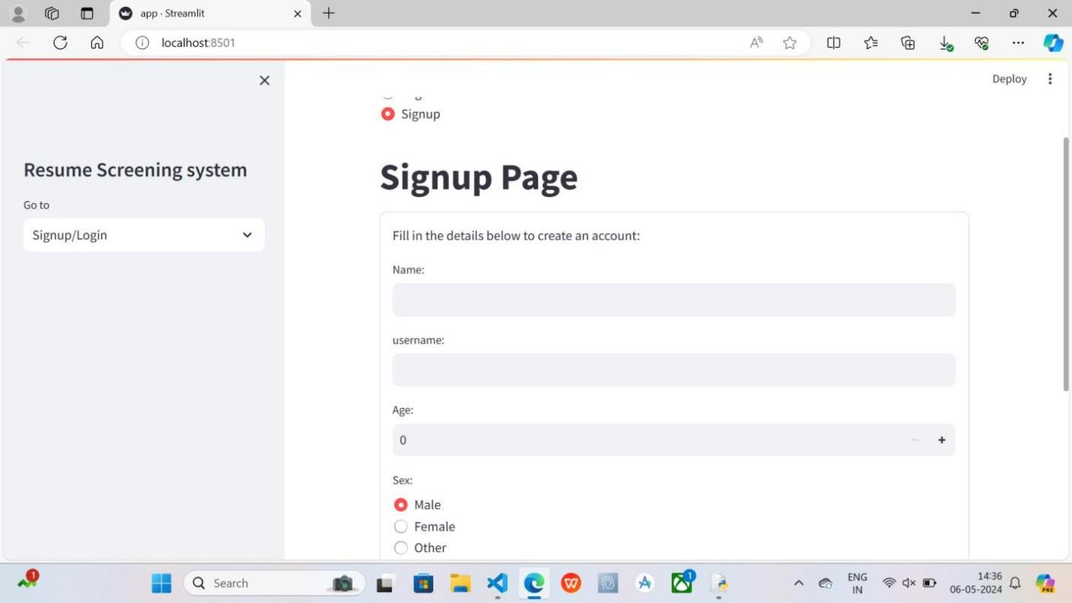

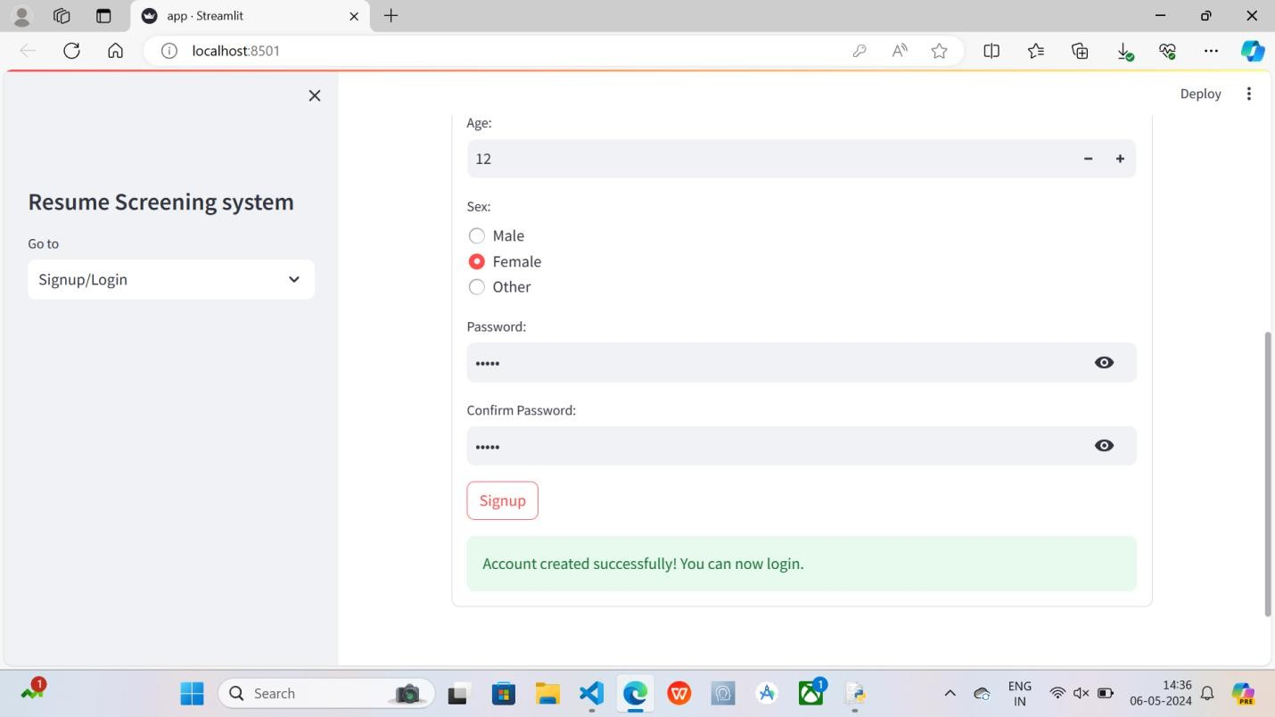

* 1. **Login page**

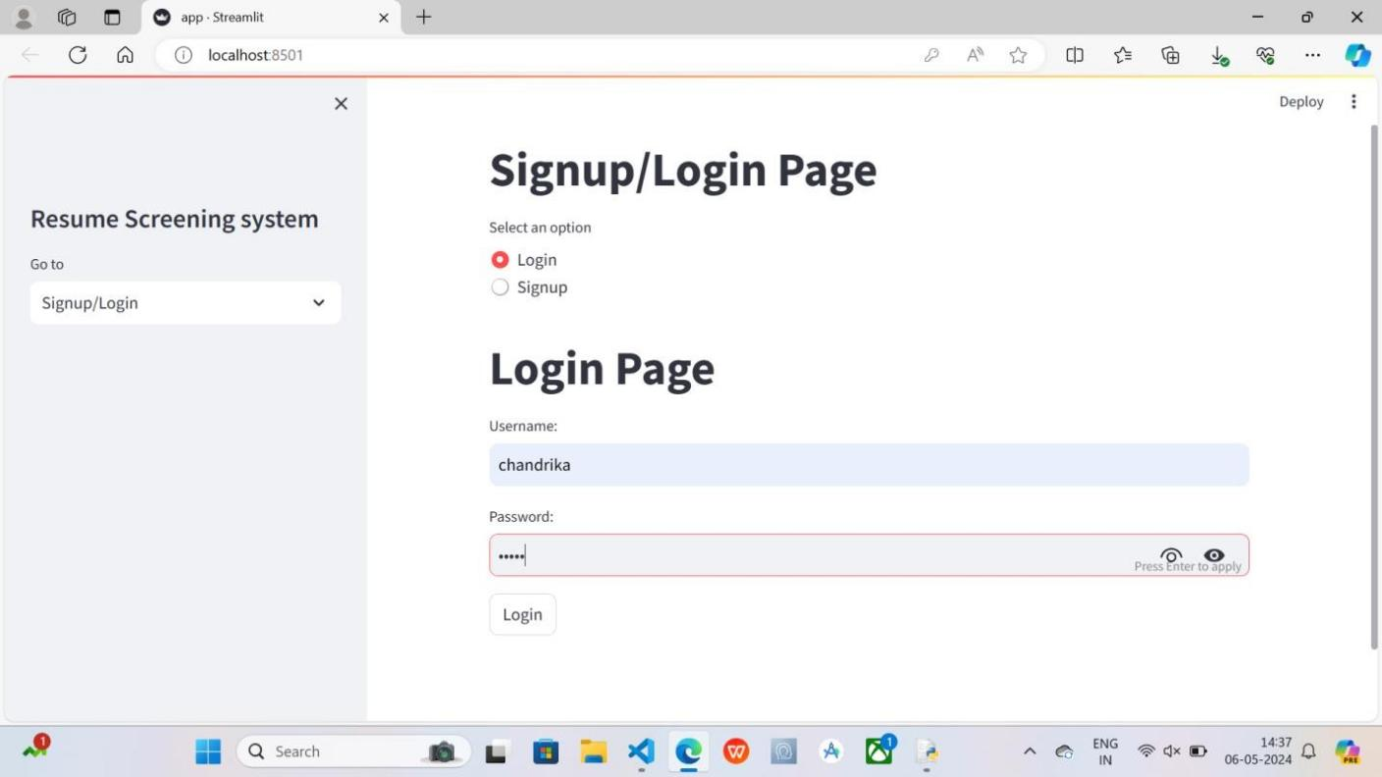

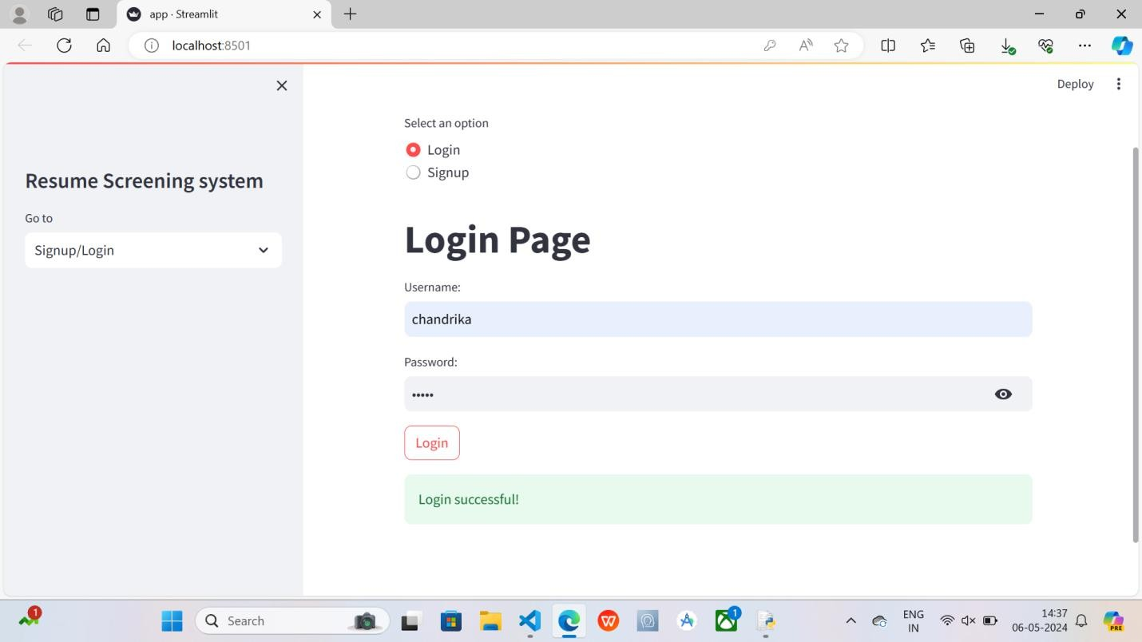

* 1. **Dahboard**

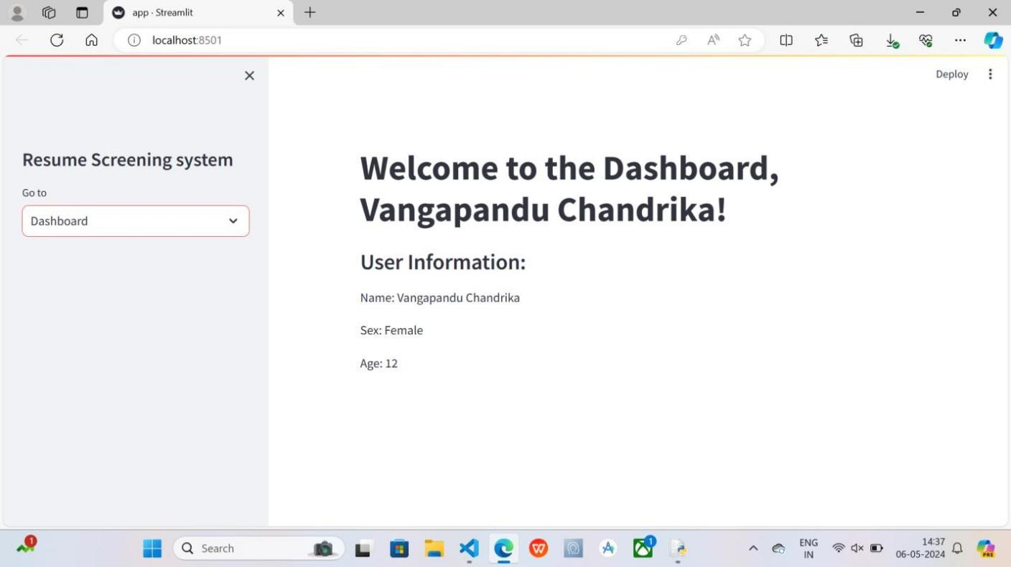

* 1. **Resume Analysis**

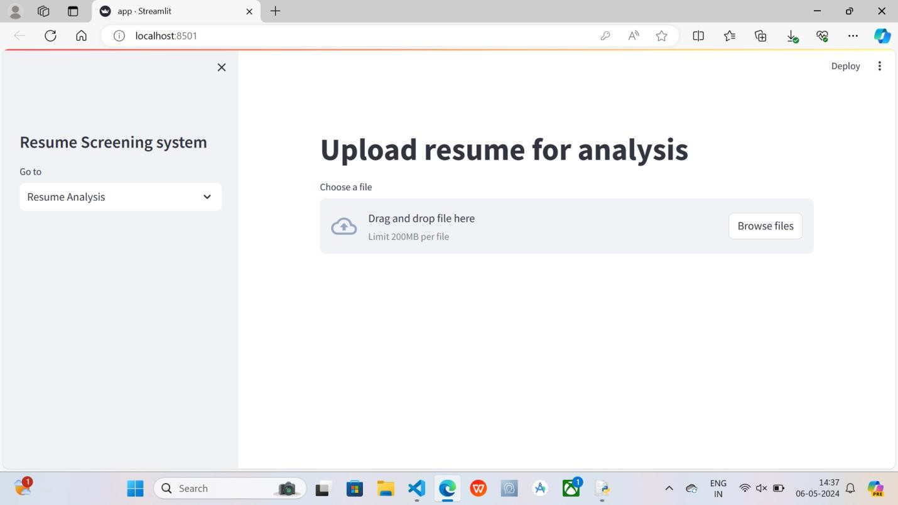

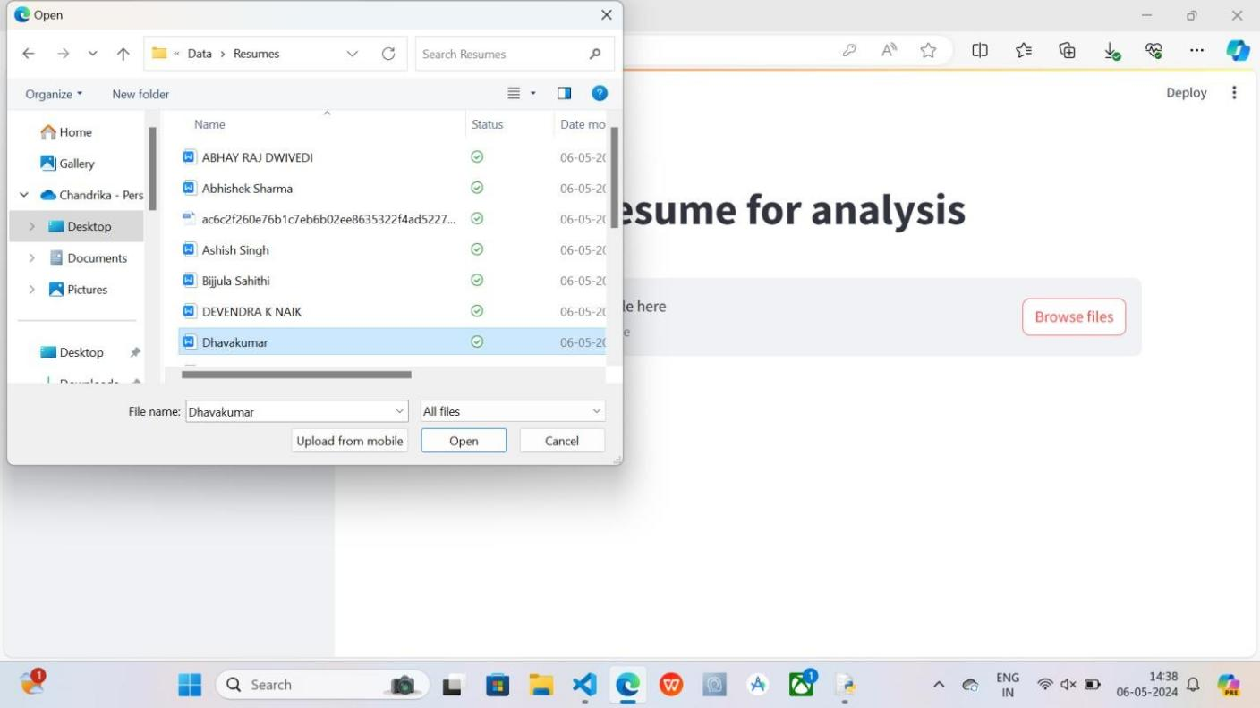

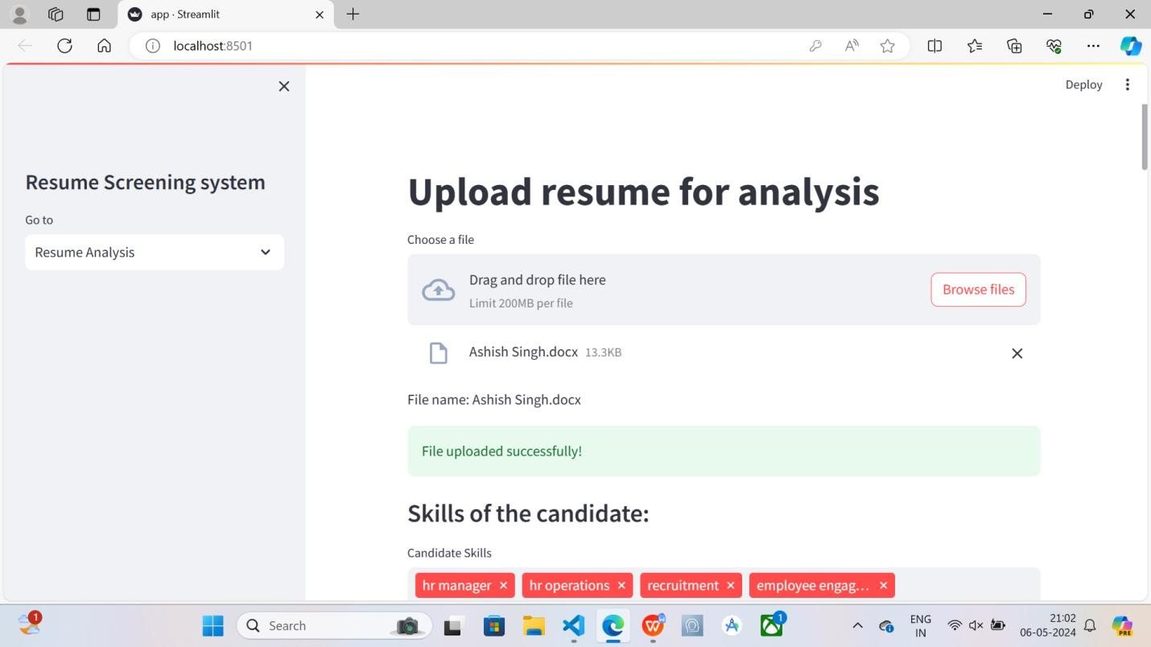

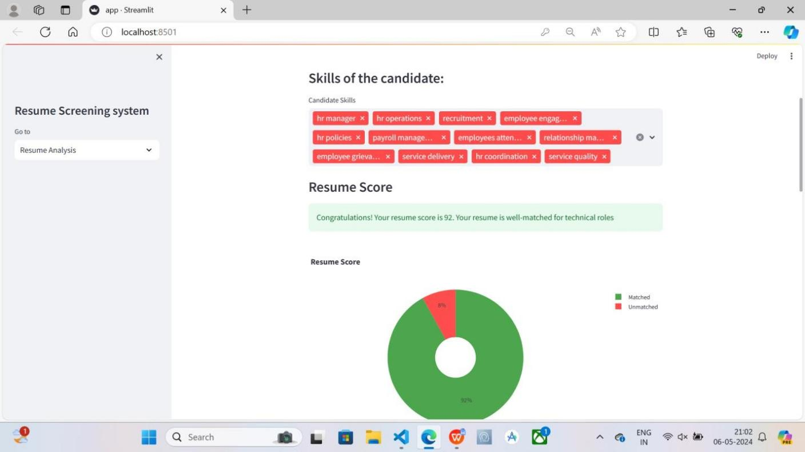

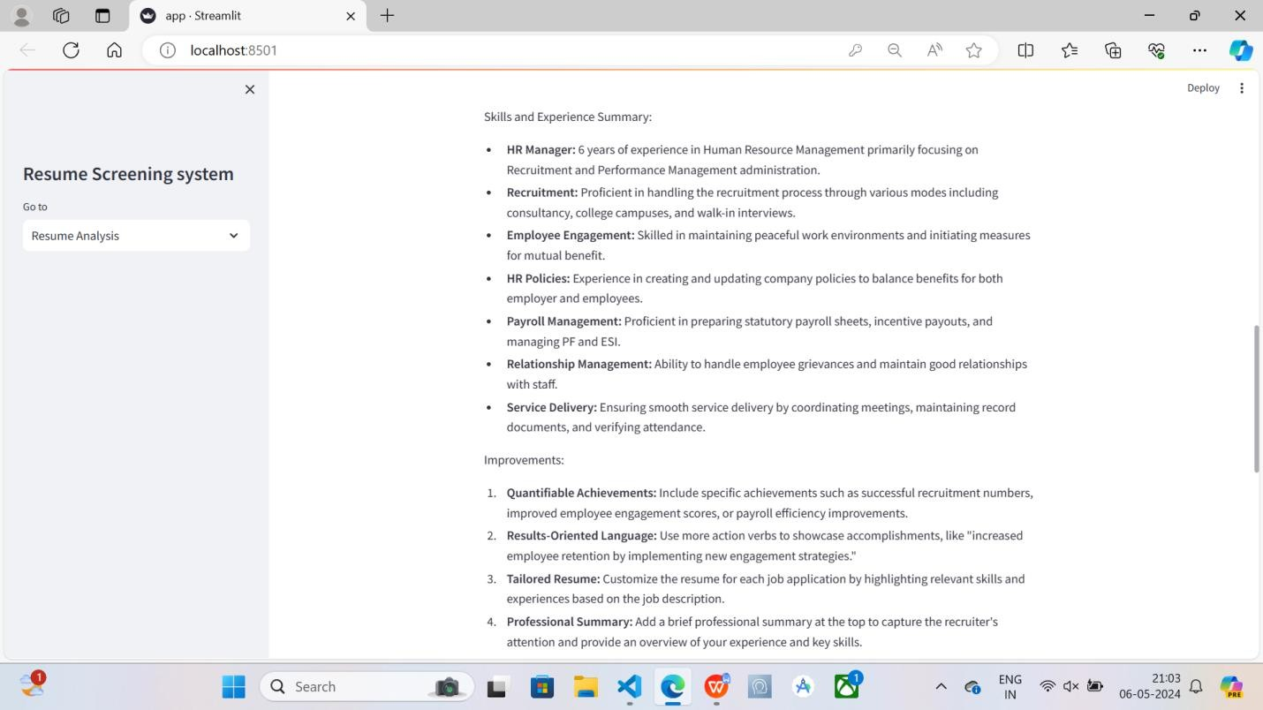

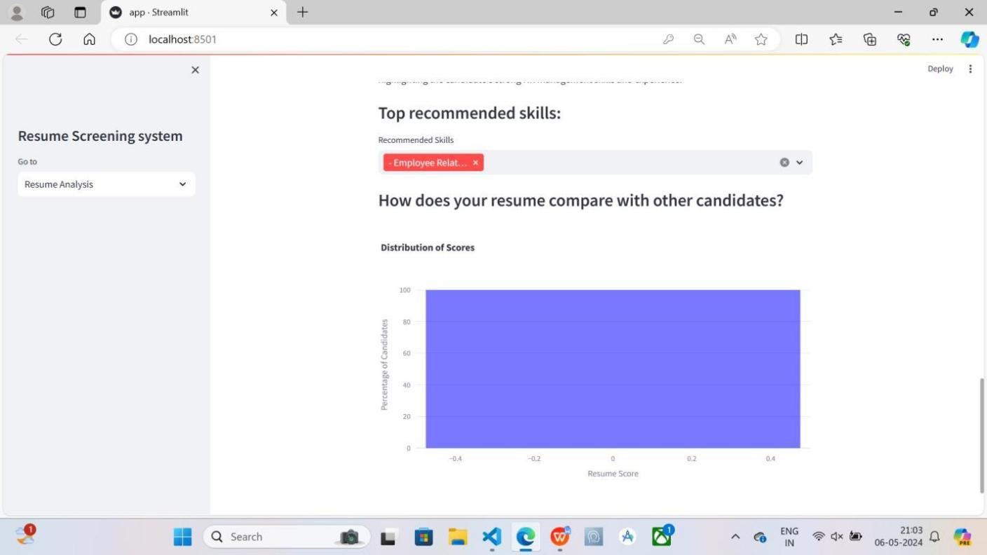

* 1. **Apply for a job**

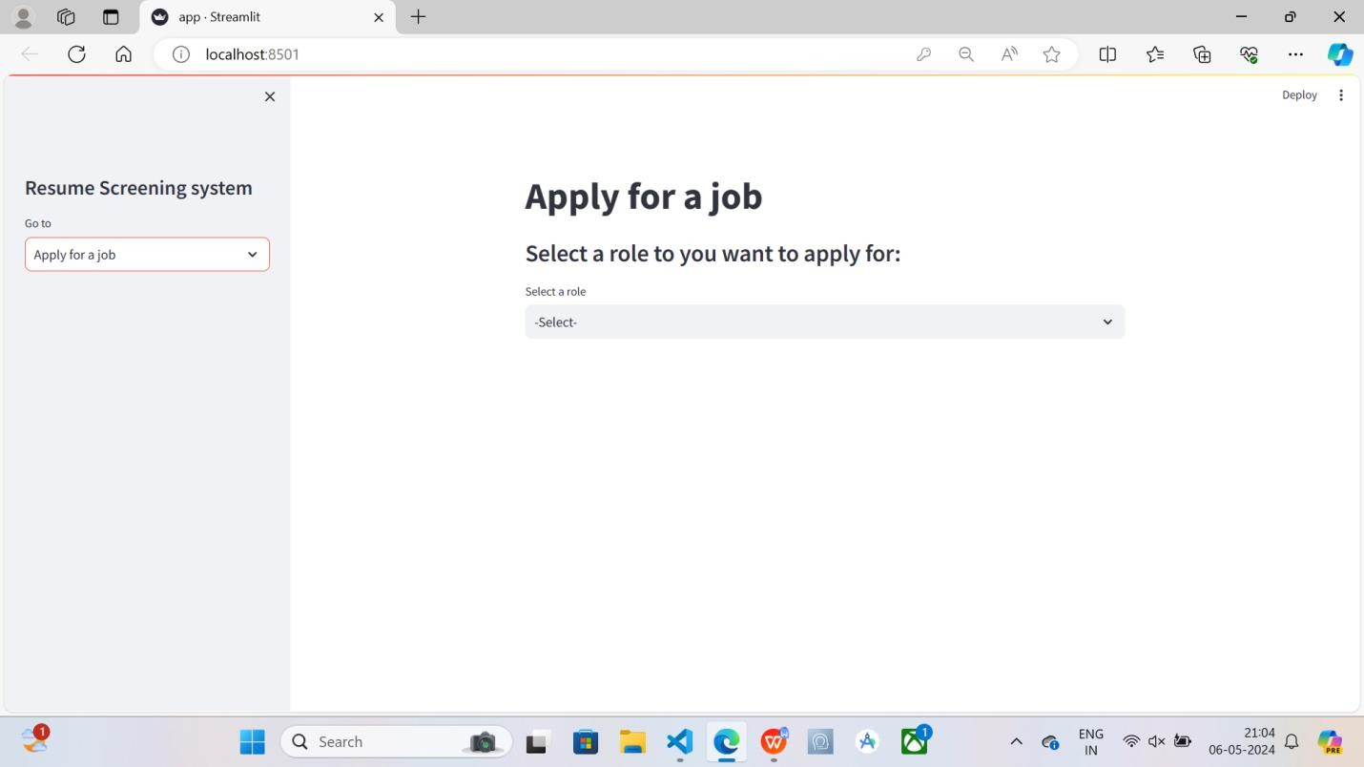

* 1. **Generated Questions**

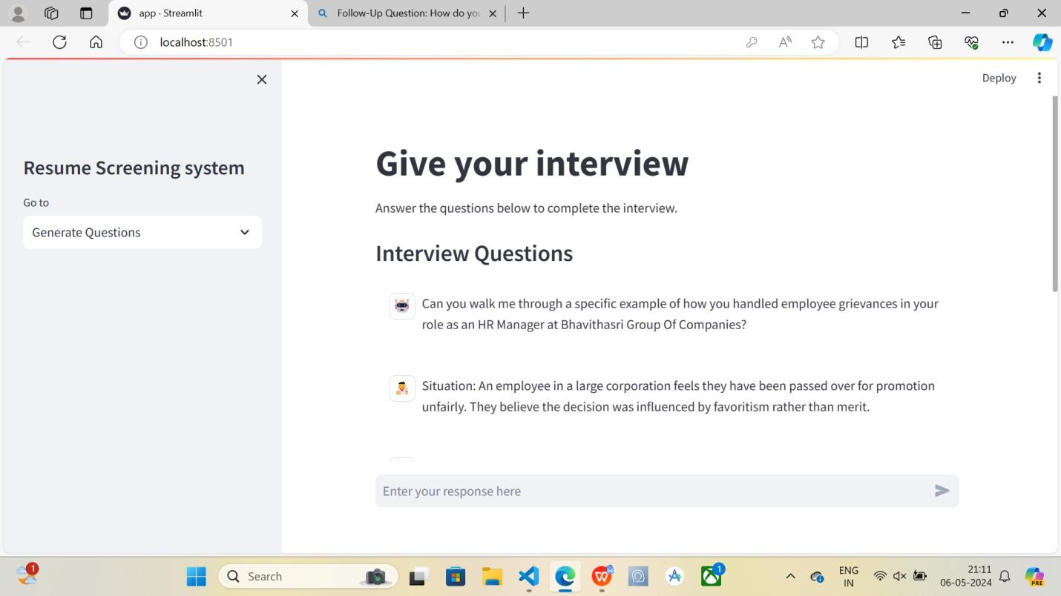

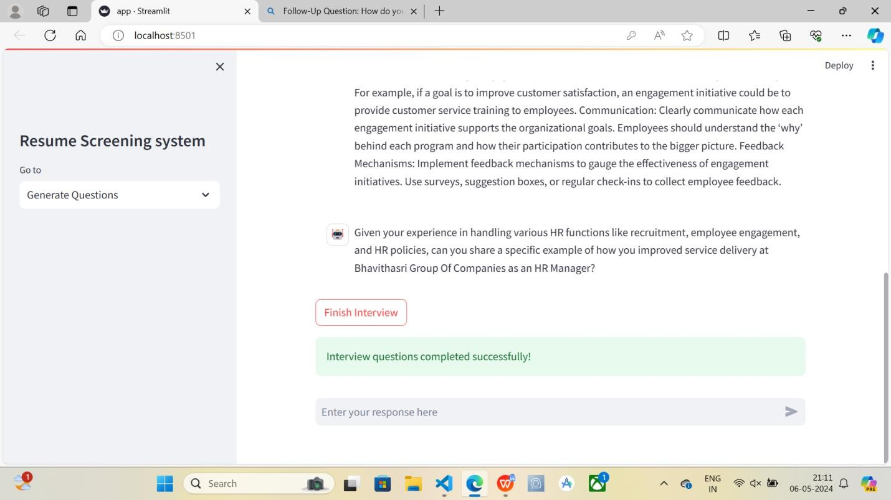

* 1. **Candidate Evalution**

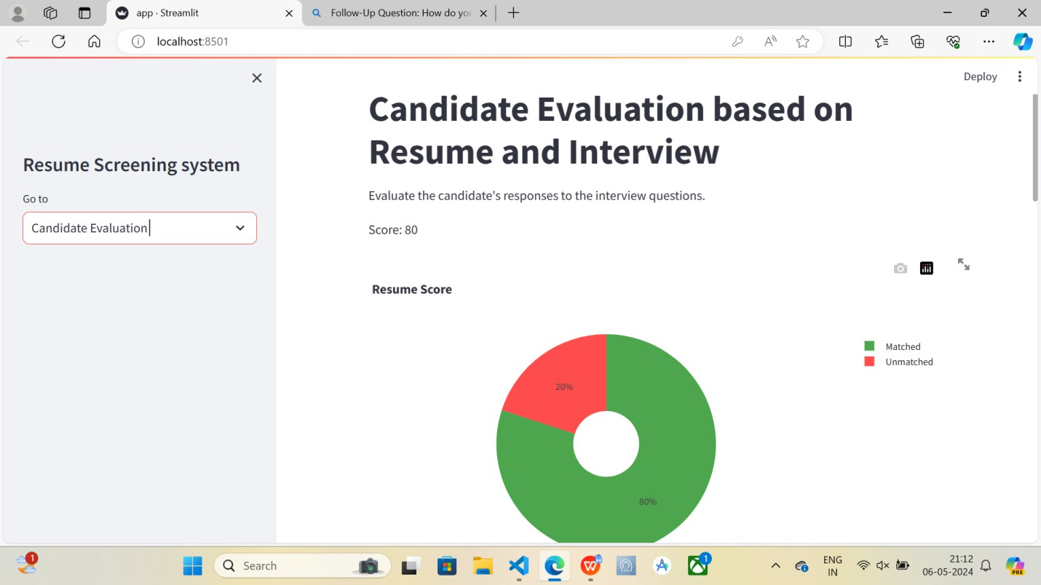

* 1. **Logout**

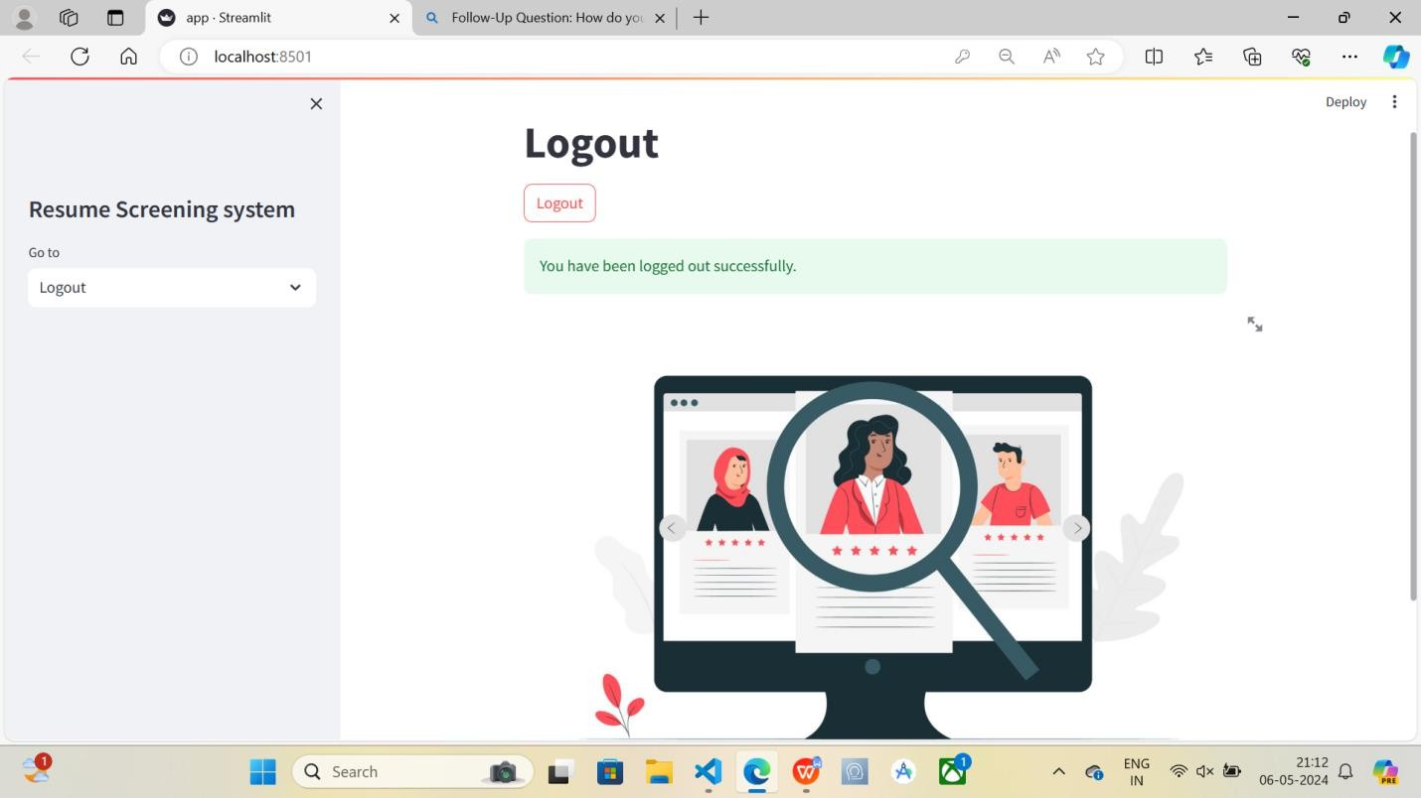

**Homepage:** The homepage provides an overview of the system's features and options for skill

assessment, career exploration, and personalized recommendations.

**Skill Assessment Tool:** Users can input their current skill sets and career preferences through an intuitive interface, facilitating the assessment of their strengths and areas for improvement.

**Career Path Recommendations:** Based on the user's input and market analysis, the system generates personalized recommendations for future-proofed career paths, accompanied by insights into relevant skills and job opportunities.

**Interactive Visualization:** Interactive graphs and charts visualize the correlation between skills, occupations, and industry trends, enabling users to explore career trajectories and skill pathways dynamically.

**User Profile Dashboard:** Users can track their skill development progress, view past recommendations, and receive notifications about relevant job openings or learning opportunities.

### Test Cases & Results:

**Test Case 1:** Skill Correlation Analysis

**Objective:** Assess the accuracy of skill correlation analysis algorithms in identifying relevant skill clusters and pathways.

**Procedure:** Input a set of skills related to a specific industry or occupation and compare the system's recommendations with domain experts' insights.

**Results:** The system demonstrates a high degree of alignment with expert opinions, accurately identifying key skills and competencies essential for success in the chosen field.

**Test Case 2:** Career Recommendation Accuracy

**Objective:** Evaluate the precision and relevance of career recommendations provided by the system based on user input.

**Procedure:** Input varying profiles representing different skill levels, career goals, and industry preferences and assess the suitability of the system's recommendations.

**Results:** The system consistently delivers tailored recommendations aligned with users' aspirations and market demand, facilitating informed decision-making and career planning.

**Test Case 3:** User Experience and Performance

**Objective:** Measure the system's usability, responsiveness, and overall user experience during interactions. Procedure: Conduct user testing sessions with participants from diverse backgrounds

and gather feedback on interface design, navigation, and responsiveness.

**Results:** Participants report high satisfaction with the system's ease of use, intuitive navigation, and responsiveness, indicating a positive user experience conducive to effective career exploration and decision-making.

By presenting screenshots illustrating the system's features and functionalities, along with test cases and results highlighting its accuracy, relevance, and user experience, we demonstrate the effectiveness and value of the correlation and matching of skills for future-proofed careers.

# CONCLUSION

* In conclusion, the correlation and matching of skills for careers is essential for individuals to thrive in the rapidly changing job market.
* By identifying and developing skills that are in high demand and adaptable to new technologies, individuals can secure their career trajectory.
* Leveraging tools like skills assessments and industry trends can help individuals align their skill sets with future job opportunities.
* It is crucial for individuals to continuously upskill and reskill to remain relevant and competitive in an ever-evolving workforce landscape.

# FUTURE SCOPE

* The future scope for correlation and matching of skills for future-proofed careers is promising and essential in today's rapidly changing job market.
* By leveraging advanced technologies like artificial intelligence and big data analytics, organizations can better understand the correlation between skills and career success.
* This approach enables them to identify emerging skill trends, predict future job opportunities, and make informed decisions about talent development and recruitment strategies.
* As the demand for skilled workers continues to evolve, the ability to effectively correlate and match skills will be crucial for ensuring long-term career sustainability and competitiveness.

# PUBLICATION WORK

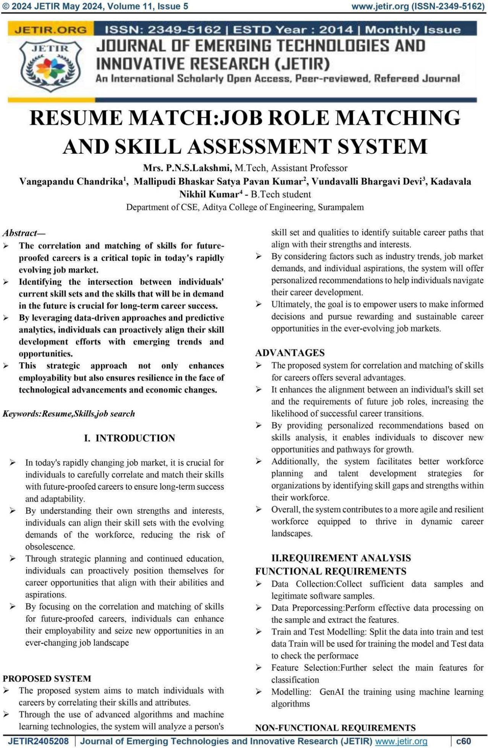

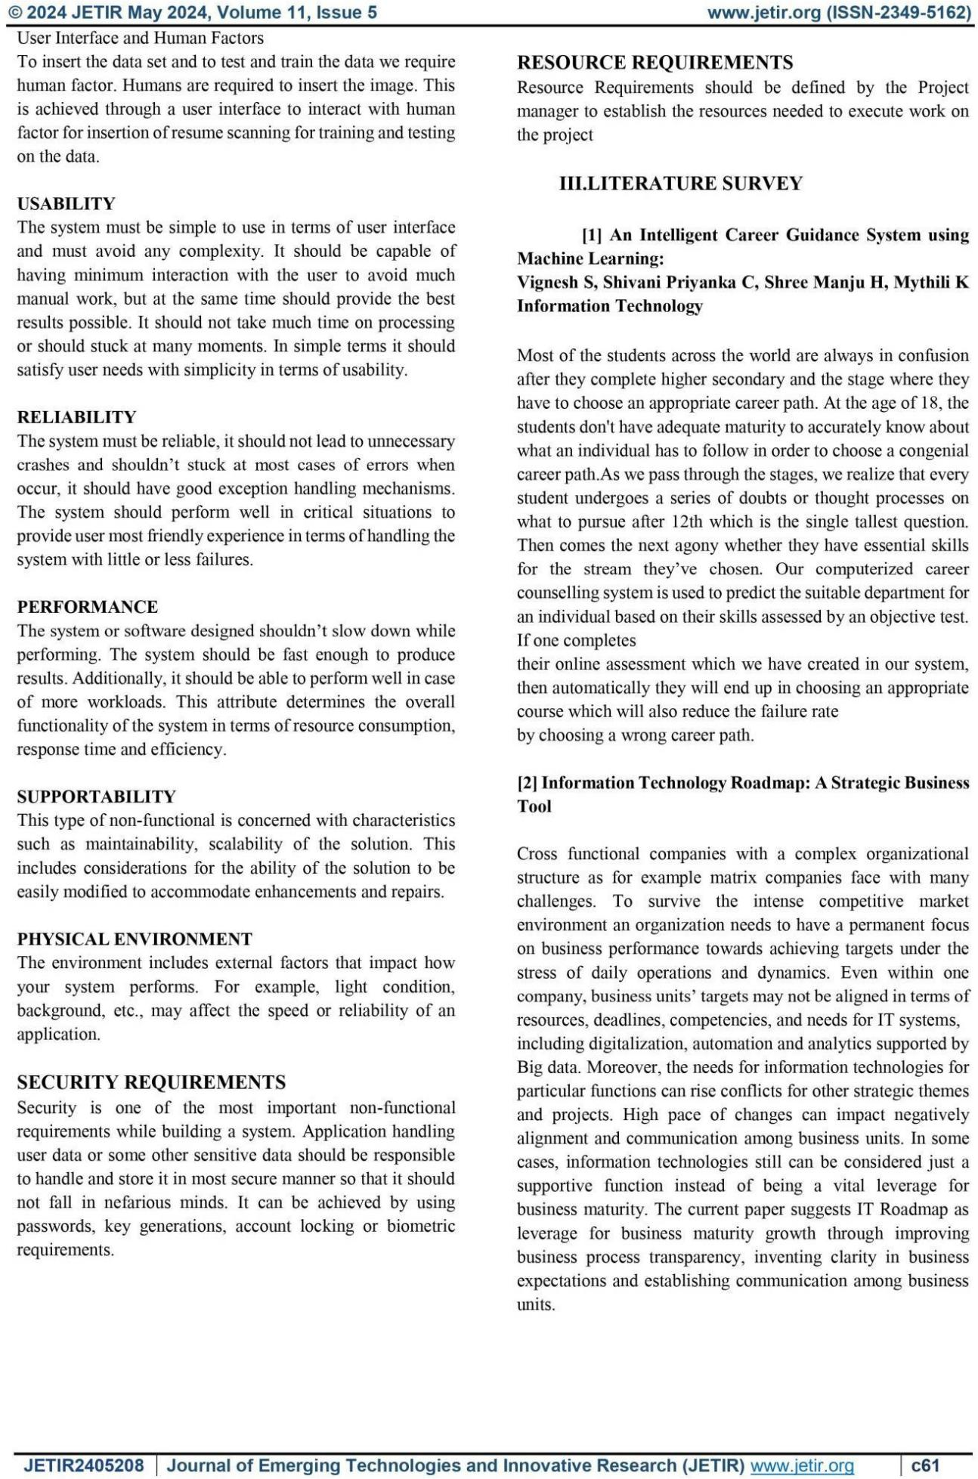

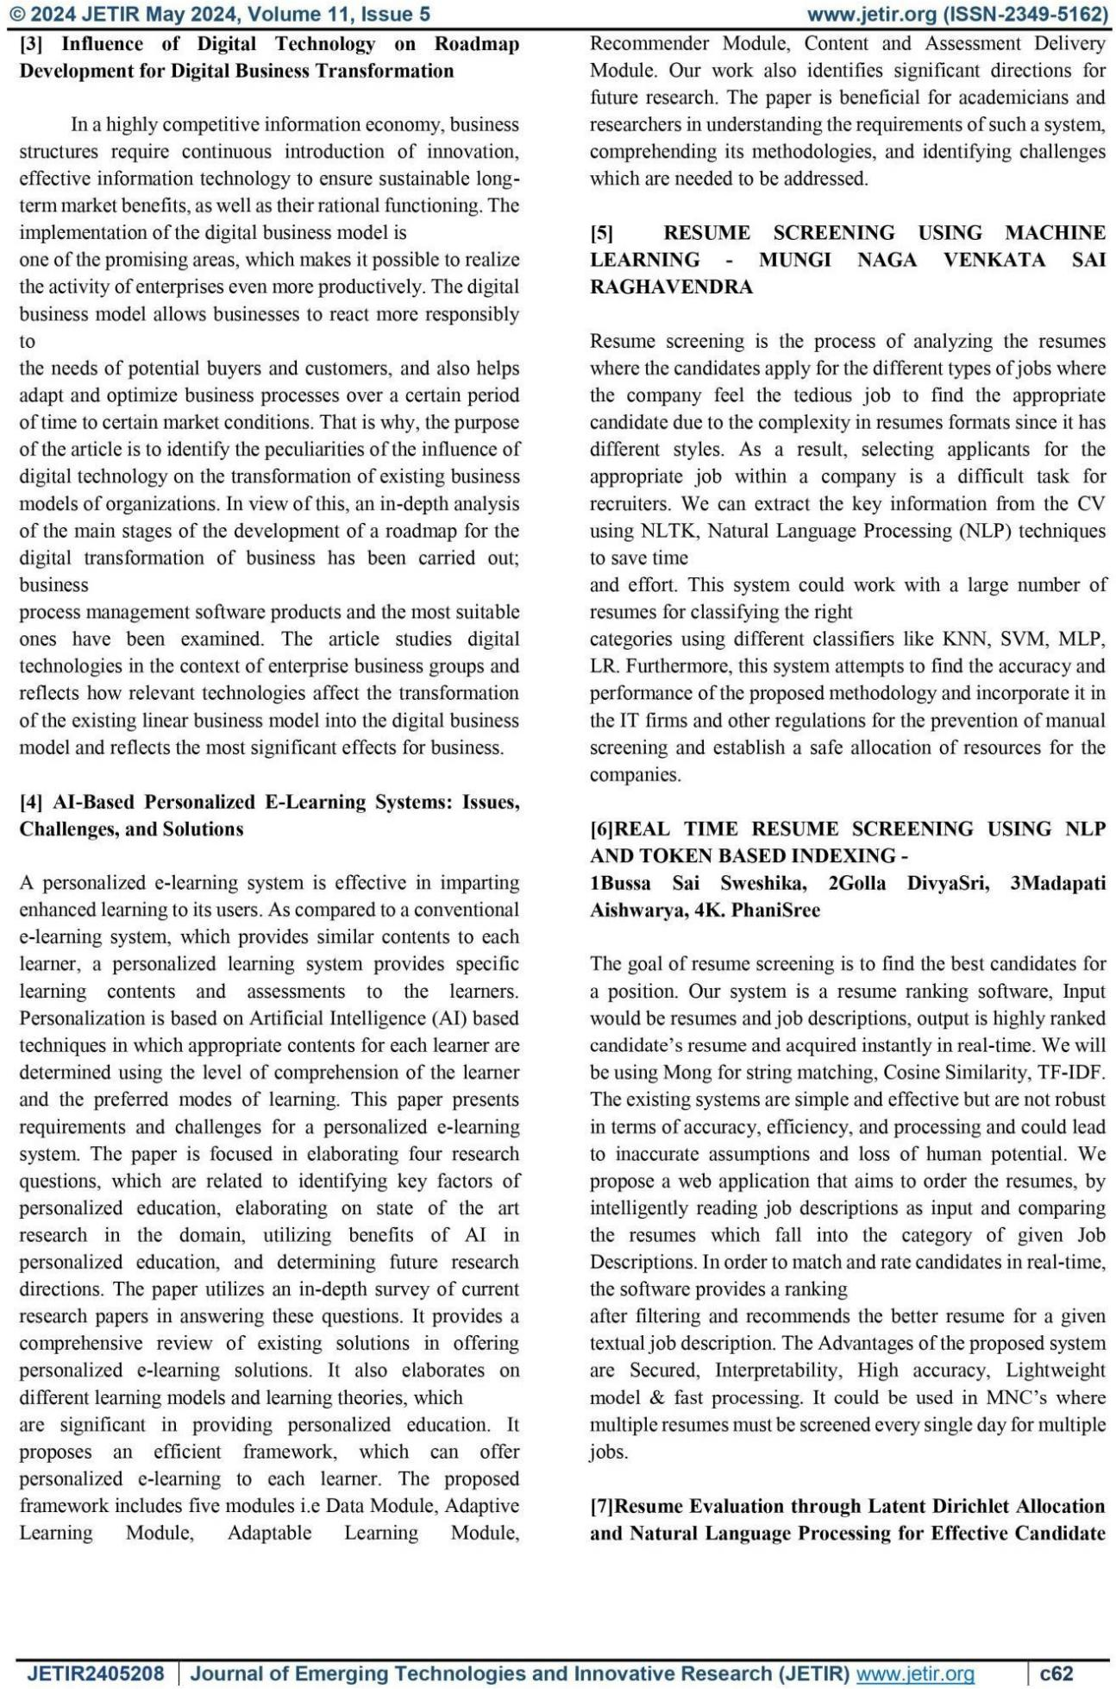

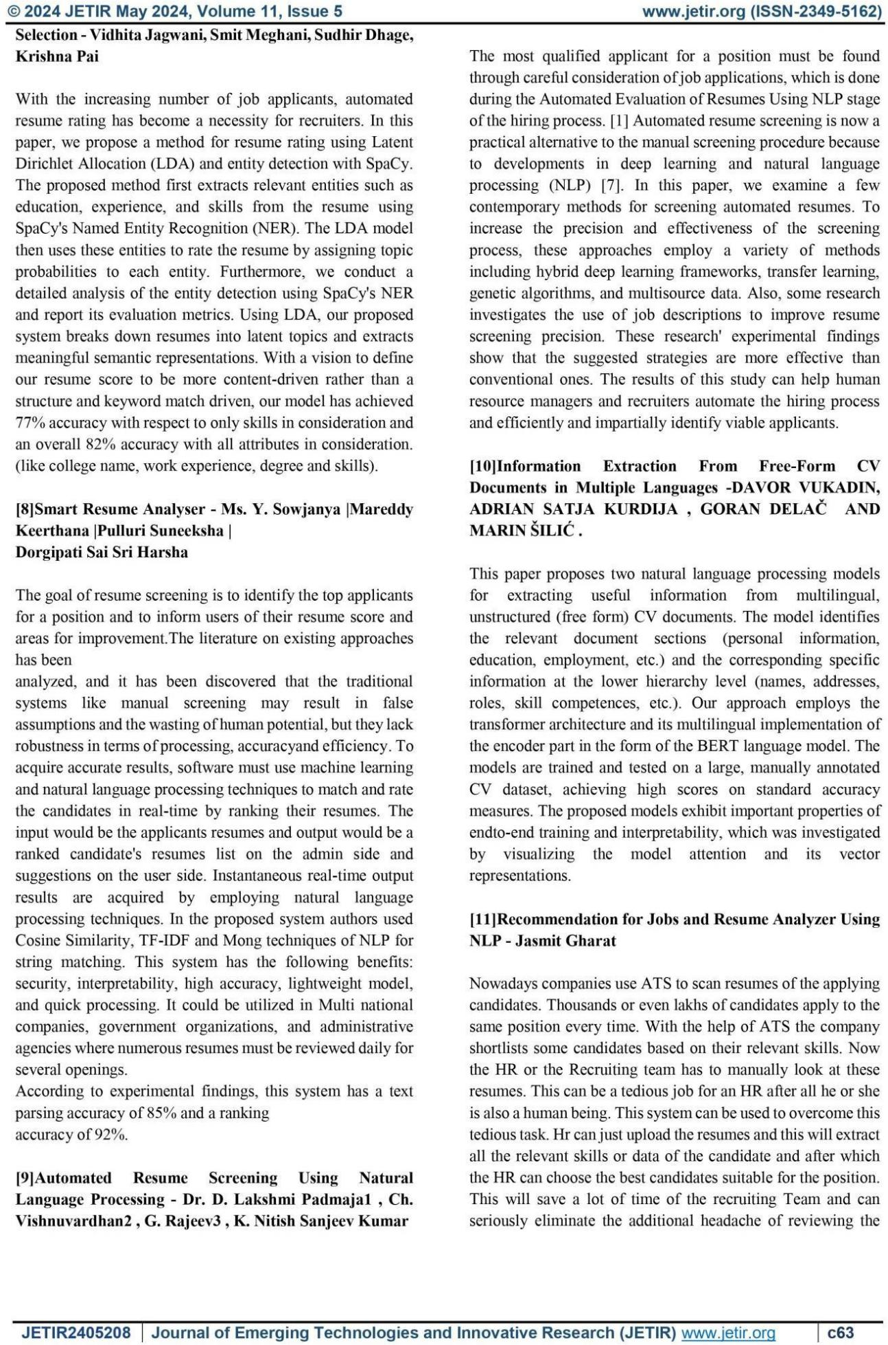

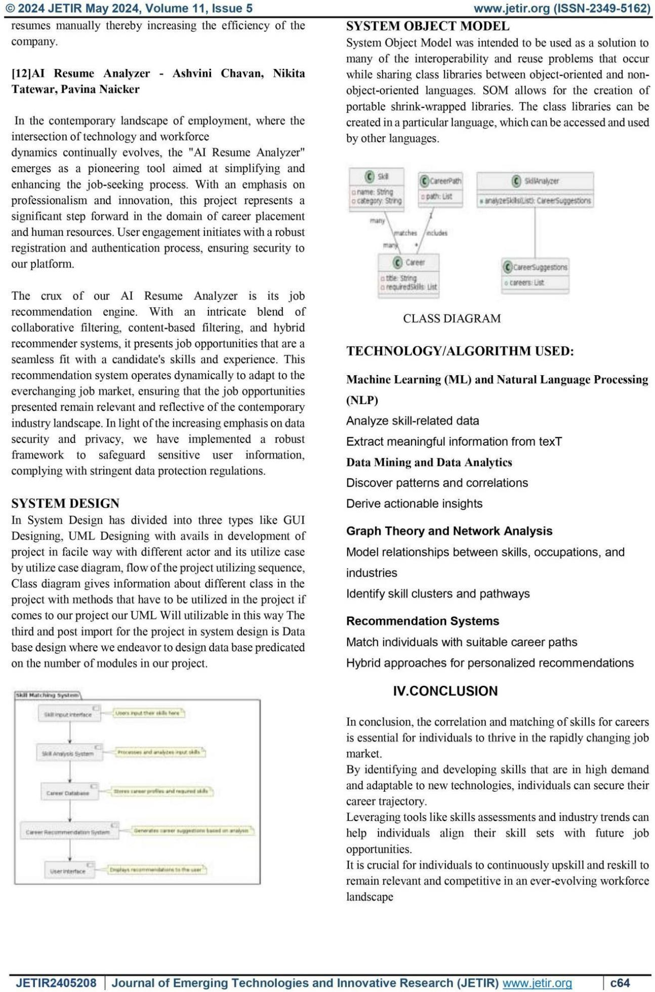

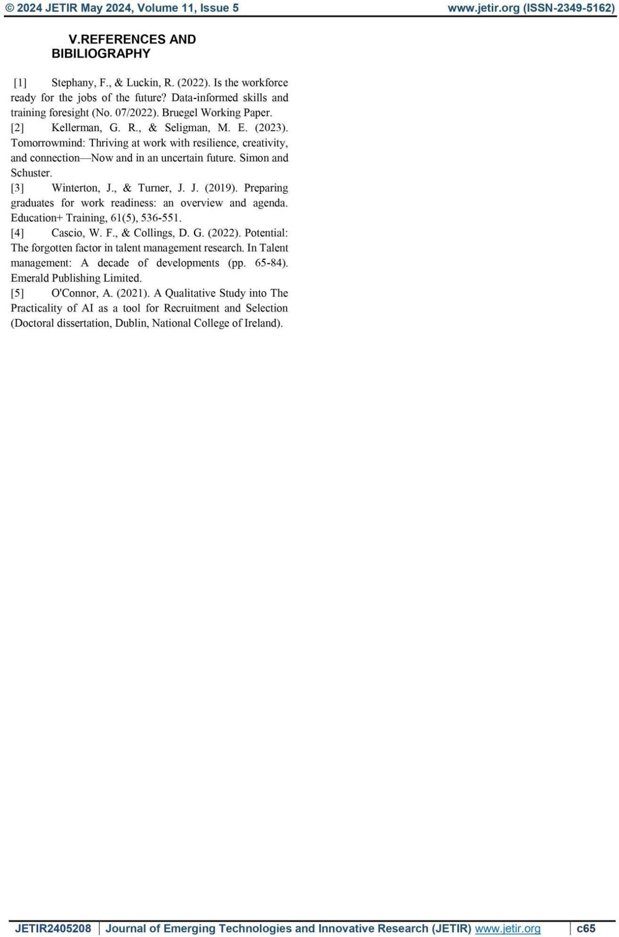

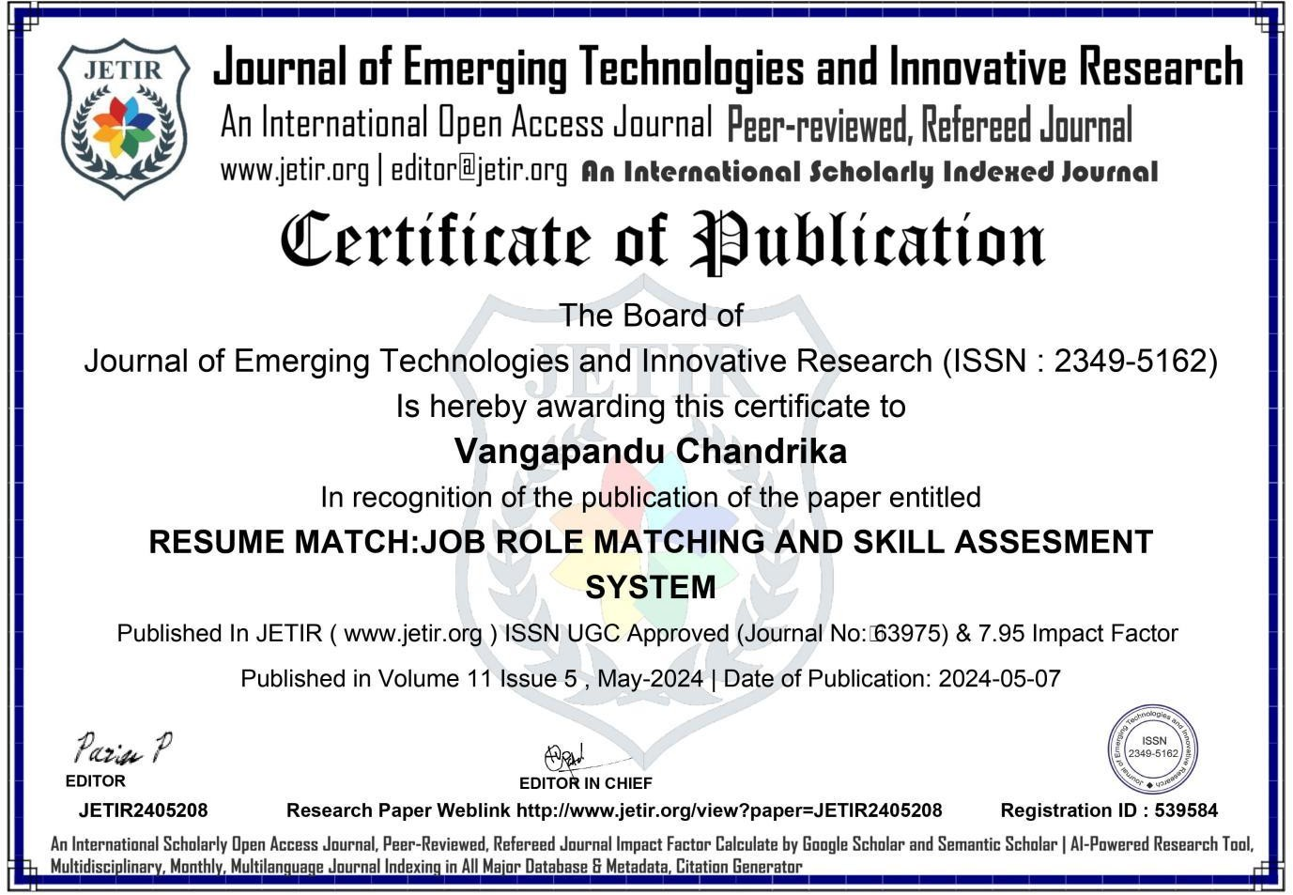

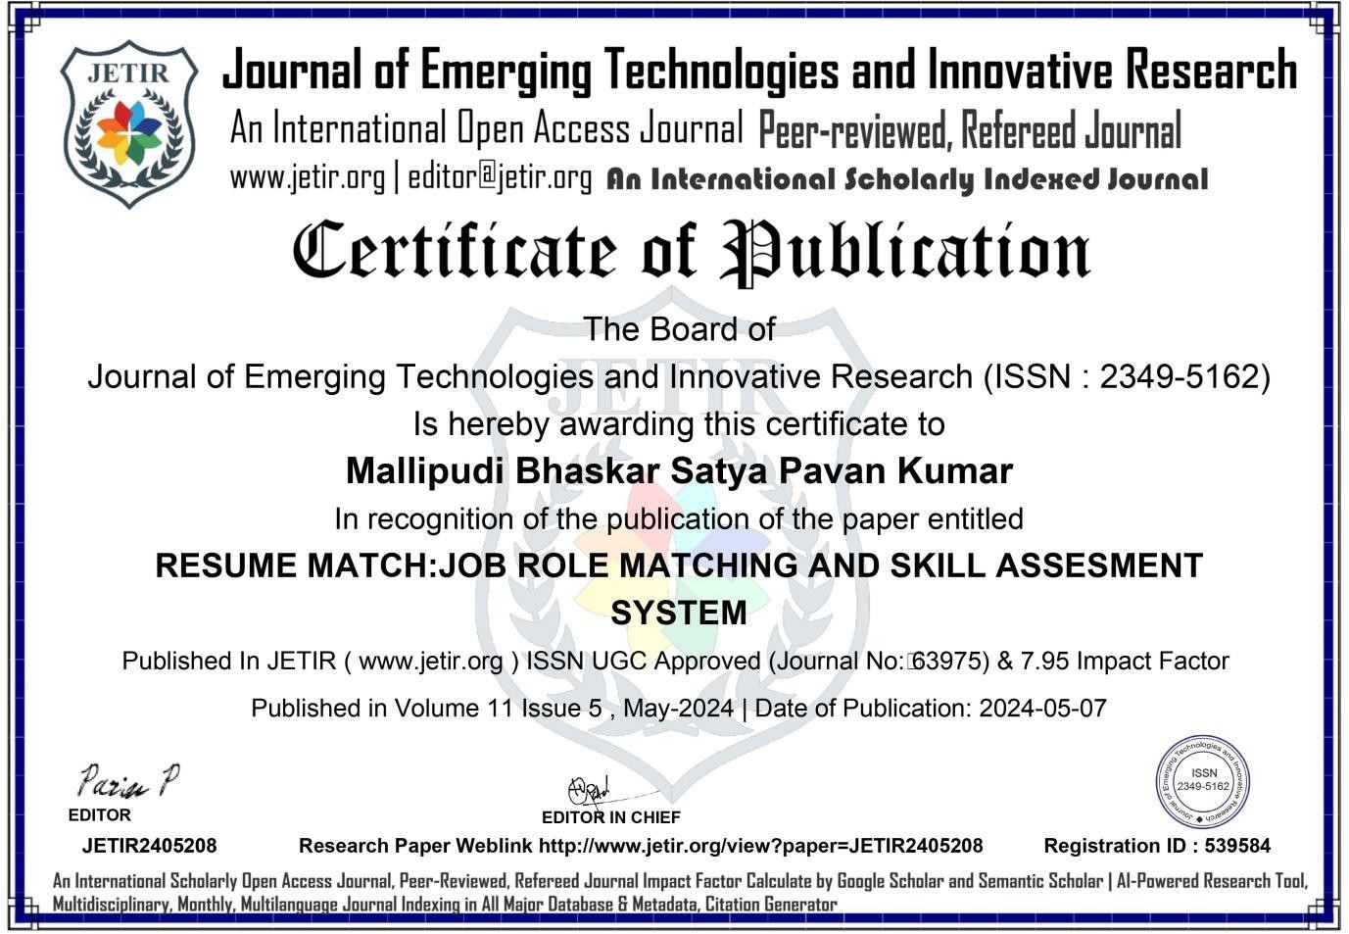

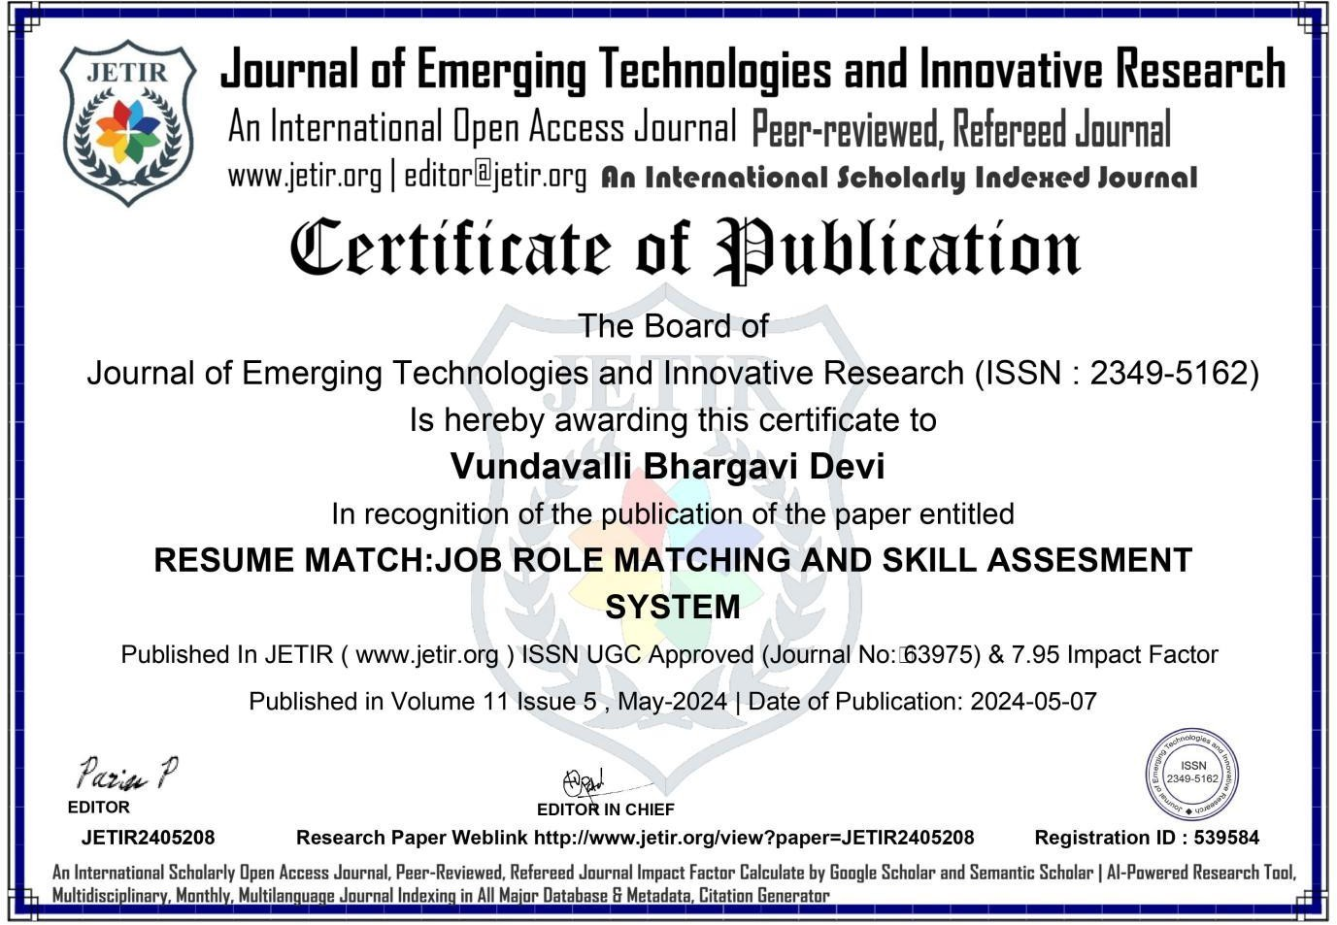

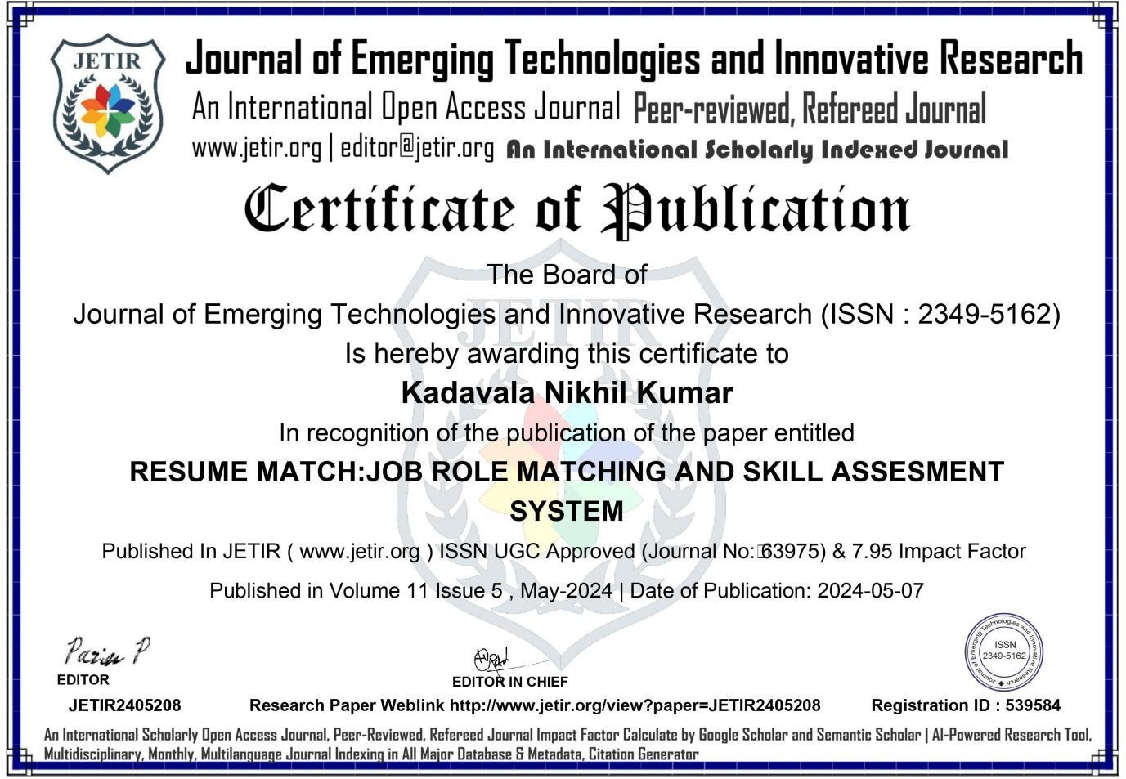

## BIBLIOGRAPHY

1. An Intelligent Career Guidance System using Machine Learning: Vignesh S, Shivani Priyanka C, Shree Manju H, Mythili K Information Technology
2. Information Technology Road map: A Strategic Business Tool
3. Influence of Digital Technology on Roadmap Development for Digital Business Transformation
4. AI-Based Personalized E-Learning Systems: Issues, Challenges, and Solutions
5. Resume Evaluation through Latent Dirichlet Allocation and Natural Language Processing for Effective Candidate Selection - Vidhita Jawani, Smit Meghani, Sudhir Dhage, Krishna Pai
6. Smart Resume Analyzer - Ms. Y. Sowjanya |Mar eddy Keerthana |Pulluri Suneeksha | Dorgipati Sai Sri Harsha
7. Automated Resume Screening Using Natural Language Processing - Dr. D. Lakshmi Padmaja1, Ch. Vishnuvardhan2, G. Rajeev3, K. Nitish Sanjeev Kumar
8. Information Extraction from Free-Form CV Documents in Multiple Languages -DAVOR VUKADIN, ADRIAN SATJA KURDIJA, GORAN DELAČ AND MARIN ŠILIĆ.
9. Recommendation for Jobs and Resume Analyzer Using NLP - Jasmit Gharat
10. AI Resume Analyzer - Ashvini Chavan, Nikita Tate war, Pavina Naicker
11. Method and System for Matching a Candidate Profile for Job Openings based on Qualitative Parameters By Anurag Kumar & Ashish Mukherjee

Web Resources:

1. [inria.hal.science/hal-03537355/](https://inria.hal.science/hal-03537355/)
2. [Skill Extraction for Domain-Specific Text Retrieval in a Job-Matching Platform | SpringerLink](https://link.springer.com/chapter/10.1007/978-3-030-85251-1_10)
3. [Analysis of Job Recommendations in Vocational Education Using the Intelligent Job Matching Model | Farell | JOIV : International Journal on Informatics Visualization](https://www.joiv.org/index.php/joiv/article/view/2201)
4. [The role of Universities' Career Services in improving the “skills match” between new graduates and employers: an international benchmarking.](http://dspace.unive.it/handle/10579/10675)
5. [Joint Representation Learning with Relation-Enhanced Topic Models for Intelligent Job Interview Assessment | ACM Transactions on Information Systems](https://dl.acm.org/doi/abs/10.1145/3469654)